|  |  |
| --- | --- |
|  | **MINISTRY OF EDUCATION AND TRAINING** |

**FPT UNIVERSITY**

|  |  |
| --- | --- |
| Capstone Project Document | |
| **Scrap Collector** | |
| **Group 3 - JS** | |
| **Group members** | Nguyễn Duy Đạt – SE63093 (Leader)  Tiết Lê Bảo Khánh – SE62247  Nguyễn Hoàng Anh Trung – SE62282  Nguyễn Hoàng Nhân – SE63259 |
| **Supervisor** | Lại Đức Hùng |
| **Ext. Supervisor** | N/A |
| **Project Code** | SCHS |

– **Ho Chi Minh City, 13 January, 2020** –

**Table of contents**

A. Introduction 17

1. Project Information 17

2. Introduction 17

3. Current Situation 17

4. Problem Definition 17

5. Proposed Solution 18

**5.1 Feature functions** 18

**5.2** **Advantages and disadvantages** 18

6. Functional Requirements 18

7. Role & Responsibility 19

B. Software Project Management Plan 19

1. Problem Definition 19

2. Project Organization 22

3. Project Management Plan 25

4. Coding Convention 25

C. Software Requirement Specification 26

1. User Requirement Specification 26

2. System Requirement Specification 27

3. Software System Attribute 88

4. Conceptual Diagram 89

D. Software Design Description 90

1. Design Overview 90

2. System Architectural Design 91

3. Component Diagram 92

4. Detailed Description 93

5. Interface 127

5.1 User Interface Design 127

5.1.1 Login 127

5.1.2 Menu Manager 128

5.1.3 Manage Staff 129

5.1.4 Manage Website 130

5.1.5 Menu Staff 131

5.1.6 Sitemap 133

5.1.7 Spelling test 134

5.1.8 Grammar test 135

5.1.9 Broken page test 136

5.1.10 Broken links test 137

5.1.11 Missing file test 138

5.1.12 Prohibited content test 139

5.1.13 Mobile layout test 140

5.1.14 Speed test 141

5.1.15 Javascript error test 143

5.1.16 Favicon test 144

5.1.17 Cookie test 145

5.1.18 Server behavior test 146

5.1.19 Contact detail test 147

5.1.20 Redrection test 148

5.1.21 Page test 149

6. Database Design 150

6.1. Entity relationship diagram (ERD) 150

6.2. Data Dictionary 151

7. Algorithms 157

E. System Implementation & Test 168

1. Introduction 168

2. Data Relationship Diagram 169

3. Test Plan 171

3.1. Features To Be Tested 171

3.2. Features Not To Be Tested 172

4. System Testing Test Case 172

F. Software User’s Manual 187

G. Appendix 201

**List of tables**

Table 1 – Role & Responsibility 19

Table 1 - Hardware Requirements for Server 21

Table 2 - Hardware requirement for PC 22

Table 3 - Software Requirement 22

Table 4 - Roles and responsibilities 24

Table 5 - Tools and techniques 24

Table 6 - Deliverables 25

Table 7 <Guest> Login use case specification 30

Table 8 - <Guest> Test broken links use case specification 32

Table 9 - <Guest> Test missing file use case specification 33

Table 10 - <Staff> Determine specific pages to test use case specification 36

Table 11 - <Staff> View Sitemap use case specification 37

Table 12 - <Staff> View pages referencing to the specific page use case specification 39

Table 13 - <Staff> Test spelling use case specification 41

Table 14 - <Staff> Test Grammar use case specification 42

Table 15 - <Staff> Test prohibited for website's content use case specification 44

Table 16 - <Staff> Test broken links use case specification 45

Table 17 - <Staff> Test broken pages use case specification 47

Table 18 - <Staff> Test missing file use case specification 49

Table 19-<Staff> Test the mobile layout use case specification 50

Table 20 - <Staff> Measure the speed of each page use case specification 52

Table 21 - <Staff> Test JavaScript errors use case specification 53

Table 22- <Staff> Test favicon use case specification 55

Table 23 - <Staff> Test cookies use case specification 56

Table 24 - <Staff> Test server behavior use case specification 58

Table 25 - <Staff> Test contact details on the website use case specification 59

Table 26 - <Staff> View all pages that contain the contact defined use case specification 61

Table 27 - <Staff> Test redirection use case specification 62

Table 28 - <Staff> Test pages use case specification 64

Table 29 - <Staff> Create report use case specification 65

Table 30 <Staff> View history reports use case specification 67

Table 31 - <Manager> Build sitemap use case specification 69

Table 32 - <Manager> View sitemap use case specification 71

Table 33 - <Manager> View pages referencing on the specific page use case specification 72

Table 34 - <Manager> Add new website use case specification 74

Table 35 - <Manager> Delete website use case specification 75

Table 36 - <Manager> Create new staff use case specification 77

Table 37 - <Manager> Delete staff use case specification 78

Table 38 <Manager> Assign staff use case specification 79

Table 39 <Manager> Add new word website's dictionary use case specification 81

Table 40<Manager> Delete word website's dictionary use case specification 82

Table 41 <Manager> Add new warning word use case specification 84

Table 42 <Manager> Delete warning word use case specification 85

Table 43 <Manager> Edit warning word use case specification 87

Table 44 <Manager> View all reports use case specification 88

Table 45 Conceptual Diagram Data Dictionary 90

Table 46 Front End Component Diagram Dictionary 92

Table 47 Back End Component Diagram Dictionary 93

Table 48 Class Diagram Dictionary 96

Table 49<Class Diagram Attributes> Account 97

Table 50 <Class Diagram Methods> Account 97

Table 51 <Class Diagram Attributes> Role 97

Table 52<Class Diagram Methods> Role 97

Table 53<Class Diagram Attributes> Website 98

Table 54 <Class Diagram Methods> Website 98

Table 55 <Class Diagram Attributes> Dictionary 98

Table 56 <Class Diagram Methods> Dictionary 98

Table 57 <Class Diagram Attributes> Sitemap 99

Table 58 <Class Diagram Methods> Sitemap 99

Table 59 <Class Diagram Attributes> Warningword 99

Table 60 <Class Diagram Methods> Warningword 99

Table 61 <Class Diagram Attributes> Topic 100

Table 62 <Class Diagram Methods> Topic 100

Table 63 <Class Diagram Attributes> Page 100

Table 64 <Class Diagram Methods> Page 101

Table 65 <Class Diagram Attributes> Version 101

Table 66 <Class Diagram Attributes> GrammarReport 102

Table 67 <Class Diagram Attributes> SpellingReport 102

Table 68 <Class Diagram Methods> SpellingReport 102

Table 69 <Class Diagram Attributes> WarningWordReport 103

Table 70 <Class Diagram Attributes> PageReport 103

Table 71 <Class Diagram Attributes> ContactReport 104

Table 72 <Class Diagram Attributes> BrokenLinkReport 104

Table 73 <Class Diagram Attributes> RedirectionReport 104

Table 74 <Class Diagram Attributes> BrokenPageReport 105

Table 75 <Class Diagram Attributes> MissingFileReport 105

Table 76 <Class Diagram Attributes> FaviconReport 106

Table 77 <Class Diagram Attributes> SpeedReport 106

Table 78 <Class Diagram Attributes> JavascriptReport 106

Table 79<Class Diagram Attributes> MobileLayoutReport 107

Table 80<Class Diagram Attributes> CookieReport 107

Table 81<Class Diagram Attributes> ServerBehaviorReport 108

Table 82 <Fields> Login 127

Table 83 <Buttons/Hyperlinks> Login 127

Table 84 <Buttons/Hyperlinks> Menu Manage 128

Table 85 <Fields> Manage Staff 129

Table 86 <Buttons/Hyperlinks> Manage Staff 129

Table 87 <Fields> Manage Website 130

Table 88 <Buttons/Hyperlinks> Manage Website 131

Table 89 <Buttons/Hyperlinks> Menu Staff 133

Table 90 <Fields> Sitemap 134

Table 91 <Buttons/Hyperlinks> Sitemap 134

Table 92 <Fields> Spelling Test 134

Table 93 <Buttons/Hyperlinks> Grammar Test 135

Table 94 <Fields> Grammar Test 135

Table 95 <Buttons/Hyperlinks> Grammar Test 136

Table 96 <Fields> Broken Pages Test 136

Table 97 <Buttons/Hyperlinks> Broken Pages Test 137

Table 98 <Fields> Broken Links Test 137

Table 99 <Buttons/Hyperlinks> Broken Links Test 138

Table 100 <Fields> Missing File Test 139

Table 101 <Buttons/Hyperlinks> Missing File Test 139

Table 102 <Fields> Prohibited Content Test 140

Table 103 <Buttons/Hyperlinks> Prohibited Content Test 140

Table 104 <Fields> Mobile Layout Test 141

Table 105 <Buttons/Hyperlinks> Mobile Layout Test 141

Table 106 <Fields> Speed Test 142

Table 107 <Buttons/Hyperlinks> Speed Test 142

Table 108 <Fields> JavaScript Errors Test 143

Table 109 <Buttons/Hyperlinks> JavaScript Errors Test 143

Table 110 <Fields> Favicon Test 144

Table 111 <Buttons/Hyperlinks> Favicon Test 145

Table 112 <Fields> Cookie Test 145

Table 113 <Buttons/Hyperlinks> Cookie Test 146

Table 114 <Fields> Server Behavior 146

Table 115 <Buttons/Hyperlinks> Server Behavior 146

Table 116 <Fields> Contact Details 147

Table 117 <Buttons/Hyperlinks> Contact Details Test 148

Table 118 <Fields> Redirection Test 148

Table 119 <Buttons/Hyperlinks> Redirection Test 148

Table 120 <Fields> Page Test 149

Table 121 <Buttons/Hyperlinks> Page Test 149

Table 122 Entity Relationship Diagram Dictionary 152

Table 123 Physical Diagram Dictionary 171

Table 124 <Test case> Manage Page Option 173

Table 125<Test case> Broken Links Test 174

Table 126 <Test case> Broken Pages Test 175

Table 127 <Test case> Prohibited Content Test 176

Table 128 <Test case> Mobile Layout Test 176

Table 129 <Test case> Speed Test 177

Table 130 <Test case> Javascript Errors Test 178

Table 131 <Test case> Cookie Law Test 179

Table 132 <Test case> Server Behavior Test 180

Table 133 <Test case> Missing File Test 181

Table 134 <Test case> Favicon Test 182

Table 135 <Test case> Contact Details Test 183

Table 136 <Test case> Redirection Test 183

Table 137 <Test case> Pages Test 184

Table 138 <Test case> Spelling Test 185

Table 139 <Test case> Grammar Test 186

Table 140 - Hardware requirement for server 187

Table 141 - Software requirement for server 188

Table 142 - Add Staff Steps 190

Table 143 - Edit Staff Steps 190

Table 144 - Delete Staff Steps 191

Table 145 - Make new version Steps 192

Table 146 - View Sitemap Steps 192

Table 147 - Assign website steps 193

Table 148 - Add warning word steps 194

Table 149 - Edit warning word steps 196

Table 150 - Select website steps 196

Table 151 - Add page option steps 198

Table 152 - Rename or Delete page option steps 199

Table 153 - Do a test function steps 200

**List of Figures**

Figure 1 - Scrum Framework 23

Figure 2 - System Overview Use Case 28

Figure 3 - Guest Overview Use Case 29

Figure 4 - <Guest> Login 29

Figure 5 - <Guest> Test broken links 30

Figure 6 - <Guest> Test missing file 32

Figure 7 - Staff Overview Use Case 34

Figure 8-<Staff> Determine specific pages to test 34

Figure 9 - <Staff> View sitemap 36

Figure 10 - <Staff> View pages referencing to the specific page 38

Figure 11 - <Staff> Test spelling 39

Figure 12 - <Staff> Test grammar 41

Figure 13 - <Staff> Test prohibited for website's content 42

Figure 14 - <Staff> Test broken links 44

Figure 15 - <Staff> Test broken pages 46

Figure 16 - <Staff> Test missing file 47

Figure 17 - <Staff> Test the mobile layout 49

Figure 18 - <Staff> Measurethe speed test of each page 51

Figure 19 - <Staff> Test JavaScript errors 52

Figure 20-<Staff> Test favicon 53

Figure 21 - <Staff> Test cookies 55

Figure 22 - <Staff> Test server behavior 57

Figure 23 - <Staff> Test contact details on the website 58

Figure 24 - <Staff> View all pages that contain the contact defined 60

Figure 25 - <Staff> Test redirection 61

Figure 26 - <Staff> Test pages 63

Figure 27 <Staff> Create report 64

Figure 28 - <Staff> View history reports 65

Figure 29 - Manager Overview Use Case 67

Figure 30 - <Manager> Build Sitemap 68

Figure 31 - <Manager> View sitemap 70

Figure 32 - <Manager> View pages referencing on the specific page 71

Figure 33 - <Manager> Add new website 73

Figure 34 <Manager> Delete website 74

Figure 35 - <Manager> Create new staff 75

Figure 36 - <Manager> Delete staff 77

Figure 37 <Manager> Assign staff 78

Figure 38 <Manager> Add new word website's dictionary 80

Figure 39 <Manager> Delete word website's dictionary 81

Figure 40 <Manager> Add new warning word 83

Figure 41 <Manager> Delete warning word 84

Figure 42 <Manager> Edit warning word 86

Figure 43 <Manager> View all reports 87

Figure 44 Conceptual Diagram 89

Figure 45 Software Architecture Design 91

Figure 46 Front End Component Diagram 92

Figure 47 Back End Component Diagram 93

Figure 48 Class Diagram 94

Figure 49 <Sequence Diagram> Guest Login 109

Figure 50 <Sequence Diagram> Staff Test Pages 110

Figure 51 <Sequence Diagram> Staff Test Favicon 111

Figure 52<Sequence Diagram> Staff Test Contact Details 112

Figure 53 <Sequence Diagram> Staff Test Redirection 113

Figure 54 <Sequence Diagram> Staff Test Missing File 115

Figure 55 <Sequence Diagram> Manager Build Sitemap 116

Figure 56 <Sequence Diagram> Staff Test Cookie 117

Figure 57 <Sequence Diagram> Staff Test Broken Pages 118

Figure 58 <Sequence Diagram> Staff Test Broken Links 119

Figure 59 <Sequence Diagram> Staff Test Mobile Layout 120

Figure 60 <Sequence Diagram> Staff Test Javascript Errors 121

Figure 61 <Sequence Diagram> Staff Test Prohibited 122

Figure 62 <Sequence Diagram> Staff Test Spelling 123

Figure 63 <Sequence Diagram> Staff Test Grammar 124

Figure 64 <Sequence Diagram> Staff Test Server Behavior 125

Figure 65 <Sequence Diagram>Staffmeasure the speed test 126

Figure 66 Login 127

Figure 67 Menu Manager 128

Figure 68 Manage Staff 129

Figure 69 Manage Website 130

Figure 70 Menu Staff 131

Figure 71 Sitemap 133

Figure 72 Spelling Test 134

Figure 73 Grammar Test 135

Figure 74 Broken Pages Test 136

Figure 75 Broken Links Test 137

Figure 76 Missing File Test 138

Figure 77 Prohibited content test 139

Figure 78 Mobile Layout Test 140

Figure 79 Speed Test 141

Figure 80 - JavaScript Errors Test 143

Figure 81 Favicon Test 144

Figure 82 Cookie Test 145

Figure 83 Server Behavior 146

Figure 84 - Contact Details Test 147

Figure 85 - Redirection Test 148

Figure 86 Page Test 149

Figure 87 Entity Relationship Diagram 150

Figure 88 Define Sitemap 157

Figure 89 Trie Tree 162

Figure 90 Structure Trie Tree 163

Figure 91 Physical Diagram 169

Figure 92 - Add Staff UI 189

Figure 93 - Add Staff Popup 189

Figure 94 - Edit Staff UI 190

Figure 95 - Edit Staff Popup 190

Figure 96 - Delete Staff UI 191

Figure 97 - Delete Staff Popup 191

Figure 98 - Make new version UI 191

Figure 99 - View Sitemap UI 192

Figure 100 - Sitemap Screen 192

Figure 101 - Assign website UI 193

Figure 102 - Assign website popup 193

Figure 103 - Assign website popup 193

Figure 104 - Add warning word UI 194

Figure 105 - Add warning word popup 194

Figure 106 - Add warning word popup 194

Figure 107 - Edit warning word UI 195

Figure 108 - Edit warning word popup 195

Figure 109 - Edit warning word popup 195

Figure 110 - Select website UI 196

Figure 111 - Select page option UI 196

Figure 112 - Add page option popup 197

Figure 113 - Add page option popup 197

Figure 114 - Add page option popup 197

Figure 115 - Select page option UI 198

Figure 116 - Select page option popup 198

Figure 117 - Rename or Delete page option popup 199

Figure 118 - Select page option UI 199

Figure 119 - Select page option popup 200

Figure 120 - Test function UI 200

# Introduction

## Project Information

* Project name:  **Scrap Collector**
* Project Code: **SCH**
* Product Type: **Mobile Application, Website Application**
* Start Date: **January 13rd, 2020**
* End Date: **--**

## Introduction

In this document, we introduce a new solution for those who are doing the job as collecting scraps. Scrap is understood as unusable materials such as iron, aluminum, plastic bottles, cans, etc… which can be recycled. Current job of the scrap collectors is to go around the place where they are living and ask if anybody has scrap to sell. That traditional way is such an inconvenient way for both the collector and the homeowner.

Based on our researches and analysis, we came to a solution for scrap collector and people who want to sell scrap in Viet Nam. We build a system which help the scrap collectors to find near-by scrap posted in the defined radius of 5km or 10km, and based on those location, we help the collector to find out the smartest way to go and collect all the scrap that they have dealt. Beside of that, we also provide a mobile application that help homeowner who want to sell scrap to post scrap and contact the collector easily.

## Current Situation

Now, there is no mobile application that helps both homeowner and collector to organize their work in a smarter way yet. Every day, the collector go around his/her living place to collect scrap, and the homeowner have to wait for the collector. Some large scrap collector service post their contact information onto websites, Facebook pages or E-commerce websites for those who want to sell scrap can contact. The homeowner can call and require the scrap collector service to go to their house or can bring their scrap to the address of that service.

## Problem Definition

Below are the disadvantages of the current situation:

* The collector spends all day outside but cannot find any scrap.
* The collector forgets to go to collect the scrap that has been dealt with the customer.
* The collector cannot optimize his/her routes.
* The homeowner has to wait for the scrap collector to pass by his/her house and call the collector.

## Proposed Solution

Building a mobile application known as a scrap collector helping system named “Scrap collector”. It helps scrap collectors to enhance their productivity in daily work. The following workflow and features should be implemented:

### **5.1 Feature functions**

### **5.2** **Advantages and disadvantages**

The advantages and disadvantages of the proposed solution:

* **Advantages**:
  + More effective way for the collector to collect scraps
  + The good interaction between the homeowner and the collector
  + Support the homeowner to sell scraps for further recycling instead of throwing scrap
  + Save time and effort for both homeowner and collector
* **Disadvantages**:
  + Only support for scrap collectors in Viet Nam
  + Not all scrap collector has smart phone to take advantage of this application

## Functional Requirements

Function requirements of the system are listed as below:

**6.1 Admin:**

* Admin can create, activate, de-activate or update account.
* Admin can create, activate, de-activate or update category of scrap.
* Admin can activate, de-activate or update scrap posted by customer.

**6.2 Collector:**

* Collector can find near-by scrap with defined radius.
* Collector can view detail of each scrap.
* Collector can contact with the owner customer of the scrap.
* Collector can negotiate the price of scrap with customer.
* Collector can view the list of dealt scrap.
* Collector can find the best route to go to collect scrap.
* Collector can update or de-active account.

**6.3 Homeowner**:

* Homeowner can post scrap for sale.
* Homeowner can contact the collector.
* Homeowner can negotiate price of scrap with collector.
* Homeowner can cancel, update status of posted scrap.
* Homeowner can review collector.
* Homeowner can update or de-activate account.

## Role & Responsibility

|  |  |  |  |  |
| --- | --- | --- | --- | --- |
| **No** | **Full Name** | **Role** | **Position** | **Contact** |
| 1 | Lại Đức Hùng | Project Manager | Supervisor | hungld5@fe.edu.vn |
| 2 | Nguyễn Duy Đạt | Developer | Leader | datndse63093@fpt.edu.vn |
| 3 | Tiết Lê Bảo Khánh | Developer | Member | khanhtlbse62247@fpt.edu.vn |
| 4 | Nguyễn Hoàng Anh Trung | Developer | Member | trungnhase62282@fpt.edu.vn |
| 5 | Nguyễn Hoàng Nhân | Developer | Member | nhannhse63259@fpt.edu.vn |

Table 1 – Role & Responsibility

# Software Project Management Plan

## Problem Definition

* 1. **Name of this Capstone Project**
* Official name: Scrap collector
* Vietnamese name: Ứng dụng hỗ trợ thu mua ve chai
* Abbreviation: SCH
  1. **Problem Abstract**
* As current Vietnamese scrap collectors have to waste a lot of time to go around and find who has scrap to sell. This traditional way is ineffective, for example, the collectors don’t know exactly where to go, so they just go around and ask loudly for scrap, which takes their time, their force and harms to their health.
* This project is concern about implementing information technologies and mapping direction algorithms into scrap collectors’ daily work. We call it Scrap Collector Helper System (SCH). SCH provides the homeowner an easy way to post the scrap they want to sell with detail information and the recommended price. Besides that, SCH also provides the collector a feature to find out near-by scrap, book scrap and contact with the homeowner. Moreover, SCH helps the collector to save time and force by providing the optimized route to collect all booked scrap. Finally, SCH gives homeowner chances to review the collector and those collector with good review will have priority in their work.
  1. **Project Overview**
     1. **Current Situation**

Below are the problems encountered in this project:

* Limit of time: our team has only 4 members and we have to get requirements, complete document, develop product and do the test in just 14 weeks.
* New technique and framework: when applying new framework into capstone project, all members of the team need an amount of time to get used to new techniques.
* Lack of User Interface and User Experience design skill: all team members are studying JS for major, no one has studied about UI and UC designing before.
* Misunderstanding in business logic: the business login of scrap collecting is quite strange with us, and all requirements are given by the mentor, who is not a scrap collector. Although we have observed many scrap collectors, there are still some misunderstood logic.
* Absence of team member: team members can have a conflict in meeting schedule because of sick, class timetable or work schedule, etc…
  + 1. **The Proposed System**

According to the technology researches, we found out that the Dijkstra's Algorithm (Dijkstra's Shortest Path First algorithm) is very capable of resolving the problem of collecting scrap. Because of its popularity and the high applicability, we decided to choose Dijkstra's Algorithm to use in application.

We also build a high available web server to maintain the main system to work 24/7 to make sure that if mobile applications have the need of accessing to the server to get or update the information there will always be available.

We assign responsibility in vertical to make sure if any member in this problem cannot continue to work in our team there will be the least harmful to the project processes.

Our system includes 2 main subsystems:

* An online website for the admins to help them manage user account, category and scrap post.
* A mobile application for homeowner and collector to sell and buy scrap.
  + - 1. **Web application**

Web application is common tool to help admin manage user, category and scrap post. This application is used by administrator team and do followings:

* + Web Manage user account
  + Manage scrap category
  + Manage posted scrap
    - 1. **Mobile application**

Mobile application is a tool to help homeowner and collector to sell and buy scrap. Mobile application provide following features:

* For homeowner:
  + Post Scrap for sale
  + Contact the collector
  + Manage scrap
  + Negotiate scrap price
  + Update information
* For collector:
  + Find near-by scrap
  + Book scrap
  + Contact the homeowner
  + Schedule scrap
  + Negotiate price
    1. **Boundaries of the System**

The system can:

* Allow Admin to manage user accounts .
* Allow Admin to manage list category of scrap.
* Allow Admin to manage scrap posted by homeowner.
* Allow Homeowner to post scrap for sale.
* Allow Homeowner to negotiate scrap price.
* Allow Homeowner to contact the collector.
* Allow Homeowner to review the collector.
* Allow Collector to find near-by scrap.
* Allow Collector to negotiate scrap price.
* Allow Collector to schedule a pickup.
* Allow Collector to contact the homeowner.

The system cannot:

* Help collector make payment online.
  + 1. **Future Plans**
    2. **Development environment**
       1. **Hardware requirements**

**For server**

|  |  |  |
| --- | --- | --- |
| **Hardware** | **Minimum Requirement** | **Recommended** |
| **Internet Connection** | Cable, Wi-Fi (8 Mbps) | Cable, Wi-Fi (50 Mbps or more) |
| **Operation System** | XP, Vista, 7, 10, Window Server 2008 | 10, Window server 2008 |
| **Computer Processor** | Intel® Xeon ® 1.4GHz | Intel® Xeon ® Quad Core (12M Cache, 2.50 GHz) |
| **Computer memory** | 4GB RAM | 32 GB RAM or more |
| **Storage space** | 1GB | 8GB or more |

Table 2 - Hardware Requirements for Server

**For PC**

|  |  |  |
| --- | --- | --- |
| **PC** | **Minimum Requirements** | **Recommended** |
| **Internet Connection** | Cable, Wi-Fi (4 Mbps) | Cable, Wi-Fi (8 Mbps) |
| **Operating System** | Window 7 | Window 7 or more. |
| **Computer Processor** | Intel® Core i3 1.4GHz | Intel® Core i5 2.50GHz |
| **Computer Memory** | 1GB RAM | 2GB RAM or more |
| **Web Browser** | Chromes (v42 or higher) | Chrome latest stable version |

Table 3 - Hardware requirement for PC

* + - 1. **Software requirement**

|  |  |  |
| --- | --- | --- |
| **Software** | **Name / Version** | **Description** |
| **Operation System** | Windows Server 2014 | Operating system and platform for development |
| **Environment** | Java EE 8.0, Node v10, npm v6, react-native v0.61 | Specification for developing web application |
| **Modeling tool** | StarUML | Used to design diagram |
| **IDE** | Visual Studio Code 1.27.2, A5M2 2.12.1 (SQL) | Programming tools |
| **DBMS** |  | Used to create & manage the database for system |
| **Source control** | GitHub, GitHub Desktop | Used for source control |
| **Web browser** | Chrome 69 or above | Testing browser |

Table 4 - Software Requirement

## Project Organization

* 1. **Software Process Model**

Figure 1 – Software process model

* 1. **Roles and responsibilities**

|  |  |  |  |
| --- | --- | --- | --- |
| **No** | **Full name** | **Role in Group** | **Responsibilities** |
| **1** | Lại Đức Hùng | Product Owner | * Specify user requirement * Control the development process * Give out technique and business analysis support |
| **2** | Nguyễn Duy Đạt | Scrum Master | * Managing process * Designing database * Clarifying requirements * Prepare documents * GUI Design * Create test plan * Coding * Testing * Arrange Meeting * Risk Management |
| **3** | Tiết Lê Bảo Khánh | Scrum team member | * Designing database * Clarifying requirements * Prepare documents * GUI Design * Create test plan * Coding * Testing |
| **4** | Nguyễn Hoàng Anh Trung | Scrum team member | * Designing database * Clarifying requirements * Prepare documents * GUI Design * Create test plan * Coding * Testing |
| **5** | Nguyễn Hoàng Nhân | Scrum team member | * Clarifying requirements * Prepare documents * GUI Design * Create test plan * Coding * Testing |

Table 5 - Roles and responsibilities Details

* 1. **Tools and Techniques**

|  |  |
| --- | --- |
| Tool/Technique | Name |
| Front-end | HTML, CSS, JavaScript, jQuery, React, AngularJS |
| Back-end | JavaEE, SpringBoot framework, JPA, Hibernate |
| IDE | Visual Studio Code |
| DBMS | Firebase, PostgreSQL |
| Source Control | GitHub, GitHub Desktop |
| Modelling tool | StarUML |

Table 6 - Tools and techniques

## Project Management Plan

* + 1. **All Meeting Minutes**

All sprint meeting minutes could be found here.

## Coding Convention

**Summary**:

* **Naming Convention**:
* Variable names should be short yet meaningful. The choice of a variable name should be designed to indicate to the casual observer the intent of its use.
* Methods should be verbs, in mixed case with the first letter lowercase, with the first letter of each internal word capitalized (Camel case).
* **Indentation**:
* One declaration per line is recommended since it encourages commenting.
* In absolutely no case should variables and functions be declared on the same line.
* Do not put different types on the same line.
* **Declarations Convention:**
  + One declaration per line is recommended since it encourages commenting.
  + Using Java Code Convention from:

<http://www.oracle.com/technetwork/java/codeconvtoc-136057.html>

* + Using Javascript Code Convention from:

<https://google.github.io/styleguide/jsguide.html>

# Software Requirement Specification

## User Requirement Specification

* 1. **Guest Requirement**

*Guest is a person who doesn’t have access to the system. To use all functions, guest must login. These are some functions guest can use:*

* Login.
* Register an account
  1. **Homeowner Requirement**

*Homeowner is an authorized user who has permission to login into the system. With homeowner role, user can use below functions:*

* Post scrap for sale
  1. **Collector Requirement**

*Collector is an authorized user has permission to login into the system under collector role, Collector can use below management functions:*

* Find near-by scrap posts
  1. **Admin Requirement**

*Admin is an authorized user has permission to login into the system under admin role, Admin can use below management functions:*

* Manage user account

## System Requirement Specification

* 1. **External Interface Requirement**
     1. **User Interface**
* GUI should be simple, clear, intuitive, and reminiscent.
* The interface design is an iterate process includes: design, sketching, prototyping, user assessment.
* The User Interface uses language is English.
  + 1. **Hardware Interface**
* Desktop PC.
  + 1. **Software Interface**
* Web application: work with browsers Firefox (v52 or higher), Chromes (v28 or higher), Internet Explorer (v10 or above) or with any web browser that supports HTML5 & CSS3.
  + 1. **Communication Protocol**

Use HTTP protocol 1.1 for communication between:

Web application and web server

* 1. **System Overview Use Case**

Figure 2 - System Overview Use Case

* 1. **List of use case**
     1. **<Guest> Overview Use Case**

Figure 3 - Guest Overview Use Case

* + - 1. **Login**

Figure 4 - <Guest> Login

|  |  |  |  |
| --- | --- | --- | --- |
| **USE CASE – WCS_UC_1** | | | |
| **Use Case No.** | WCS_UC_1 | **Use Case Version** | 1.0 |
| **Use Case Name** | Login | | |
| **Author** | ViNTT | | |
| **Date** | 24/10/2018 | **Priority** | Normal |
| **Actor:**   * Guest   **Summary:**   * Allow guest to log in the system.   **Goal:**   * Guest can log in the system with specific role.   **Triggers:**   * Guest sends login command.   **Preconditions:** N/A  **Post conditions:**   * Success: Guest is exactly authorized with specific role in the system. * Fail: System shows error messages.   **Main Success Scenario:**   |  |  |  | | --- | --- | --- | | **Step** | **Actor Action** | **System Response** | | 1 | Guest goes to login view. | System requires identity information from Guest:  - Email or customer code: text input.  - Password: text input. | | 2 | Guest inputs information. |  | | 3 | Guest sends command to login to system. | Guest logins system with his specific role. [Alternative 1] [Exception 1] |   **Alternative Scenario:**   |  |  |  | | --- | --- | --- | | **No** | **Actor Action** | **System Response** | | 1 | Guest enter wrong identity information. | System shows error message “Wrong username or password. Please try again.” |   **Exceptions:**   |  |  |  | | --- | --- | --- | | **No** | **Actor Action** | **System Response** | | 1 |  | System shows message the "Please check your connection" when the internet is lost. |   **Relationships:** N/A  **Business Rules:**   * Password is encrypted before being sent to server. * After login to system, guest will be redirected to specific view based on their role on the system: staff or manager. * If role is “Staff”, the system will display to Staff view. * If role is “Manager”, the system will display to Manager Dashboard view. | | | |

Table 7 <Guest> Login use case specification

* + - 1. **Test broken links**

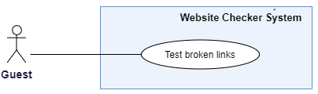

Figure 5 - <Guest> Test broken links

|  |  |  |  |
| --- | --- | --- | --- |
| **USE CASE – WCS_UC_2** | | | |
| **Use Case No.** | WCS_UC_2 | **Use Case Version** | 1.0 |
| **Use Case Name** | Test broken links | | |
| **Author** | ViNTT | | |
| **Date** | 24/10/2018 | **Priority** | Normal |
| **Actor:**   * Guest   **Summary:**   * This use case allow guest to detect broken links with the defined website’s address.   **Goal:**   * Guest can view broken link’s information: URL, HTTP status code and response message.   **Triggers:**   * Guest sends test broken links command.   **Preconditions:** N/A  **Post conditions:**   * Success: Display the result test on screen. * Fail: System shows error messages.   **Main Success Scenario:**   |  |  |  | | --- | --- | --- | | **Step** | **Actor Action** | **System Response** | | 1 | Guest enter the address of a website at input field. |  | | 2 | Guest send command to test broken links. | System response the result with information: “Page”, “Broken Link”, “Issue”. [Alternative 1] [Exception 1, 2] |   **Alternative Scenario:**   |  |  |  | | --- | --- | --- | | **No** | **Actor Action** | **System Response** | | 1 | Guest click out of the loading dialog. | Display a dialog with message “Do you want to cancel Test Broken Links process?”   * “Yes” - system end the process and redirect guest back to landing page. * “No” – Continue to find broken links. |   **Exceptions:**   |  |  |  | | --- | --- | --- | | **No** | **Actor Action** | **System Response** | | 1 |  | System shows message the "Please check your connection" when the internet is lost. | | 2 | Guest enter invalid URL. | System shows message “400 Bad request” |   **Relationships:** N/A  **Business Rules:**   * Both internal and external links of the website are tested. * Reasons that make links become broken are shown in detail. * With guest role, the limit of page test is set. System only tests five pages of the input website’s address. For more pages, guest must register account and login to use full other features. | | | |

Table 8 - <Guest> Test broken links use case specification

* + - 1. **Test missing files**

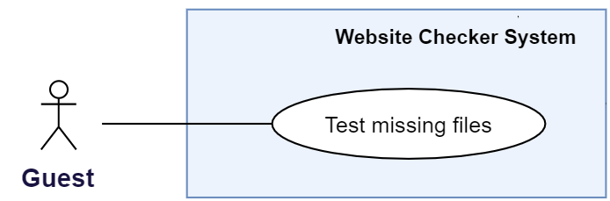

Figure 6 - <Guest> Test missing file

|  |  |  |  |
| --- | --- | --- | --- |
| **USE CASE – WCS_UC_3** | | | |
| **Use Case No.** | WCS_UC_3 | **Use Case Version** | 1.0 |
| **Use Case Name** | Test missing files | | |
| **Author** | ViNTT | | |
| **Date** | 24/10/2018 | **Priority** | Normal |
| **Actor:**   * Guest   **Summary:**   * This use case allows guest to detect missing file with the defined website’s address.   **Goal:**   * Guest can view missing file information: file URL source, description missing of each page on the result screen.   **Triggers:**   * Guest sends test missing file command.   **Preconditions:** N/A  **Post conditions:**   * Success: Display the result test on screen. * Fail: System shows error messages.   **Main Success Scenario:**   |  |  |  | | --- | --- | --- | | **Step** | **Actor Action** | **System Response** | | 1 | Guest enter the address of a website at input field. |  | | 2 | Guest send command to test missing files. | System response the result with information: “File”, “Description”, “Page affected”.  [Alternative 1] [Exception 1, 2] |   **Alternative Scenario:**   |  |  |  | | --- | --- | --- | | **No** | **Actor Action** | **System Response** | | 1 | Guest click out of the loading dialog. | Display a dialog with message “Do you want to cancel Test Missing Files process?”   * “Yes” - system end the process and redirect guest back to landing page. * “No” – Continue to find missing files. |   **Exceptions:**   |  |  |  | | --- | --- | --- | | **No** | **Actor Action** | **System Response** | | 1 |  | System shows message the "Please check your connection" when the internet is lost. | | 2 | Guest enter invalid URL. | System shows message “400 Bad request”. |   **Relationship:** N/A  **Business Rules:**   * Reasons why files become missing are shown in detail. * With guest role, the limit of page test is set. System only tests five pages of the input website’s address. For more pages, guest must register account and login to use full features. * With guest role, the limit of file’s format is set. System only check files that have .PNG and .JPEG extension. For more formats, guest must register account and login to use full features. | | | |

Table 9 - <Guest> Test missing file use case specification

* + 1. **<Staff> Overview Use Case**

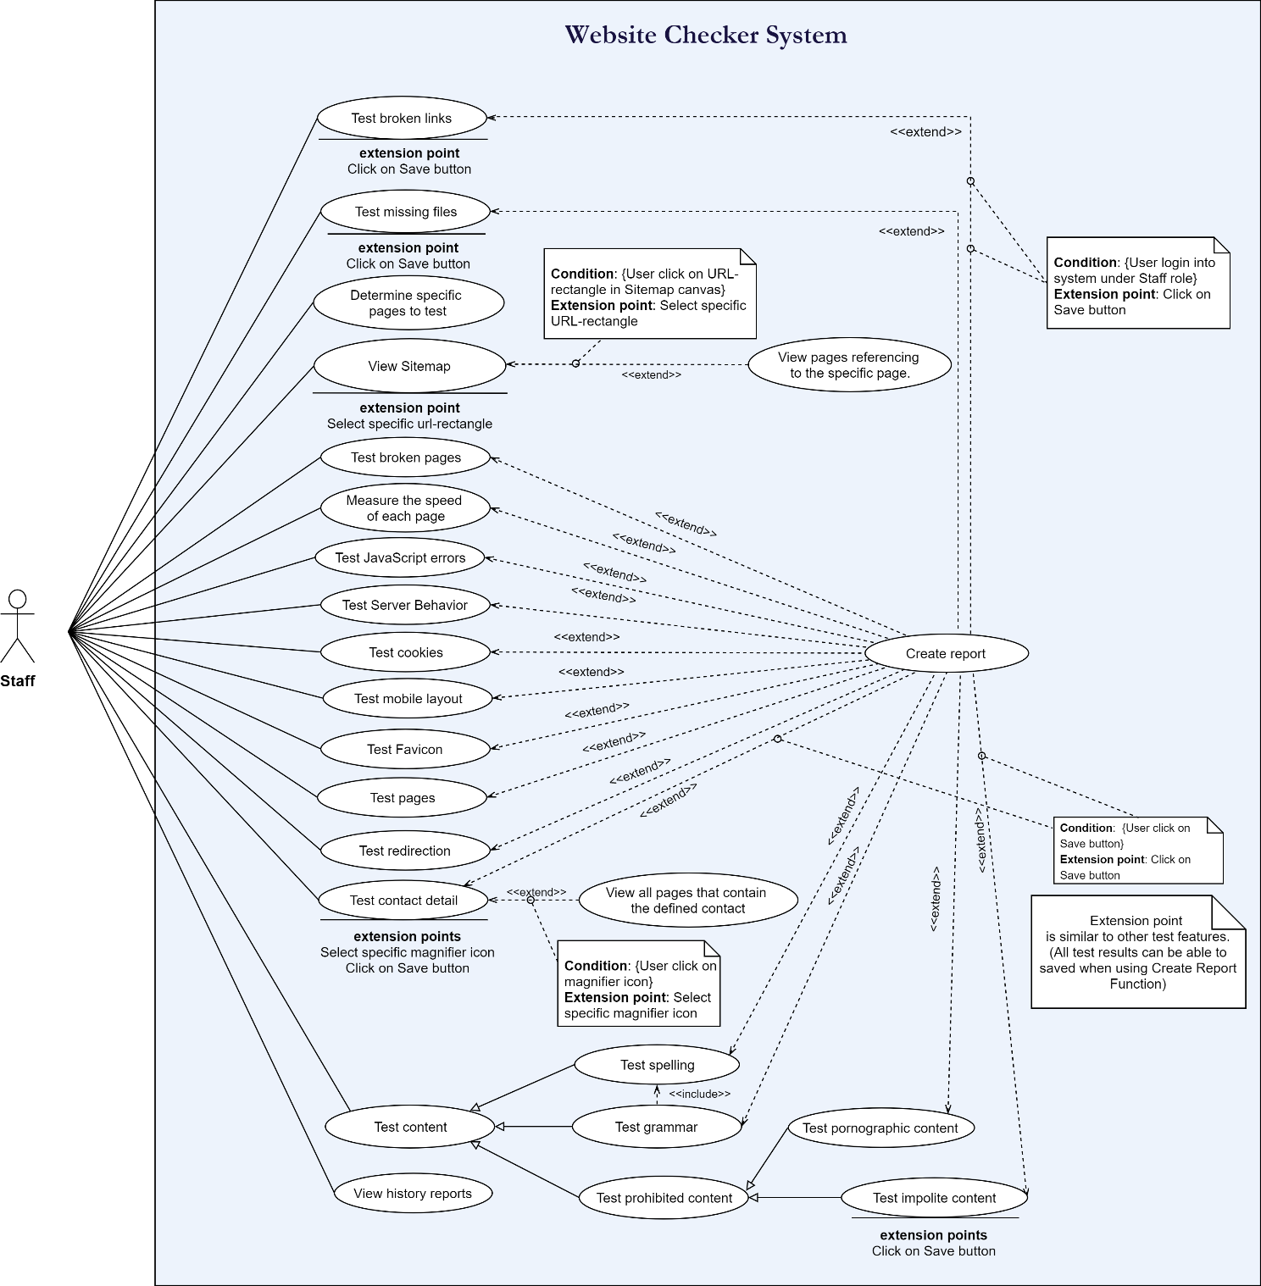

Figure 7 - Staff Overview Use Case

* + - 1. **Determine specific pages to test**

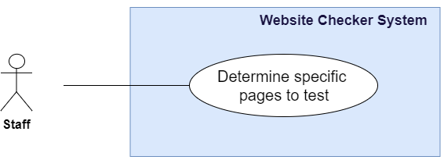

Figure 8-<Staff> Determine specific pages to test

|  |  |  |  |
| --- | --- | --- | --- |
| **USE CASE – WCS_UC_4** | | | |
| **Use Case No.** | WCS_UC_4 | **Use Case Version** | 1.0 |
| **Use Case Name** | Determine specific page to test | | |
| **Author** | TruongLN | | |
| **Date** | 24/10/2018 | **Priority** | High |
| **Actor:**   * Staff   **Summary:**   * This use case allows staff to determine specific pages to test.   **Goal:**   * Staff can determine specific pages to test option.   **Triggers:**   * Staff sends determine specific pages command.   **Preconditions:**   * User must login into the system with role Staff. * Staff must be assigned for testing on this website by Manager.   **Post conditions:**   * Success: Display page option on screen. * Fail: System shows error messages.   **Main Success Scenario:**   |  |  |  | | --- | --- | --- | | **Step** | **Actor Action** | **System Response** | | 1 | Staff go to create page option screen. | Page option screen is shown with the following labels and fields:   * Create Page Option : Plus button | | 2 | Staff click plus button. | Create page option screen is shown with the following labels and fields:   * Page Option Name: text, required, length: 8-30. | | 3 | Staff inputs information. |  | | 4 | Staff send create page option command. | Determine specific page view is shown with the following fields:   * Page url: toggle checkbox | | 5 | Staff chooses page to test. |  | | 6 | Staff send command to determine specific page. | Determine sepcific page to test in system.  [Exception 1] |   **Alternative Scenario:**  **Exceptions:**   |  |  |  | | --- | --- | --- | | **No** | **Actor Action** | **System Response** | | 1 | Determine specific page failed. | Show message to notify manager that remove failed. |   **Relationships:** WCS_UC_1, WCS_UC_4, WCS_UC_22, WCS_UC_23, WCS_UC_28.  **Business rules:**   * When website and sitemap must be created by manager * At the first use, page option must default at root page * The page which belong to website must be internal | | | |

Table 10 - <Staff> Determine specific pages to test use case specification

* + - 1. **View sitemap**

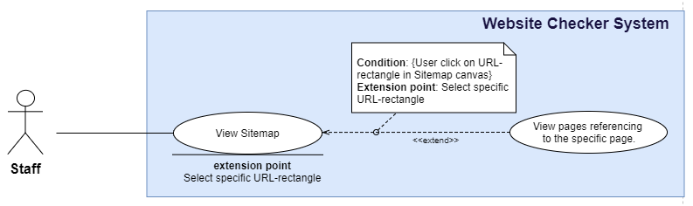

Figure 9 - <Staff> View sitemap

|  |  |  |  |
| --- | --- | --- | --- |
| **USE CASE – WCS_UC_5** | | | |
| **Use Case No.** | WCS_UC_5 | **Use Case Version** | 1.0 |
| **Use Case Name** | View Sitemap | | |
| **Author** | ViNTT | | |
| **Date** | 24/10/2018 | **Priority** | High |
| **Actor:**   * Staff   **Summary:**   * This use case allows staff to view sitemap.   **Goal:**   * Staff can get visual sitemap image on canvas, then they can view the detail references of each page.   **Triggers:**   * Staff sends view sitemap command.   **Preconditions:**   * User must login into the system with role Staff. * Staff must be assigned for testing at least one website by Manager. * Staff must select the specific website to view sitemap. * The sitemap structure must be built before by Manager.   **Post conditions:**   * Success: Display website sitemap canvas on screen. * Fail: System shows error messages.   **Main Success Scenario:**   |  |  |  | | --- | --- | --- | | **Step** | **Actor Action** | **System Response** | | 1 | Staff go to sitemap screen. | Show visual sitemap image on canvas screen. [Exceptions 1] [Exceptions 2] |   **Alternative Scenario:**  **Exceptions:**   |  |  |  | | --- | --- | --- | | **No** | **Actor Action** | **System Response** | | 1 |  | System shows error message "Please check your connection" when the internet is lost. | | 2 |  | System show error message when the sitemap’s data is not found for rendering. |   **Relationships:** WCS_UC_1, WCS_UC_6, WCS_UC_24 to WCS_UC_26.  **Business rules:**  - The sitemap should be clearly visualized, supply user a general view about entire web structure.  - Staff can click on this visual image for more detail info. With each page, user easily know that page is referencing to which pages, or how many pages are referencing to it. By that way, user can ensure that there is no confusion in implement process. | | | |

Table 11 - <Staff> View Sitemap use case specification

* + - 1. **View pages referencing to the specific page**



Figure 10 - <Staff> View pages referencing to the specific page

|  |  |  |  |
| --- | --- | --- | --- |
| **USE CASE – WCS_UC_6** | | | |
| **Use Case No.** | WCS_UC_6 | **Use Case Version** | 1.0 |
| **Use Case Name** | View pages referencing to the specific page | | |
| **Author** | ViNTT | | |
| **Date** | 24/10/2018 | **Priority** | High |
| **Actor:**   * Staff   **Summary:**   * This use case allows staff to view pages referencing to the same page.   **Goal:**   * Staff can know redirect information of each page in details to check whether there is any confusion or not.   **Triggers:**   * Staff click on each URL rectangle in sitemap canvas.   **Preconditions:**   * User must login into the system with role Staff. * Staff must be assigned for testing at least one website by Manager. * Staff must select the specific website to view sitemap. * The sitemap structure must be built before by Manager.   **Post conditions:**   * Success: Display the redirect information of selected URL in detail. * Fail: System shows error messages.   **Main Success Scenario:**   |  |  |  | | --- | --- | --- | | **Step** | **Actor Action** | **System Response** | | 1 | Staff go to sitemap screen. | Show visual sitemap image on canvas screen. [Exceptions 1] [Exceptions 2] | | 2 | Staff click on URL rectangle in sitemap canvas. | Display the redirect information of selected URL in detail. [Exception 1, 2] |   **Alternative Scenario:**  **Exceptions:**   |  |  |  | | --- | --- | --- | | **No** | **Actor Action** | **System Response** | | 1 |  | Show error message "Please check your connection" when the internet is lost. | | 2 | If the URL not be valid anymore (or broken). | Show error message “System not received information of selected URL” |   **Relationships:** WCS_UC_1, WCS_UC_5, WCS_UC_24 to WCS_UC_26.  **Business Rules:**   * With each URL selection of user, the system should let user chooses option: view selected page is referencing to which pages, or how many pages are referencing to it. Besides, the type of link is addition information: internal (backlink) or external. | | | |

Table 12 - <Staff> View pages referencing to the specific page use case specification

* + - 1. **Test spelling for website’s content**

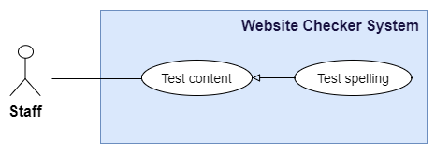

Figure 11 - <Staff> Test spelling

|  |  |  |  |
| --- | --- | --- | --- |
| **USE CASE – WCS_UC_7** | | | |
| **Use Case No.** | WCS_UC_7 | **Use Case Version** | 1.0 |
| **Use Case Name** | Test spelling | | |
| **Author** | ViNTT | | |
| **Date** | 24/10/2018 | **Priority** | High |
| **Actor:**   * Staff   **Summary:**   * This use case allows staff to detect spelling mistake in web’s content.   **Goal:**   * Staff can know which word is wrong then received recommend alternative words.   **Triggers:**   * Staff send test spelling command.   **Preconditions:**   * User must login into the system with role Staff. * Staff must be assigned for testing at least one website by Manager. * Staff must select the specific website and sub-pages to test. * English dictionary must be predefined under DBMS.   **Post conditions:**   * Success: Display test result with alternative suggestions. * Fail: System shows error messages.   **Main Success Scenario:**   |  |  |  | | --- | --- | --- | | **Step** | **Actor Action** | **System Response** | | 1 | Staff go to Spelling screen. | Display screen including:   * Table: contains previous test result. * Buttons: “Check” for sending test spelling command, “Save” for creating report and “Export” for exporting file in Excel format. | | 2 | Staff sends test spelling for website’s content command by clicking the “Check” button. | Display the result including: spelling mistakes with 3 recommend words. [Exception 1, 2] |   **Alternative Scenario:**  **Exceptions:**   |  |  |  | | --- | --- | --- | | **No** | **Actor Action** | **System Response** | | 1 |  | Show error message "Please check your connection" when the internet is lost. | | 2 | Server cannot connect to DBMS. | Show error message “Dictionary is not available for test.” |   **Relationships:** WCS_UC_1, WCS_UC_4, WCS_UC_8, WCS_UC_22, WCS_UC_23, WCS_UC_37.  **Business Rules:**   * After giving the predicted words, system should give options for users: view suggestions, choose an alternative word, or confirm ignore those mistakes. Ignore cases are saved. Next times, before giving suggestion, processor traverse from that list to decide to handle with detected mistakes. * User’s responding is collected and used for increasing the accuracy of spelling test processor. Chosen alternative words is marked with higher priority for giving suggestion results. | | | |

Table 13 - <Staff> Test spelling use case specification

* + - 1. **Test grammar for website’s content**

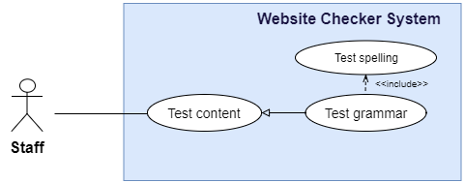

Figure 12 - <Staff> Test grammar

|  |  |  |  |
| --- | --- | --- | --- |
| **USE CASE – WCS_UC_8** | | | |
| **Use Case No.** | WCS_UC_8 | **Use Case Version** | 1.0 |
| **Use Case Name** | Test grammar | | |
| **Author** | ViNTT | | |
| **Date** | 24/10/2018 | **Priority** | High |
| **Actor:**   * Staff   **Summary:**   * This use case allows staff to test grammar of website’s content.   **Goal:**   * Staff can know where the grammar is wrong, reason why and how to correct those grammar mistakes. * .   **Triggers:**   * Staff send test grammar command.   **Preconditions:**   * User must login into the system with role Staff. * Staff must be assigned for testing at least one website by Manager. * Staff must select the specific website to test grammar.   **Post conditions:**   * Success: Display the test result with grammar mistakes in detail. * Fail: System shows error messages.   **Main Success Scenario:**   |  |  |  | | --- | --- | --- | | **Step** | **Actor Action** | **System Response** | | 1 | Staff go to Grammar screen. | Display screen including:   * Table: contains previous test result.   Buttons: “Check” for sending test grammar command, “Save” for creating report and “Export” for exporting file in Excel format. | | 2 | Staff send test grammar command by clicking on “Check” button. | Display the result including: fragments contain grammar mistakes, and reason make it wrong. [Exception 1, 2] |   **Alternative Scenario:**  **Exceptions:**   |  |  |  | | --- | --- | --- | | **No** | **Actor Action** | **System Response** | | 1 |  | Show error message "Please check your connection" when the internet is lost. |   **Relationships:** WCS_UC_1, WCS_UC_4, WCS_UC_7, WCS_UC_22, WCS_UC_23, WCS_UC_37.  **Business Rules:**   * Grammar test includes test spelling mistake to ensure there is no confusion. * Reason why the grammar is wrong need to be displayed clearly with specific excerpt | | | |

Table 14 - <Staff> Test Grammar use case specification

* + - 1. **Test prohibited words for website’s content**

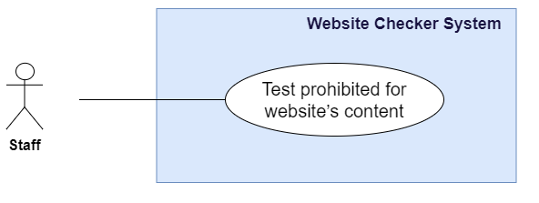

Figure 13 - <Staff> Test prohibited for website's content

|  |  |  |  |
| --- | --- | --- | --- |
| **USE CASE – WCS_UC_9** | | | |
| **Use Case No.** | WCS_UC_9 | **Use Case Version** | 1.0 |
| **Use Case Name** | Test prohibited for website’s content | | |
| **Author** | TrinhND | | |
| **Date** | 24/10/2018 | **Priority** | High |
| **Actor:**   * Staff   **Summary:**   * Allow Staff to test prohibited for website’s content.   **Goal:**   * Staff can view prohibited content information: Word, Type, Fragment and Page.   **Triggers:**   * Staff sends test prohibited for website’s content command.   **Preconditions:**   * User must login into the system with role Staff. * Staff must be assigned for testing on this website by Manager. * Staff must select pages which will be tested. * The warning word list must be defined.   **Post conditions:**   * Success: Display the result test on screen, and Staff can create report also. * Fail: System shows error messages.   **Main Success Scenario:**   |  |  |  | | --- | --- | --- | | **Step** | **Actor Action** | **System Response** | | 1 | Staff goes to Test prohibited content view. | System render test prohibited for website’s content screen.    [Alternative 1] | | 2 | Staff sends test prohibited for website’s content command. | System response the result with information: “Word”, “Type”, “Fragment “, “Page”.  [Exception 1] |   **Alternative Scenario:**   |  |  |  | | --- | --- | --- | | **No** | **Actor Action** | **System Response** | | 1 | System check the “Report History” in the data storage. | Render the result table that contains the previous test results with information: “Word”, “Type”, and “URL”. |   **Exceptions:**   |  |  |  | | --- | --- | --- | | **No** | **Actor Action** | **System Response** | | 1 |  | System shows message the "Please check your connection" when the internet is lost. |   **Relationships:** WCS_UC_4, WCS_UC_22, WCS_UC_23, WCS_UC_28, WCS_UC_30.  **Business Rules:**   * Plural, past tense of warning word will also be checked. * Warning word will be added by manager. * All positions where the warning word appear are checked * Fragment include prohibited will be show. * Staff can create report about result test. * Staff can export result test to excel file. | | | |

Table 15 - <Staff> Test prohibited for website's content use case specification

* + - 1. **Test broken links**

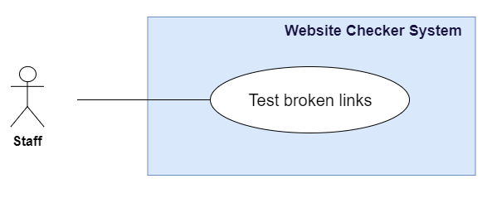

Figure 14 - <Staff> Test broken links

|  |  |  |  |
| --- | --- | --- | --- |
| **USE CASE – WCS_UC_10** | | | |
| **Use Case No.** | WCS_UC_10 | **Use Case Version** | 1.0 |
| **Use Case Name** | Test broken links | | |
| **Author** | TrinhND | | |
| **Date** | 24/10/2018 | **Priority** | High |
| **Actor:**   * Staff   **Summary:**   * Allow Staff to test broken links of a website.   **Goal:**   * Staff can view broken links information: page URL, broken link URL, and status code.   **Triggers:**   * Staff sends test broken links command.   **Preconditions:**   * User must login into the system with role Staff. * Staff must be assigned for testing on this website by Manager. * Staff must select pages which will be tested.   **Post conditions:**   * Success: Display the result test on screen, and Staff can create report also. * Fail: System shows error messages.   **Main Success Scenario:**   |  |  |  | | --- | --- | --- | | **Step** | **Actor Action** | **System Response** | | 1 | Staff goes to Test broken links view. | System render test broken links screen.  [Alternative 1] | | 2 | Staff sends test broken links command. | System response the result with information: “Page”, “Broken Link”, “Issue”.  [Exception 1] |   **Alternative Scenario:**   |  |  |  | | --- | --- | --- | | **No** | **Actor Action** | **System Response** | | 1 | System check the “Report History” in the data storage. | Render the result table that contains the previous test results with information: “Page”, “Broken Link”, and “Issue”. |   **Exceptions:**   |  |  |  | | --- | --- | --- | | **No** | **Actor Action** | **System Response** | | 1 |  | System shows message the "Please check your connection" when the internet is lost. |   **Relationships:** WCS_UC_1, WCS_UC_4, WCS_UC_22, WCS_UC_23, WCS_UC_28.  **Business Rules:**   * Test both internal links and external links of the website. * Only HTTP_NOT_FOUND and HTTP_BAD_REQUEST will be checked. * Issue that make broken links will be shown in detail. * Staff can create report about result test. * Staff can export result test to excel file. | | | |

Table 16 - <Staff> Test broken links use case specification

* + - 1. **Test broken pages**

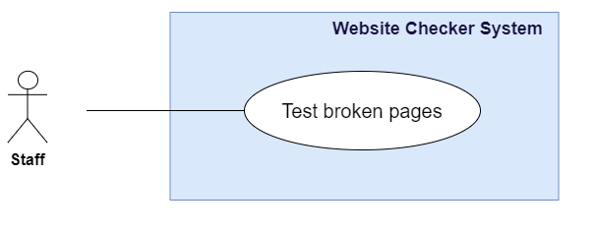

Figure 15 - <Staff> Test broken pages

|  |  |  |  |
| --- | --- | --- | --- |
| **USE CASE – WCS_UC_11** | | | |
| **Use Case No.** | WCS_UC_11 | **Use Case Version** | 1.0 |
| **Use Case Name** | Test broken pages | | |
| **Author** | TrinhND | | |
| **Date** | 24/10/2018 | **Priority** | High |
| **Actor:**   * Staff   **Summary:**   * Allow Staff to test broken pages of a website.   **Goal:**   * Staff can view broken pages information: page URL, status code and response message.   **Triggers:**   * Staff sends test broken pages command.   **Preconditions:**   * User must login into the system with role Staff. * Staff must be assigned for testing on this website by Manager. * Staff must select pages which will be tested.   **Post conditions:**   * Success: Display the result test on screen, and Staff can create report also. * Fail: System shows error messages.   **Main Success Scenario:**   |  |  |  | | --- | --- | --- | | **Step** | **Actor Action** | **System Response** | | 1 | Staff goes to Test broken pages view. | System render test broken pages screen.  [Alternative 1] | | 2 | Staff sends test broken pages command. | System response the result with information: “Page”, “Status”, “Issue”. [Exception 1] |   **Alternative Scenario:**   |  |  |  | | --- | --- | --- | | **No** | **Actor Action** | **System Response** | | 1 | System check the “Report History” in the data storage. | Render the result table that contains the previous test results with information: “Page”, “Status”, and “Issue”. |   **Exceptions:**   |  |  |  | | --- | --- | --- | | **No** | **Actor Action** | **System Response** | | 1 |  | System shows message the "Please check your connection" when the internet is lost. |   **Relationships:** WCS_UC_1, WCS_UC_4, WCS_UC_22, WCS_UC_23, WCS_UC_28.  **Business Rules:**   * Test only internal pages of the website. * Status code of Success (2xx), Client errors (4xx), Server errors (5xx) will be checked. * Issue that make broken pages will be shown in detail. * Staff can create report about result test. * Staff can export result test to excel file. | | | |

Table 17 - <Staff> Test broken pages use case specification

* + - 1. **Test missing files**

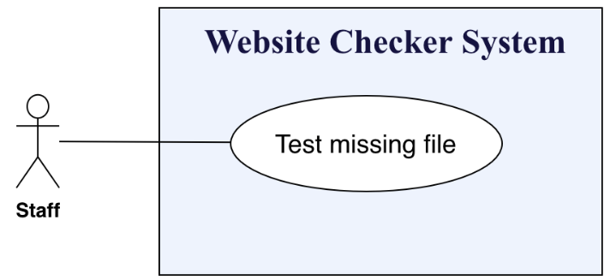

Figure 16 - <Staff> Test missing file

|  |  |  |  |
| --- | --- | --- | --- |
| **USE CASE – WCS_UC_12** | | | |
| **Use Case No.** | WCS_UC_12 | **Use Case Version** | 1.0 |
| **Use Case Name** | Test Missing File | | |
| **Author** | AnhTP | | |
| **Date** | 24/10/2018 | **Priority** | High |
| **Actor:**   * Staff   **Summary:**   * This use case allows staff to detect missing file with the defined website’s address.   **Goal:**   * Staff cam view missing file information: file URL source, description missing of each page on the result screen.   **Triggers:**   * Staff sends test missing file command.   **Preconditions:**   * User must login into the system with role Staff. * Staff must be assigned for testing on this website by Manager. * Staff must select pages which will be tested.   **Post conditions:**   * Success: Display the result test on screen. * Fail: System shows error messages.   **Main Success Scenario:**   |  |  |  | | --- | --- | --- | | **Step** | **Actor Action** | **System Response** | | 1 | Staff go to missing file screen. | System render the missing file screen. | | 2 | Staff send command to test missing file. | System response the result with information: “File”, “Description”, “Page affected”.  [Exception 1, 2] |   **Alternative Scenario:**  **Exceptions:**   |  |  |  | | --- | --- | --- | | **No** | **Actor Action** | **System Response** | | 1 | Tested missing file fail | Show message to notify manager that test missing file failed. |   **Relationships:** WCS_UC_1, WCS_UC_4, WCS_UC_22, WCS_UC_23, WCS_UC_28.  **Business Rules:**   * Reasons that files become missing are shown in detail. * Missing file is a file cannot connect or file size is 0. * Staff can test all type file or choose type file for testing missing file: image, CSS, doc, archives. * System only check files image that have .png, .jpeg, .jpg extension. * System only check files CSS that have .css extension. * System only check files DOC that have .doc, .pdf, .ppt, xls extension. * System only check files archives that have .rar, .jar, .zip extension. * System only check files video that have .mp4 extension. * System only check files audio that have .mp3 extension. * After the missing file test is finished, staff can save and export to excel the result. | | | |

Table 18 - <Staff> Test missing file use case specification

* + - 1. **Test the mobile layout**

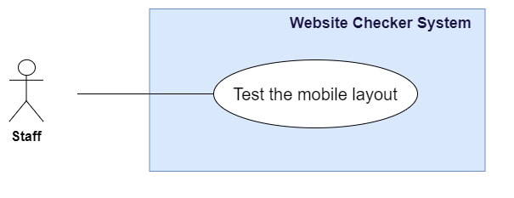

Figure 17 - <Staff> Test the mobile layout

|  |  |  |  |
| --- | --- | --- | --- |
| **USE CASE – WCS_UC_13** | | | |
| **Use Case No.** | WCS_UC_13 | **Use Case Version** | 1.0 |
| **Use Case Name** | Test the mobile layout | | |
| **Author** | TrinhND | | |
| **Date** | 24/10/2018 | **Priority** | High |
| **Actor:**   * Staff   **Summary:**   * Allow Staff to test mobile layout of each page in website.   **Goal:**   * Staff can view mobile layout information: Screenshot, URL page, and Issue.   **Triggers:**   * Staff sends test the mobile layout command.   **Preconditions:**   * User must login into the system with role Staff. * Staff must be assigned for testing on this website by Manager. * Staff must select pages which will be tested.   **Post conditions:**   * Success: Display the result test on screen, and Staff can create report also. * Fail: System shows error messages.   **Main Success Scenario:**   |  |  |  | | --- | --- | --- | | **Step** | **Actor Action** | **System Response** | | 1 | Staff goes to Test broken pages view. | System render test broken pages screen.  [Alternative 1] | | 2 | Staff sends test broken pages command. | System response the result with information: “Page”, “Status”, “Issue”. [Exception 1] |   **Alternative Scenario:**   |  |  |  | | --- | --- | --- | | **No** | **Actor Action** | **System Response** | | 1 | System check the “Report History” in the data storage. | Render the result table that contains the previous test results with information: “Screenshot”, “Page”, and “Issue”. |   **Exceptions:**   |  |  |  | | --- | --- | --- | | **No** | **Actor Action** | **System Response** | | 1 |  | System shows message the "Please check your connection" when the internet is lost. | | 2 |  | System show alt of Screenshot when the Screenshot can’t load. |   **Relationships:** WCS_UC_4, WCS_UC_22, WCS_UC_23, WCS_UC_28.  **Business Rules:**   * Standard of the mobile layout will be defined base on W3 recommendation. * Best font-size is 16px, touch-size is 44x44. * Check viewport meta tag, manifest, mobile version, framework. * Check support pinch to zoom, scroll horizontally. * The test will be simulated in a mobile device and take a screenshot after load. * Staff can create report about result test. * Staff can export result test to excel file. | | | |

Table 19-<Staff> Test the mobile layout use case specification

* + - 1. **Measure the speed test**

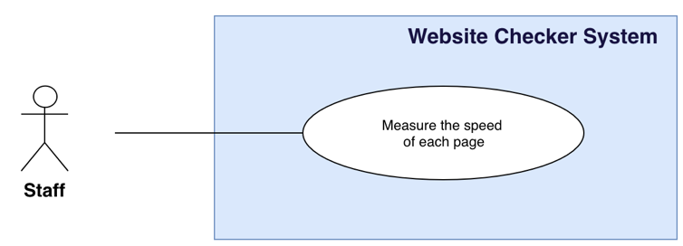

Figure 18 - <Staff> Measurethe speed test of each page

|  |  |  |  |
| --- | --- | --- | --- |
| **USE CASE – WCS_UC_14** | | | |
| **Use Case No.** | WCS_UC_14 | **Use Case Version** | 1.0 |
| **Use Case Name** | Measure the speed of each page | | |
| **Author** | TruongLN | | |
| **Date** | 24/10/2018 | **Priority** | High |
| **Actor:**   * Staff   **Summary:**   * This use case allows staff to measure the speed of each page with a defined page’s address.   **Goal:**   * Staff can view measure the speed of each page information: Interactive time, page load time and page size on the result screen.   **Triggers:**   * Staff sends measure the speed of each page command.   **Preconditions:**   * User must login into the system with role Staff. * Staff must be assigned for testing on this website by Manager. * Staff must select pages which will be tested.   **Post conditions:**   * Success: Display the result test on screen. * Fail: System shows error messages.   **Main Success Scenario:**   |  |  |  | | --- | --- | --- | | **Step** | **Actor Action** | **System Response** | | 1 | Staff go to measure the speed of each page screen. | System render the measure the speed of each page screen. | | 2 | Staff send command to test measure the speed of each page. | System response the result with information: “URL”, “Interactive time”, “page load time ”,” page size”.  [Exception 1] |   **Alternative Scenario:**  **Exceptions:**   |  |  |  | | --- | --- | --- | | **No** | **Actor Action** | **System Response** | | 1 | Measured the speed of each page fail. | Show message to notify manager that measure the speed of each page failed. |   **Relationships:** WCS_UC_1, WCS_UC_4, WCS_UC_22, WCS_UC_23, WCS_UC_28.  **Business Rules:**   * The page interactive time must be lower than the page load time. * The result page size must be in first time load without cache. | | | |

Table 20 - <Staff> Measure the speed of each page use case specification

* + - 1. **Test JavaScript errors**

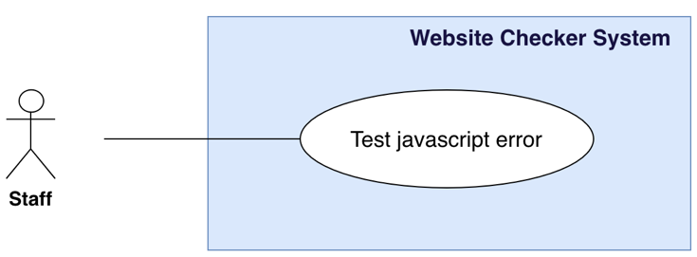

Figure 19 - <Staff> Test JavaScript errors

|  |  |  |  |
| --- | --- | --- | --- |
| **USE CASE – WCS_UC_15** | | | |
| **Use Case No.** | WCS_UC_15 | **Use Case Version** | 1.0 |
| **Use Case Name** | Test JavaScript errors | | |
| **Author** | TruongLN | | |
| **Date** | 24/10/2018 | **Priority** | High |
| **Actor:**   * Staff   **Summary:**   * This use case allows staff to detect JavaScript errors with a defined page’s address.   **Goal:**   * Staff can view JavaScript errors information: error message, type on the result screen.   **Triggers:**   * Staff sends test JavaScript errors command.   **Preconditions:**   * User must login into the system with role Staff. * Staff must be assigned for testing on this website by Manager. * Staff must select pages which will be tested.   **Post conditions:**   * Success: Display the result test on screen. * Fail: System shows error messages.   **Main Success Scenario:**   |  |  |  | | --- | --- | --- | | **Step** | **Actor Action** | **System Response** | | 1 | Staff go to javascript errors screen. | System render the test javascript errors screen. | | 2 | Staff send command to test javascript errors. | System response the result with information: “Error Message”, “Type”, “Page”.  [Exception 1] |   **Alternative Scenario:**  **Exceptions:**   |  |  |  | | --- | --- | --- | | **No** | **Actor Action** | **System Response** | | 1 | Test javascript error fail. | Show message to notify manager that test javascript error failed. |   **Relationships:** WCS_UC_1, WCS_UC_4, WCS_UC_22, WCS_UC_23, WCS_UC_28.  **Business Rules:**   * Test the website page has javascriprt errors or not * Every error must show error line and error javascript file. | | | |

Table 21 - <Staff> Test JavaScript errors use case specification

* + - 1. **Test Favicon**

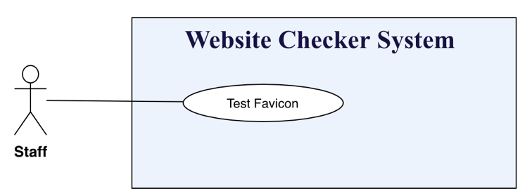

Figure 20-<Staff> Test favicon

|  |  |  |  |
| --- | --- | --- | --- |
| **USE CASE – WCS_UC_16** | | | |
| **Use Case No.** | WCS_UC_16 | **Use Case Version** | 1.0 |
| **Use Case Name** | Test Favicon | | |
| **Author** | AnhTP | | |
| **Date** | 24/10/2018 | **Priority** | High |
| **Actor:**   * Staff   **Summary:**   * This use case allows staff to detect favicon with the defined website’s address.   **Goal:**   * Staff can view favicon information: favicon image, favicon URL source, favicon size and type favicon on the result screen.   **Triggers:**   * Staff sends test favicon command.   **Preconditions:**   * User must login into the system with role Staff. * Staff must be assigned for testing on this website by Manager. * Staff must select pages which is tested.   **Post conditions:**   * Success: Display the result test on screen. * Fail: System shows error messages.   **Main Success Scenario:**   |  |  |  | | --- | --- | --- | | **Step** | **Actor Action** | **System Response** | | 1 | Staff go to favicon screen. | System render the favicon screen. | | 2 | Staff send command to test favicon. | System response the result with information: “Favicon”, “URL”, “Width”, “Type”, “Page”.  [Exception 1]. |   **Alternative Scenario:**  **Exceptions:**   |  |  |  | | --- | --- | --- | | **No** | **Actor Action** | **System Response** | | 1 | Test Favicon fail. | Show message to notify manager that test favicon failed. |   **Relationships:** WCS_UC_1, WCS_UC_4, WCS_UC_22, WCS_UC_23, WCS_UC_28.  **Business Rules:**   * Test the website page has favicon or not. * System only check favicon two ways:   + Check a rel attribute value defined in a profile.   + Check the favicon at a predifined URI. * Number of favicon different and number pages missing favicon * If the website page has the favicon, the result display the favicon information. * If the website pages has not the favicon, the result display missing favicon message. * After the favicon test is finished, staff can save and export to excel the result. | | | |

Table 22- <Staff> Test favicon use case specification

* + - 1. **Test cookie website using**

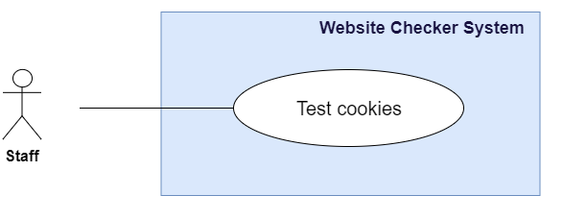

Figure 21 - <Staff> Test cookies

|  |  |  |  |
| --- | --- | --- | --- |
| **USE CASE – WCS_UC_17** | | | |
| **Use Case No.** | WCS_UC_17 | **Use Case Version** | 1.0 |
| **Use Case Name** | Test cookies | | |
| **Author** | TrinhND | | |
| **Date** | 24/10/2018 | **Priority** | High |
| **Actor:**   * Staff   **Summary:**   * Allow Staff to test cookies be used in website.   **Goal:**   * Staff can view cookies information: Name, Category, Party and Description.   **Triggers:**   * Staff sends test cookies command.   **Preconditions:**   * User must login into the system with role Staff. * Staff must be assigned for testing on this website by Manager. * Staff must select pages which will be tested.   **Post conditions:**   * Success: Display the result test on screen, and Staff can create report also. * Fail: System shows error messages.   **Main Success Scenario:**   |  |  |  | | --- | --- | --- | | **Step** | **Actor Action** | **System Response** | | 1 | Staff goes to Test broken links view. | System render test cookies screen.  [Alternative 1] | | 2 | Staff sends test cookies command. | System response the result with information: “Name”, “Category”, “Party”, “Description”.  [Exception 1] |   **Alternative Scenario:**   |  |  |  | | --- | --- | --- | | **No** | **Actor Action** | **System Response** | | 1 | System check the “Report History” in the data storage. | Render the result table that contains the previous test results with information: “Name”, “Category”, “Party”, and “Description”. |   **Exceptions:**   |  |  |  | | --- | --- | --- | | **No** | **Actor Action** | **System Response** | | 1 |  | System shows message the "Please check your connection" when the internet is lost. |   **Relationships:** WCS_UC_4, WCS_UC_22, WCS_UC_23, WCS_UC_28.  **Business Rules:**   * Cookies will be checked base on EU Cookie Law, description and party of popular cookies will be show in detail. * Popular cookies are provided by Google, Microsoft, Addthis.com, doubleclick.net. * All cookies used will be shown. * Staff can create report about result test. * Staff can export result test to excel file. | | | |

Table 23 - <Staff> Test cookies use case specification

* + - 1. **Test server behavior**

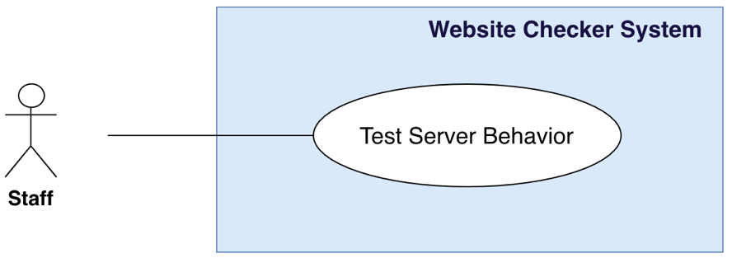

Figure 22 - <Staff> Test server behavior

|  |  |  |  |
| --- | --- | --- | --- |
| **USE CASE – WCS_UC_18** | | | |
| **Use Case No.** | WCS_UC_18 | **Use Case Version** | 1.0 |
| **Use Case Name** | Test Server Behavior | | |
| **Author** | TruongLN | | |
| **Date** | 24/10/2018 | **Priority** | High |
| **Actor:**   * Staff   **Summary:**   * This use case allows staff to detect server behavior.   **Goal:**   * Staff can view server behavior information: website redirects from www to non-www and HTTP to HTTPS, HTTPS, website has a working page “Page Not Found” page, all pages use SSL on the result screen.   **Triggers:**   * Staff sends test server behav command.   **Preconditions:**   * User must login into the system with role Staff. * Staff must be assigned for testing on this website by Manager. * Staff must select pages which will be tested.   **Post conditions:**   * Success: Display the result test on screen. * Fail: System shows error messages.   **Main Success Scenario:**   |  |  |  | | --- | --- | --- | | **Step** | **Actor Action** | **System Response** | | 1 | Staff go to server behavior screen. | System render the server behavior screen. | | 2 | Staff send command to test favicon. | System response the result with information: “website redirects from www to non-www ”, “ Website redirects from HTTP HTTPS”,” All pages use SSL ”.  [Exception 1, 2] |   **Alternative Scenario:**  **Exceptions:**   |  |  |  | | --- | --- | --- | | **No** | **Actor Action** | **System Response** | | 1 | Test server behavior fail | Show message to notify manager that test server behavior failed. |   **Relationships:** WCS_UC_1, WCS_UC_4, WCS_UC_22, WCS_UC_23, WCS_UC_28.  **Business Rules:**   * Test the website page has redirects form www to non www or from HTTP to HTTPS. * Test All pages have SSL cetification. | | | |

Table 24 - <Staff> Test server behavior use case specification

* + - 1. **Test contact details on the website**

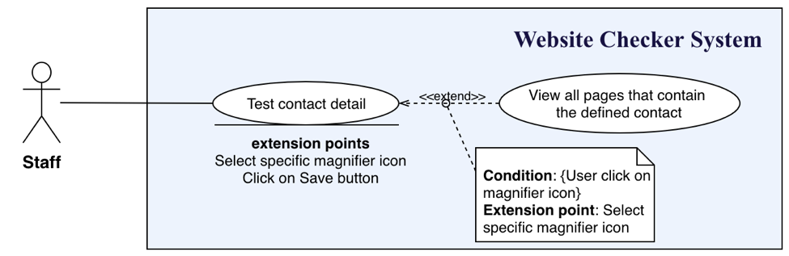

Figure 23 - <Staff> Test contact details on the website

|  |  |  |  |
| --- | --- | --- | --- |
| **USE CASE – WCS_UC_19** | | | |
| **Use Case No.** | WCS_UC_19 | **Use Case Version** | 1.0 |
| **Use Case Name** | Test Contact Details On The Website | | |
| **Author** | AnhTP | | |
| **Date** | 24/10/2018 | **Priority** | High |
| **Actor:**   * Staff   **Summary:**   * This use case allows staff to detect contact detail on page with the defined website’s address.   **Goal:**   * Staff can view contact detail information: Contact, Page Affected on the result screen.   **Triggers:**   * Staff sends test redirection command.   **Preconditions:**   * User must login into the system with role Staff. * Staff must be assigned for testing on this website by Manager. * Staff must select pages which is tested.   **Post conditions:**   * Success: Display the result test on screen. * Fail: System shows error messages.   **Main Success Scenario:**   |  |  |  | | --- | --- | --- | | **Step** | **Actor Action** | **System Response** | | 1 | Staff go to test contact details screen. | System render the contact detail screen. | | 2 | Staff send command to test contact detail. | System response the result with information: “Contact”, “Page Affected”, “Action”.  [Exception 1] |   **Alternative Scenario:**  **Exceptions:**   |  |  |  | | --- | --- | --- | | **No** | **Actor Action** | **System Response** | | 1 | Test contact detail fail. | Show message to notify manager that test contact detail failed. |   **Relationships:** WCS_UC_1, WCS_UC_4, WCS_UC_22, WCS_UC_23, WCS_UC_28.  **Business Rules:**   * Test the website page has contact detail or not. * Staff can check the contact detail is correctly on the website page. * Test contact details with pattern:   + Phone: pattern international phone number (example: +84 89 8000 8900).   + Email: pattern email (example: example@gmail.com). * If the website page has contact detail, the result display the contact details information. * After the contact detail test is finished, staff can save and export to excel the result. * Staff can click magnifier and view all pages that contain the contact defined. | | | |

Table 25 - <Staff> Test contact details on the website use case specification

* + - 1. **View all pages that contain the contact defined**

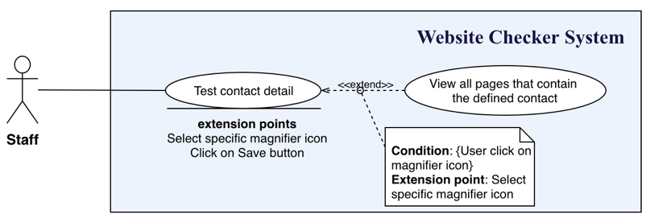

Figure 24 - <Staff> View all pages that contain the contact defined

|  |  |  |  |
| --- | --- | --- | --- |
| **USE CASE – WCS_UC_20** | | | |
| **Use Case No.** | WCS_UC_20 | **Use Case Version** | 1.0 |
| **Use Case Name** | View all pages that contain that contact defined | | |
| **Author** | AnhTP | | |
| **Date** | 24/10/2018 | **Priority** | Normal |
| **Actor:**   * Staff   **Summary:**   * This use case allows staff to view all pages that contains that contact detail defined.   **Goal:**   * Staff can view all pages that contains the contact detail defined information: list of pages on the result screen.   **Triggers:**   * Staff click on magnifier icon.   **Preconditions:**   * User must login into the system with role Staff. * Staff must be assigned for testing on this website by Manager.   **Post conditions:**   * Success: Display the result test on screen. * Fail: System shows error messages.   **Main Success Scenario:**   |  |  |  | | --- | --- | --- | | **Step** | **Actor Action** | **System Response** | | 1 | Staff go to test contact details screen. | System render the contact detail screen. | | 2 | Staff click on magnifier icon with the contact detail defined. | System response the result with information: “Page Affected”.  [Exception 1] |   **Alternative Scenario:**  **Exceptions:**   |  |  |  | | --- | --- | --- | | **No** | **Actor Action** | **System Response** | | 1 | View all pages that contains the contact detail defined fail | Show message to notify manager that view all pages that contains the contact detail defined failed. |   **Relationships:** WCS_UC_1, WCS_UC_4, WCS_UC_22, WCS_UC_23, WCS_UC_28.  **Business Rules:**   * Test contact detail is tested. * Show list of pages that contains the contact detail defined. | | | |

Table 26 - <Staff> View all pages that contain the contact defined use case specification

* + - 1. **Test redirections**

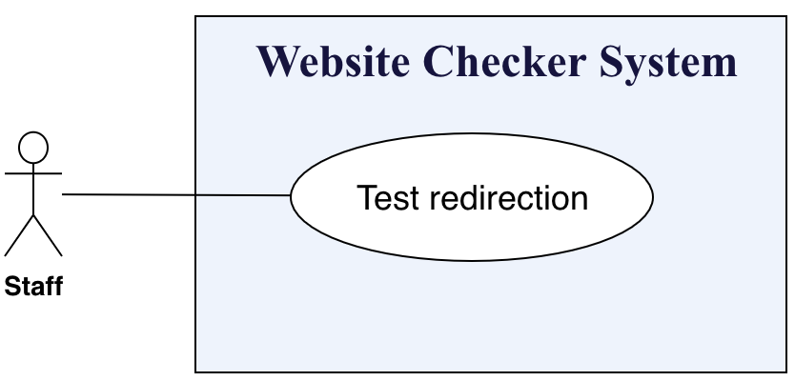

Figure 25 - <Staff> Test redirection

|  |  |  |  |
| --- | --- | --- | --- |
| **USE CASE – WCS_UC_21** | | | |
| **Use Case No.** | WCS_UC_21 | **Use Case Version** | 1.0 |
| **Use Case Name** | Test Redirection | | |
| **Author** | AnhTP | | |
| **Date** | 24/10/2018 | **Priority** | High |
| **Actor:**   * Staff   **Summary:**   * This use case allows staff to detect page redirection with the defined website’s address.   **Goal:**   * Staff can view page redirection information: web address, directs to URL, type redirection, http code response on the result screen.   **Triggers:**   * Staff sends test redirection command.   **Preconditions:**   * User must login into the system with role Staff. * Staff must be assigned for testing on this website by Manager. * Staff must select pages which will be tested.   **Post conditions:**   * Success: Display the result test on screen. * Fail: System shows error messages.   **Main Success Scenario:**   |  |  |  | | --- | --- | --- | | **Step** | **Actor Action** | **System Response** | | 1 | Staff go to redirection screen. | System render the redirection screen. | | 2 | Staff send command to test redirection. | System response the result with information: “web address”, “directs to url”, “type”, “HTTP Code”.  [[Exception 1] |   **Alternative Scenario:**  **Exceptions:**   |  |  |  | | --- | --- | --- | | **No** | **Actor Action** | **System Response** | | 1 | Tested redirections fail. | Show message to notify manager that test redirection failed. |   **Relationships:** WCS_UC_1, WCS_UC_4, WCS_UC_22, WCS_UC_23, WCS_UC_28.  **Business Rules:**   * Test the website page is redirection. * Type redirection is traditional reidrection type: HTTP 301 Moved Permanently and HTTP 302 Found * If the website page is redirection, the result display the redirection information. * If the website pages is not redirection, the result display not redirection found. * After the redirection test is finished, staff can save and export to excel the result. | | | |

Table 27 - <Staff> Test redirection use case specification

* + - 1. **Test website’s pages**

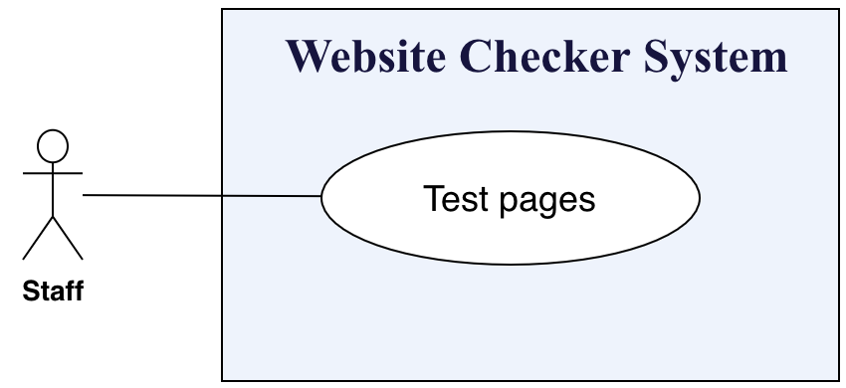

Figure 26 - <Staff> Test pages

|  |  |  |  |
| --- | --- | --- | --- |
| **USE CASE – WCS_UC_22** | | | |
| **Use Case No.** | WCS_UC_22 | **Use Case Version** | 1.0 |
| **Use Case Name** | Test Pages | | |
| **Author** | AnhTP | | |
| **Date** | 24/10/2018 | **Priority** | High |
| **Actor:**   * Staff   **Summary:**   * This use case allows staff to detect website’s page with the defined website’s address.   **Goal:**   * Staff can view page information: page title, web address, cannonical url, http code response on the result screen.   **Triggers:**   * Staff sends test pages command.   **Preconditions:**   * User must login into the system with role Staff. * Staff must be assigned for testing on this website by Manager. * Staff must select pages which will be tested.   **Post conditions:**   * Success: Display the result test on screen. * Fail: System shows error messages.   **Main Success Scenario:**   |  |  |  | | --- | --- | --- | | **Step** | **Actor Action** | **System Response** | | 1 | Staff go to page test screen. | System render the page test screen. | | 7 | Staff send command to test pages. | System response the result with information: “Title”, “web address”, “Canonical url”, “HTTP code”.  [Exception 1] |   **Alternative Scenario:**  **Exceptions:**   |  |  |  | | --- | --- | --- | | **No** | **Actor Action** | **System Response** | | 1 | Tested pages fail. | Show message to notify manager that test page failed. |   **Relationships:** WCS_UC_1, WCS_UC_4, WCS_UC_22, WCS_UC_23, WCS_UC_28.  **Business Rules:**   * Test the website page status. * The website page has title or not. * The website page has canonical URL or not. * The result display the page information. * After the page test is finished, staff can save and export to excel the result. | | | |

Table 28 - <Staff> Test pages use case specification

* + - 1. **Create report**

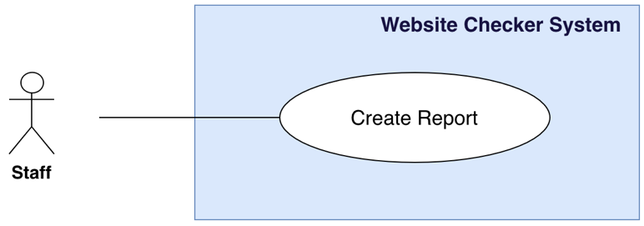

Figure 27 <Staff> Create report

|  |  |  |  |
| --- | --- | --- | --- |
| **USE CASE – WCS_UC_23** | | | |
| **Use Case No.** | WCS_UC_23 | **Use Case Version** | 1.0 |
| **Use Case Name** | Create Report | | |
| **Author** | TrinhND | | |
| **Date** | 24/10/2018 | **Priority** | Normal |
| **Actor:**   * Staff   **Summary:**   * Allow Staff to create report after do each test function.   **Goal:**   * Staff can create report after Staff do each test function and save in “Report History”.   **Triggers:**   * Staff sends create report command.   **Preconditions:**   * User must login into the system with role Staff. * Test function must be done.   **Post conditions:**   * Success: New report about tested function will be create and save. * Fail: System shows error messages.   **Main Success Scenario:**   |  |  |  | | --- | --- | --- | | **Step** | **Actor Action** | **System Response** | | 1 | Staff goes to “result test” view. | System render result test screen. | | 2 | Staff sends Create Report command. | Implement Create Report feature.  [Exception 1] | | 3 |  | Save the report to the “Report History”. |   **Alternative Scenario:** N/A  **Exceptions:**   |  |  |  | | --- | --- | --- | | **No** | **Actor Action** | **System Response** | | 1 | No test function completed yet. | Show message “The test function must be complete”. |   **Relationships:** WCS_UC_4, WCS_UC_5, WCS_UC_6… to WCS_UC_31.  **Business Rules:**   * New report will be create and save into “Report History”. * Report can be save after each function test. * At least one function test has been done and show the result. * A notification will be sent to Staff after the process is completed. | | | |

Table 29 - <Staff> Create report use case specification

* + - 1. **View history reports**

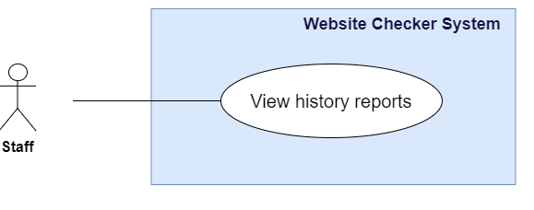

Figure 28 - <Staff> View history reports

|  |  |  |  |
| --- | --- | --- | --- |
| **USE CASE – WCS_UC_24** | | | |
| **Use Case No.** | WCS_UC_24 | **Use Case Version** | 1.0 |
| **Use Case Name** | View History Reports | | |
| **Author** | TrinhND | | |
| **Date** | 24/10/2018 | **Priority** | Normal |
| **Actor:**   * Staff   **Summary:**   * Allow Staff to view all history reports have been created.   **Goal:**   * Staff can view all reports have been created.   **Triggers:**   * Staff sends view history reports command.   **Preconditions:**   * User must login into the system with role Staff.   **Post conditions:**   * Success: History report will be show by date created. * Fail: System shows error messages.   **Main Success Scenario:**   |  |  |  | | --- | --- | --- | | **Step** | **Actor Action** | **System Response** | | 1 | Staff sends view history reports command. | System render view history reports screen.  [Alternative 1] | | 2 | Staff send date time picker command. | Show history report table by day was chosen with information: “No”, “Test Function”, “Time”  [Exception 1] |   **Alternative Scenario:**   |  |  |  | | --- | --- | --- | | **No** | **Actor Action** | **System Response** | | 1 |  | Show history report table by latest date with information: “No”, “Test Function”, “Time” |   **Exceptions:**   |  |  |  | | --- | --- | --- | | **No** | **Actor Action** | **System Response** | | 1 | Staff choose a day without report. | History report table is empty. |   **Relationships:** WCS_UC_1, WCS_UC_7… to WCS_UC_22, WCS_UC_28.  **Business Rules:**   * At least one report should be done and save. * History report will be display and filter by time created. * Staff can choose day to view history report. | | | |

Table 30 <Staff> View history reports use case specification

* + 1. **<Manager> Overview Use Case**

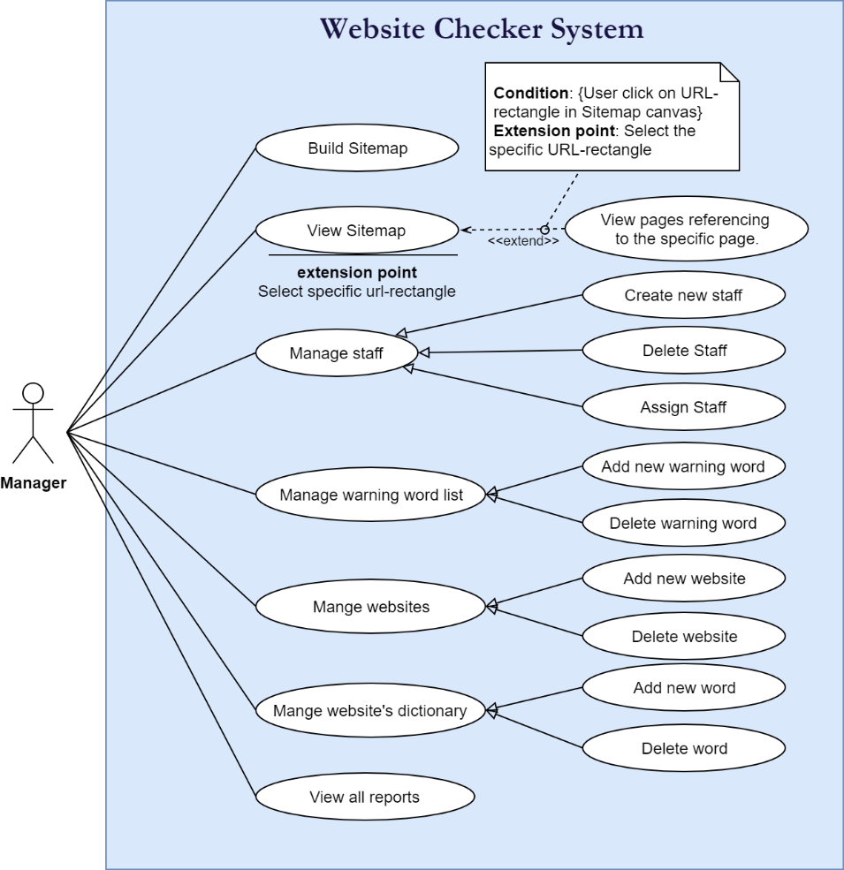

Figure 29 - Manager Overview Use Case

* + - 1. **Build Sitemap**

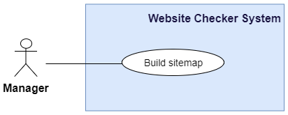

Figure 30 - <Manager> Build Sitemap

|  |  |  |  |
| --- | --- | --- | --- |
| **USE CASE – WCS_UC_24** | | | |
| **Use Case No.** | WCS_UC_24 | **Use Case Version** | 1.0 |
| **Use Case Name** | Build Sitemap | | |
| **Author** | ViNTT | | |
| **Date** | 24/10/2018 | **Priority** | High |
| **Actor:**   * Manager   **Summary:**   * This use case allows manager to build sitemap.   **Goal:**   * Manager can build or update the link structure of website with latest version.   **Triggers:**   * Manager sends build sitemap command.   **Preconditions:**   * User must login into the system with role Manager. * Staff must select the specific website to build sitemap.   **Post conditions:**   * Success: Display success message. * Fail: System shows error messages.   **Main Success Scenario:**   |  |  |  | | --- | --- | --- | | **Step** | **Actor Action** | **System Response** | | 1 | Manager goes to Manage Website screen. | Show table with website information list, addition with 2 buttons related sitemap:   * “Build”: button using for build/update version. * “View sitemap”: button using for sitemap information in detail. | | 2 | Manager sends build sitemap command. | Show “Successfully completed” message. [Exception 1, 2] |   **Alternative Scenario:**  **Exceptions:**   |  |  |  | | --- | --- | --- | | **No** | **Actor Action** | **System Response** | | 1 |  | System shows error message "Please check your connection" when the internet is lost. | | 2 |  | System shows error message when the system cannot get the link structure. |   **Relationships:** WCS_UC_1, WCS_UC_6, WCS_UC_25, WCS_UC_26.  **Business Rules:**   * The link structure of website is collected and organized as directed graph. * Graph is implemented as a list of list of <SiteLinkInfo> where SiteLinkInfo contains data: sourceURL, destinationURL, and the type of that destination URL. * A graph keeps reference information in the direction from it (current URL) to another URL. * An inverse graph keeps inverse direction: others URL direct to the same URL. * Using Breadth-First Search combined queue, mark appeared vertices before to avoid infinite loop when display relationship between sub-pages. * A HashSet with key-value pair contains: key is URL, value is an integer number (also is index number of this vertice in graph). * The built sitemap will be decoded to use for render in UI. The sitemap's structure is stored in json format and save to database for next accessing times. * The type of links is categorized: internal, external. Only concerned about internal links of website, external’s references do not need to stored. | | | |

Table 31 - <Manager> Build sitemap use case specification

* + - 1. **View sitemap**

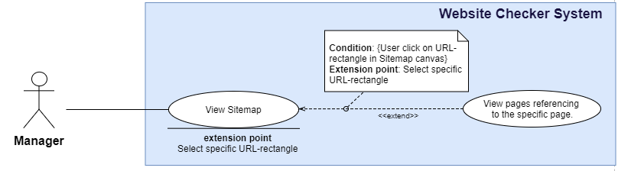

Figure 31 - <Manager> View sitemap

|  |  |  |  |
| --- | --- | --- | --- |
| **USE CASE – WCS_UC_25** | | | |
| **Use Case No.** | WCS_UC_25 | **Use Case Version** | 1.0 |
| **Use Case Name** | View Sitemap | | |
| **Author** | ViNTT | | |
| **Date** | 24/10/2018 | **Priority** | Normal |
| **Actor:**   * Manager   **Summary:**   * This use case allows manager to view sitemap.   **Goal:**   * Manager can get visual sitemap image on canvas, then they can view the detail references of each page.   **Triggers:**   * Manager sends view sitemap command.   **Preconditions:**   * User must login into the system with role Manager. * Staff must select the specific website to view sitemap. * The sitemap structure must be built before by Manager.   **Post conditions:**   * Success: Display website sitemap canvas on screen. * Fail: System shows error messages.   **Main Success Scenario:**   |  |  |  | | --- | --- | --- | | **Step** | **Actor Action** | **System Response** | | 1 | Manager go to Manage Website screen. | Show visual sitemap image on canvas screen. [Exceptions 1] [Exceptions 2] |   **Alternative Scenario:**  **Exceptions:**   |  |  |  | | --- | --- | --- | | **No** | **Actor Action** | **System Response** | | 1 |  | System shows error message "Please check your connection" when the internet is lost. | | 2 |  | System show error message when the sitemap’s data is not found for rendering. |   **Relationships:** WCS_UC_1, WCS_UC_6, WCS_UC_24 to WCS_UC_26.  **Business Rules:**   * The sitemap should be clearly visualized, supply user a general view about entire web structure. * Manager can click on this visual image for more detail info. * With each page, user easily know that page is referencing to which pages, or how many pages are referencing to it. By that way, user can ensure that there is no confusion in implement process. | | | |

Table 32 - <Manager> View sitemap use case specification

* + - 1. **View pages referencing to the specific page**



Figure 32 - <Manager> View pages referencing on the specific page

|  |  |  |  |
| --- | --- | --- | --- |
| **USE CASE – WCS_UC_26** | | | |
| **Use Case No.** | WCS_UC_26 | **Use Case Version** | 1.0 |
| **Use Case Name** | View pages referencing to the specific page | | |
| **Author** | ViNTT | | |
| **Date** | 24/10/2018 | **Priority** | Normal |
| **Actor:**   * Manager   **Summary:**   * This use case allows manager to view pages referencing to the same page.   **Goal:**   * Manager can know redirect information of each page in details to check whether there is any confusion or not.   **Triggers:**   * Manager click on each URL rectangle in sitemap canvas.   **Preconditions:**   * User must login into the system with role Manager. * Staff must select the specific website to view sitemap. * The sitemap structure must be built before by Manager.   **Post conditions:**   * Success: Display the redirect information of selected URL in detail. * Fail: System shows error messages.   **Main Success Scenario:**   |  |  |  | | --- | --- | --- | | **Step** | **Actor Action** | **System Response** | | 1 | Manager goes to sitemap screen. | Show visual sitemap image on canvas screen. [Exceptions 1] [Exceptions 2] | | 2 | Manager clicks on URL rectangle in sitemap canvas. | Display the redirect information of selected URL in detail. [Exception 1, 2] |   **Alternative Scenario:**  **Exceptions:**   |  |  |  | | --- | --- | --- | | **No** | **Actor Action** | **System Response** | | 1 |  | Show error message "Please check your connection" when the internet is lost. | | 2 | If the URL not be valid anymore (or broken). | Show error message “System not received information of selected URL” |   **Relationships:** WCS_UC_1, WCS_UC_5, WCS_UC_24 to WCS_UC_25.  **Business Rules:**   * With each URL selection of user, the system should let user chooses option: view selected page is referencing to which pages, or how many pages are referencing to it. Besides, the type of link is addition information: internal (backlink) or external. | | | |

Table 33 - <Manager> View pages referencing on the specific page use case specification

* + - 1. **Add new website**

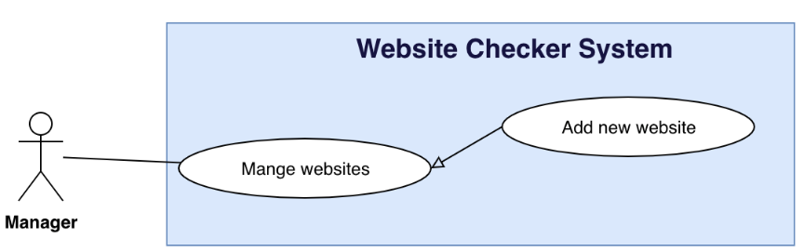

Figure 33 - <Manager> Add new website

|  |  |  |  |
| --- | --- | --- | --- |
| **USE CASE – WCS_UC_28** | | | |
| **Use Case No.** | WCS_UC_28 | **Use Case Version** | 1.0 |
| **Use Case Name** | Add new website | | |
| **Author** | AnhTP | | |
| **Date** | 24/10/2018 | **Priority** | Normal |
| **Actor:**   * Manager   **Summary:**   * This use case allows manager to add a new website with the defined website’s address.   **Goal:**   * Manager successfully adds new website.   **Triggers:**   * Manager send add new website command to the system.   **Preconditions:**   * User must login into the system with role Manager.   **Post conditions:**   * Success: New website successful store in database. * Fail: New website cannot be saved.   **Main Success Scenario:**   |  |  |  | | --- | --- | --- | | **Step** | **Actor Action** | **System Response** | | 1 | Manager goes to add new website screen. | Add new website screen is shown with following labels and fields:   * Name website: text, required, length 8-30. * Website URL: text, required, length 8-30. | | 2 | Manager inputs information. |  | | 3 | Manager send add new website command. | Add new website in the system.  [Exception 1]  System shows message website has been added successfully. |   **Alternative Scenario:**  **Exceptions:**   |  |  |  | | --- | --- | --- | | **No** | **Actor Action** | **System Response** | | 1 | Add new website fail | Show message to notify manager that add new website failed. |   **Relationships:** WCS_UC_1.  **Business Rules:**   * In case of success scenarios, a new website is added in the system. * Website URL has pattern http:// or https://. * Website URL is not duplicate. | | | |

Table 34 - <Manager> Add new website use case specification

* + - 1. **Delete website**

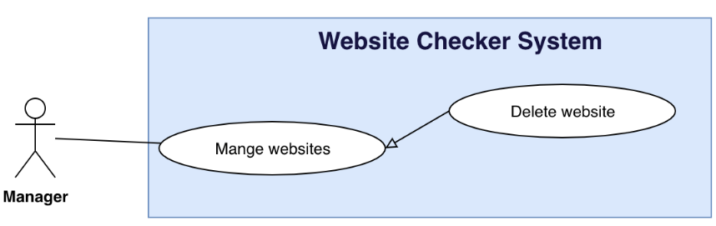

Figure 34 <Manager> Delete website

|  |  |  |  |
| --- | --- | --- | --- |
| **USE CASE – WCS_UC_29** | | | |
| **Use Case No.** | WCS_UC_29 | **Use Case Version** | 1.0 |
| **Use Case Name** | Delete website | | |
| **Author** | AnhTP | | |
| **Date** | 24/10/2018 | **Priority** | Normal |
| **Actor:**   * Manager   **Summary:**   * This use case allows manager to delete a website.   **Goal:**   * Website chosen is delete from manager.   **Triggers:**   * Manager send delete website command.   **Preconditions:**   * User must login into the system with role Manager.   **Post conditions:**   * Success: Website is removed by manager. * Fail: Show error message.   **Main Success Scenario:**   |  |  |  | | --- | --- | --- | | **Step** | **Actor Action** | **System Response** | | 1 | Manager goes to manage website view. | Display a table show list of website. | | 2 | Manager send delete website command. | System start removing webssite.  [Exception 1]  System show message remove successful. |   **Alternative Scenario:**  **Exceptions:**   |  |  |  | | --- | --- | --- | | **No** | **Actor Action** | **System Response** | | 1 | Removed fail. | Show message to notify manager that remove failed. |   **Relationships:** WCS_UC_1.  **Business Rules:**   * In case of success scenarios, website is removed in the system. | | | |

Table 35 - <Manager> Delete website use case specification

* + - 1. **Create new staff**

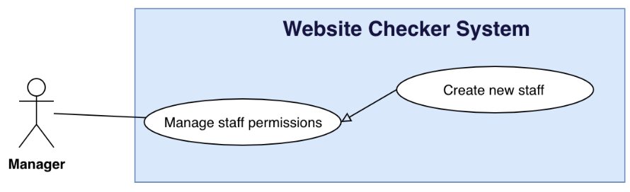

Figure 35 - <Manager> Create new staff

|  |  |  |  |
| --- | --- | --- | --- |
| **USE CASE – WCS_UC_30** | | | |
| **Use Case No.** | WCS_UC_30 | **Use Case Version** | 1.0 |
| **Use Case Name** | Create new staff | | |
| **Author** | AnhTP | | |
| **Date** | 24/10/2018 | **Priority** | Normal |
| **Actor:**   * Manager   **Summary:**   * This use case allows manager to create a new staff.   **Goal:**   * Manager successfully creates new staff.   **Triggers:**   * Manager send create new staff command to the system.   **Preconditions:**   * User must login into the system with role Manager.   **Post conditions:**   * Success: New staff successful store in database. * Fail: New website cannot be saved.   **Main Success Scenario:**   |  |  |  | | --- | --- | --- | | **Step** | **Actor Action** | **System Response** | | 1 | Manager goes to create new staff screen. | Create new staff screen is shown with following labels and fields:   * Name staff: text, required, length 8-30. * Username staff: text, required, length 8-30. * Password: text, required, length 8-30. | | 2 | Manager inputs information. |  | | 3 | Manager send create new staff command. | Create new staff in the system.  [Exception 1]  System shows message staff has been created successfully. |   **Alternative Scenario:**  **Exceptions:**   |  |  |  | | --- | --- | --- | | **No** | **Actor Action** | **System Response** | | 1 | Create new staff fail. | Show message to notify manager that create new staff failed. |   **Relationships:** WCS_UC_1.  **Business Rules:**   * In case of success scenarios, a new staff is created in the system. * New staff username is not duplicate. | | | |

Table 36 - <Manager> Create new staff use case specification

* + - 1. **Delete Staff**

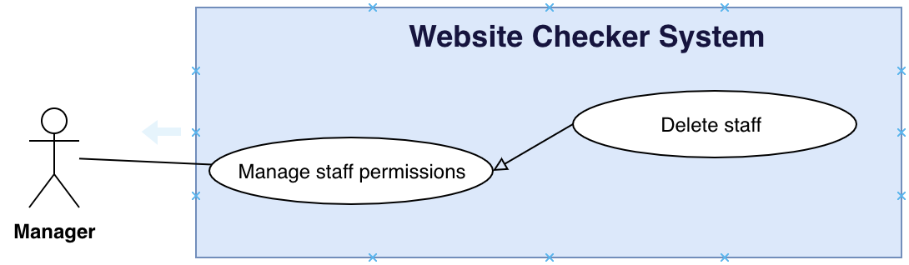

Figure 36 - <Manager> Delete staff

|  |  |  |  |
| --- | --- | --- | --- |
| **USE CASE – WCS_UC_31** | | | |
| **Use Case No.** | WCS_UC_31 | **Use Case Version** | 1.0 |
| **Use Case Name** | Delete staff | | |
| **Author** | AnhTP | | |
| **Date** | 24/10/2018 | **Priority** | Normal |
| **Actor:**   * Manager   **Summary:**   * This use case allows manager to delete staff.   **Goal:**   * Manager successfully delete staff in the system.   **Triggers:**   * Manager send delete command to the system.   **Preconditions:**   * User must login into the system with role Manager.   **Post conditions:**   * Success: Staff is removed by manager. * Fail: Show error message.   **Main Success Scenario:**   |  |  |  | | --- | --- | --- | | **Step** | **Actor Action** | **System Response** | | 1 | Manager goes to manage staff screen. | Display a table show list of staffs. | | 2 | Manager send delete staff command. | System start removing webssite.  [Exception 1]  System show message remove successful |   **Alternative Scenario:**  **Exceptions:**   |  |  |  | | --- | --- | --- | | **No** | **Actor Action** | **System Response** | | 1 | Removed fail. | Show message to notify manager that remove failed. |   **Relationships:** WCS_UC_1.  **Business Rules:**   * In case of success scenarios, a staff is deleted. * Staff is deleted who cannot log in the system. | | | |

Table 37 - <Manager> Delete staff use case specification

* + - 1. **Assign Staff**

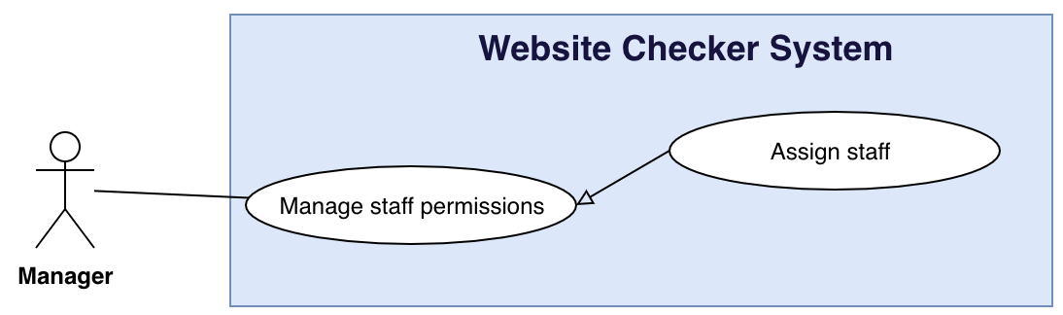

Figure 37 <Manager> Assign staff

|  |  |  |  |
| --- | --- | --- | --- |
| **USE CASE – WCS_UC_32** | | | |
| **Use Case No.** | WCS_UC_32 | **Use Case Version** | 1.0 |
| **Use Case Name** | Assign staff | | |
| **Author** | AnhTP | | |
| **Date** | 24/10/2018 | **Priority** | Normal |
| **Actor:**   * Manager   **Summary:**   * This use case allows manager to assign staff.   **Goal:**   * Manager successfully assign staff website in the system.   **Triggers:**   * Manager send assign staff command to the system.   **Preconditions:**   * User must login into the system with role Manager.   **Post conditions:**   * Success: Staff is assigned website by manager. * Fail: Show error message.   **Main Success Scenario:**   |  |  |  | | --- | --- | --- | | **Step** | **Actor Action** | **System Response** | | 1 | Manager goes to assign staff screen. | Assign staff screen is shown with following labels and fields:   * List staff: dropdown list. | | 2 | Manager chooses staff. |  | | 2 | Manager send assign staff command. | Assign staff website in the system.  [Exception 1]  System shows message staff has been assigned successfully. |   **Alternative Scenario:**  **Exceptions:**   |  |  |  | | --- | --- | --- | | **No** | **Actor Action** | **System Response** | | 1 | Assign fail. | Show message to notify manager that remove failed. |   **Relationships:** WCS_UC_1.  **Business Rules:**   * In case of success scenarios, a staff is assigned. * Staff can log in and test website assigned. | | | |

Table 38 <Manager> Assign staff use case specification

* + - 1. **Add new word website’s dictionary**

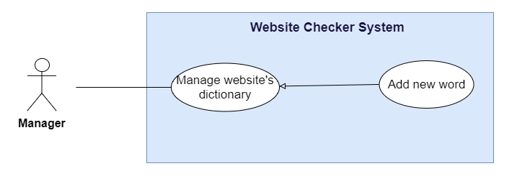

Figure 38 <Manager> Add new word website's dictionary

|  |  |  |  |
| --- | --- | --- | --- |
| **USE CASE – WCS_UC_33** | | | |
| **Use Case No.** | WCS_UC_33 | **Use Case Version** | 1.0 |
| **Use Case Name** | Add new word | | |
| **Author** | TrinhND | | |
| **Date** | 24/10/2018 | **Priority** | Normal |
| **Actor:**   * Manager   **Summary:**   * Allow Manager add new word to the website’s dictionary.   **Goal:**   * Manager can add new word to the website’s dictionary.   **Triggers:**   * Manager sends add new word to website’s dictionary command.   **Preconditions:**   * User must login into the system with role Manager.   **Post conditions:**   * Success: A new word will be added to the website’s dictionary. * Fail: System shows error messages.   **Main Success Scenario:**   |  |  |  | | --- | --- | --- | | **Step** | **Actor Action** | **System Response** | | 1 | Manager goes to Manage Website’s Dictionary view. | System render Manage Website’s Dictionary screen. | | 2 | Manager sends add new word command. | Manage Website’s Dictionary screen is shown with following labels and fields:   * Word: text, required. * Word form: text, required. * Definition: text, required. | | 3 | Manager fills data.  [Alternative 1],[Exception 1,2,3,4] | Display Manage Website’s Dictionary view with word list table include new word. |   **Alternative Scenario:**   |  |  |  | | --- | --- | --- | | **No** | **Actor Action** | **System Response** | | 1 | Manager clicks the “Cancel” button. | Display Manage Website’s Dictionary view. |   **Exceptions:**   |  |  |  | | --- | --- | --- | | **No** | **Actor Action** | **System Response** | | 1 | Manager add a word has been existed. | Show popup “This word is existed”. | | 2 | Word input is null. | “Done” button will be disabled. | | 3 | Word form input is null. | “Done” button will be disabled. | | 4 | Definition input is null. | “Done” button will be disabled. |   **Relationships:** WCS_UC_1, WCS_UC_7.  **Business Rules:**   * Website’s dictionary will be uses for test spelling. * Manger can add new word to Website’s Dictionary base on the content will be checked. | | | |

Table 39 <Manager> Add new word website's dictionary use case specification

* + - 1. **Delete word website’s dictionary**

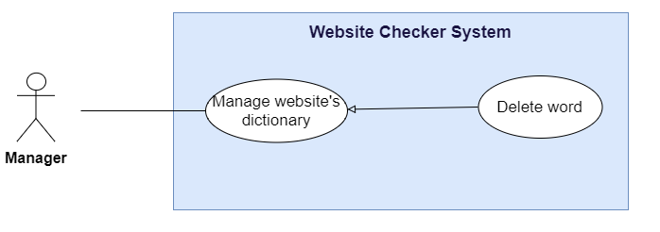

Figure 39 <Manager> Delete word website's dictionary

|  |  |  |  |
| --- | --- | --- | --- |
| **USE CASE – WCS_UC_34** | | | |
| **Use Case No.** | WCS_UC_34 | **Use Case Version** | 1.0 |
| **Use Case Name** | Delete word | | |
| **Author** | TrinhND | | |
| **Date** | 24/10/2018 | **Priority** | Normal |
| **Actor:**   * Manager   **Summary:**   * Allow Manager delete word from the website’s dictionary.   **Goal:**   * A word will be deleted from the the website’s dictionary.   **Triggers:**   * Manager sends delete word command.   **Preconditions:**   * User must login into the system with role Manager.   **Post conditions:**   * Success: A word will be deleted from the website’s dictionary. * Fail: System shows error messages.   **Main Success Scenario:**   |  |  |  | | --- | --- | --- | | **Step** | **Actor Action** | **System Response** | | 1 | Manager goes to Manage Website’s Dictionary view. | System render Manage Website’s Dictionary screen. | | 2 | Manager sends delete word command. | System show popup to confirm the command. | | 3 | Manager confirm to delete word.  [Alternative 1] | Display Manage Website’s Dictionary view with word list table not include word has been deleted. |   **Alternative Scenario:**   |  |  |  | | --- | --- | --- | | **No** | **Actor Action** | **System Response** | | 1 | Manager clicks the “No” button. | Display Manage Website’s Dictionary view. |   **Exceptions:** N/A  **Relationships:** WCS_UC_1, WCS_UC_9.  **Business Rules:**   * Website’s dictionary will be uses for test spelling. * A word has been deleted will not be used for the next test. | | | |

Table 40<Manager> Delete word website's dictionary use case specification

* + - 1. **Add the warning word list**

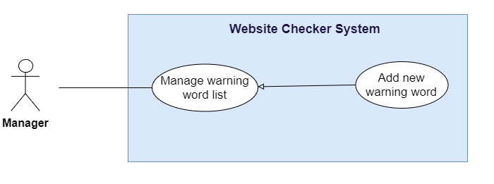

Figure 40 <Manager> Add new warning word

|  |  |  |  |
| --- | --- | --- | --- |
| **USE CASE – WCS_UC_35** | | | |
| **Use Case No.** | WCS_UC_35 | **Use Case Version** | 1.0 |
| **Use Case Name** | Add new warning word | | |
| **Author** | TrinhND | | |
| **Date** | 24/10/2018 | **Priority** | Normal |
| **Actor:**   * Manager   **Summary:**   * Allow Manager add new word to the warning word list.   **Goal:**   * Manager can add new word to the warning word list.   **Triggers:**   * Manager sends add new warning word command.   **Preconditions:**   * User must login into the system with role Manager.   **Post conditions:**   * Success: A new word will be added to the warning word list. * Fail: System shows error messages.   **Main Success Scenario:**   |  |  |  | | --- | --- | --- | | **Step** | **Actor Action** | **System Response** | | 1 | Manager goes to Manage Wordlist view. | System render Manage Wordlist screen. | | 2 | Manager sends add new warning word command. | Manage Wordlist screen is shown with following labels and fields:   * Word: text, required.   Type: text, required. | | 3 | Manager fills data.  [Alternative 1],[Exception 1,2] | Display Manage Wordlist view with word list table include new word. |   **Alternative Scenario:**   |  |  |  | | --- | --- | --- | | **No** | **Actor Action** | **System Response** | | 1 | Manager cancel add new warning word command. | Display Manage Wordlist view. |   **Exceptions:**   |  |  |  | | --- | --- | --- | | **No** | **Actor Action** | **System Response** | | 1 | Manager add a word has been existed. | Show popup “This word is existed”. | | 2 | Word input is null. | “Done” button will be disabled. |   **Relationships:** WCS_UC_1, WCS_UC_9.  **Business Rules:**   * Manager can choose type of warning word base on topic. * Warning word list will be uses for test prohibited content. * Manger can add new word to warning word list base on the content will be checked. | | | |

Table 41 <Manager> Add new warning word use case specification

* + - 1. **Delete warning word**

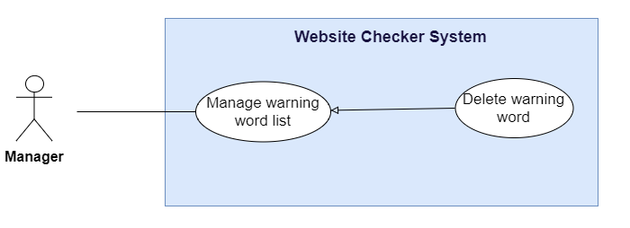

Figure 41 <Manager> Delete warning word

|  |  |  |  |
| --- | --- | --- | --- |
| **USE CASE – WCS_UC_36** | | | |
| **Use Case No.** | WCS_UC_36 | **Use Case Version** | 1.0 |
| **Use Case Name** | Delete warning word | | |
| **Author** | TrinhND | | |
| **Date** | 24/10/2018 | **Priority** | Normal |
| **Actor:**   * Manager   **Summary:**   * Allow Manager delete word from the warning word list.   **Goal:**   * A word will be deleted from the warning word list.   **Triggers:**   * Manager sends delete warning word command.   **Preconditions:**   * User must login into the system with role Manager.   **Post conditions:**   * Success: A word will be deleted from the warning word list. * Fail: System shows error messages.   **Main Success Scenario:**   |  |  |  | | --- | --- | --- | | **Step** | **Actor Action** | **System Response** | | 1 | Manager goes to Manage Wordlist view. | System render Manage Wordlist screen. | | 2 | Manager sends delete word command. | System show popup to confirm the command. | | 3 | Manager confirm to delete word.  [Alternative 1] | Display Manage Wordlist view with word list table not include word has been deleted. |   **Alternative Scenario:**   |  |  |  | | --- | --- | --- | | **No** | **Actor Action** | **System Response** | | 1 | Manager cancel delete word command. | Display Manage Wordlist view. |   **Exceptions:** N/A  **Relationships:** WCS_UC_1, WCS_UC_9.  **Business Rules:**   * Warning word list will be uses for test prohibited content. * A word has been deleted will not be used for the next test. | | | |

Table 42 <Manager> Delete warning word use case specification

* + - 1. **Edit warning word**

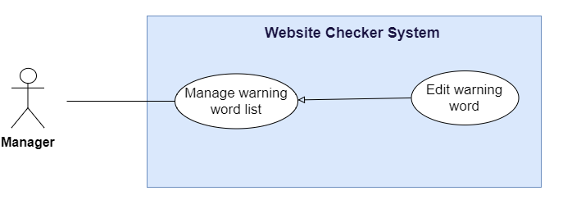

Figure 42 <Manager> Edit warning word

|  |  |  |  |
| --- | --- | --- | --- |
| **USE CASE – WCS_UC_37** | | | |
| **Use Case No.** | WCS_UC_37 | **Use Case Version** | 1.0 |
| **Use Case Name** | Edit warning word | | |
| **Author** | TrinhND | | |
| **Date** | 24/10/2018 | **Priority** | Normal |
| **Actor:**   * Manager   **Summary:**   * Allow Manager edit word of the warning word list.   **Goal:**   * Manager can edit word of the warning word list.   **Triggers:**   * Manager sends edit warning word command.   **Preconditions:**   * User must login into the system with role Manager.   **Post conditions:**   * Success: Data of word will be updated and add to the warning word list. * Fail: System shows error messages.   **Main Success Scenario:**   |  |  |  | | --- | --- | --- | | **Step** | **Actor Action** | **System Response** | | 1 | Manager goes to Manage Wordlist view. | System render Manage Wordlist screen. | | 2 | Manager sends edit word command. | Manage Wordlist screen is shown with following labels and fields:   * Word: text, required.   Type: text, required. | | 3 | Manager fills data.  [Alternative 1], [Exception 1] | Display Manage Wordlist view with word list table include new data of word. |   **Alternative Scenario:**   |  |  |  | | --- | --- | --- | | **No** | **Actor Action** | **System Response** | | 1 | Manager clicks the “Cancel” button. | Display Manage Wordlist view. |   **Exceptions:**   |  |  |  | | --- | --- | --- | | **No** | **Actor Action** | **System Response** | | 1 | Word input is null. | “Done” button will be disabled. |   **Relationships:** WCS_UC_1, WCS_UC_9.  **Business Rules:**   * Manager can choose type of warning word base on topic. * Newest data of the warning word list will be uses for test prohibited content. | | | |

Table 43 <Manager> Edit warning word use case specification

* + - 1. **View all reports**

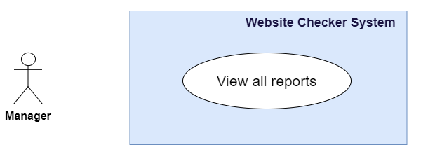

Figure 43 <Manager> View all reports

|  |  |  |  |
| --- | --- | --- | --- |
| **USE CASE – WCS_UC_37** | | | |
| **Use Case No.** | WCS_UC_37 | **Use Case Version** | 1.0 |
| **Use Case Name** | View All Reports | | |
| **Author** | TrinhND | | |
| **Date** | 24/10/2018 | **Priority** | Normal |
| **Actor:**   * Manager   **Summary:**   * Allow Manager to view all reports have been created.   **Goal:**   * Manager can view all reports have been created.   **Triggers:**   * Manager sends view all reports command.   **Preconditions:**   * User must login into the system with role Manager.   **Post conditions:**   * Success: all reports have been created will be show by created time. * Fail: System shows error messages.   **Main Success Scenario:**   |  |  |  | | --- | --- | --- | | **Step** | **Actor Action** | **System Response** | | 1 | Manager sends view all reports command. | System render view all reports screen.  [Exception 1] | | 2 | Staff send view detail report by Staff command. | Show details report created by Staff. |   **Alternative Scenario:** N/A  **Exceptions:**   |  |  |  | | --- | --- | --- | | **No** | **Actor Action** | **System Response** | | 1 | There are not report has been created. | History report table is empty. |   **Relationships:** WCS_UC_1, WCS_UC_7… to WCS_UC_22.  **Business Rules:**   * At least one report should be done and save. * History report will be display by Staff and filter by time created. * Manager can view all report by each Staff. | | | |

Table 44 <Manager> View all reports use case specification

## Software System Attribute

#### Usability

Website’s UI is fit for each browser on each device

* Font style: Arial, Sans-serif
* Font size: 12px -26px
* Color: green, black, red, white, blue, Light Slate Grey, Fuego, Honeysuckle…
* Background: White, Catalina Blue, Whisper…

#### 3.2 Reliability

* The information storing on the database is permanent.

#### Availability

* The system must be available at any time 24/7.

#### Security

* Only Manager has fully access to the system
* Input data is validated before saving to database.

#### Maintainability

* The system is divided into separated modules for easy maintain.

#### Portability

* Web application can be run on Chrome browser version 42 or later.

#### Performance

* System has successfully test with basic standard

## Conceptual Diagram



Figure 44 Conceptual Diagram

**Data Dictionary**

|  |  |
| --- | --- |
| **Entity Data dictionary: describe all content of all entities** | |
| **Entity Name** | **Description** |
| Authorized User | Abstract entity describes a user in system |
| Staff | Contain the staff information |
| Manager | Contain the manager information |
| Permission Handler | Represent a staff is assigned to maintain each page |
| Website | Contain the website information |
| Dictionary | Contain the dictionary information |
| Page | Contain the page information |
| Sitemap | Contain the sitemap information |
| Report | Contain the page information |

Table 45 Conceptual Diagram Data Dictionary

# Software Design Description

## Design Overview

- This document describes the technical and user interface design of MSSC System. It includes the architectural design, the detailed design of common functions and business functions and the design of database model.

- The architectural design describes the overall architecture of the system and the architecture of each main component and subsystem.

- The detailed design describes static and dynamic structure for each component and functions. It includes class diagrams, class explanations and sequence diagrams for each use cases.

- The database design describes the relationships between entities and details of each entity.

- Document overview:

Section 2: gives an overall description of the system architecture design.

Section 3: gives component diagrams that describe the connection and integration of the system.

Section 4: gives the detail design description which includes class diagram, class explanation, and sequence diagram to details the application functions.

Section 5: describe screens design.

Section 6: describe a fully attributed ERD.

Section 7: describe algorithms

## System Architectural Design

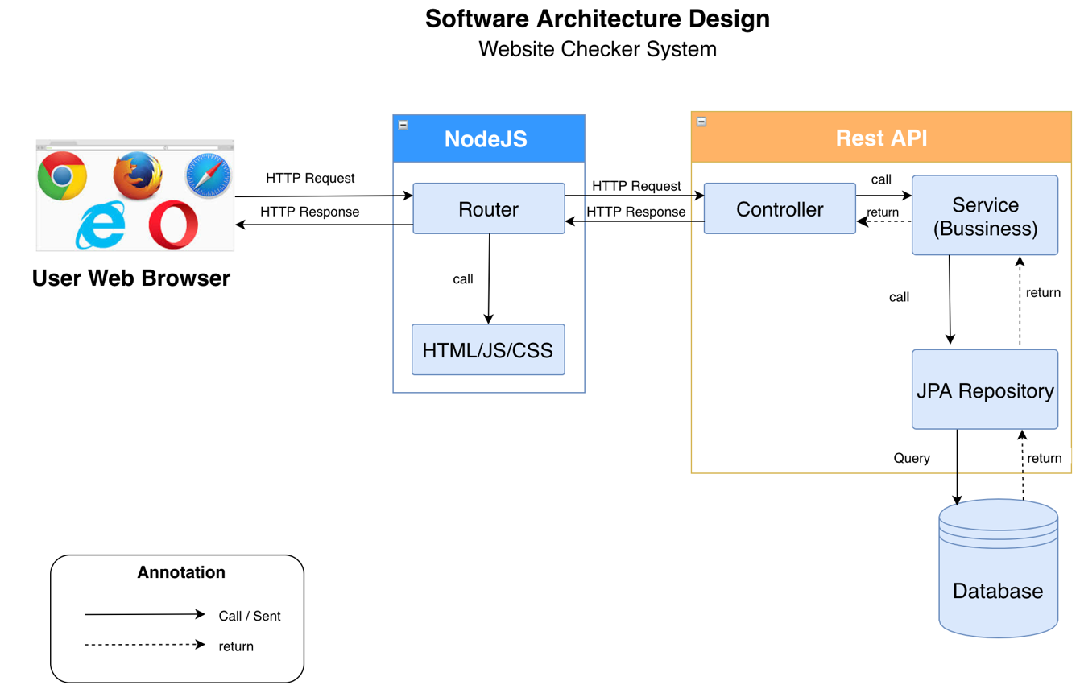

Figure 45 Software Architecture Design

In Web Application, the system is developed under MVC architecture style. We choose this architecture for Web Application because of following advantages:

* Ecosystem: Java has a big ecosystem. It has a lot of libraries and support for nearly every platform (OS, Database, etc.).
* It offers wide support for enterprise capabilities like messaging (Using JMS), Webservices, Rest and big data.
* ReactJS is quite easy to be mastered.
* ReactJS is easy to maintain isolated components in React.
* Constant re-rendering of components provides efficient arranging at increasing complexity.
* Convenient React is highly competitive to MVC. One-way data flow provides maintainability and efficient arrangement of data and DOM elements.
* It is the most light-weighted framework among the ones that are widely used today.

## Component Diagram

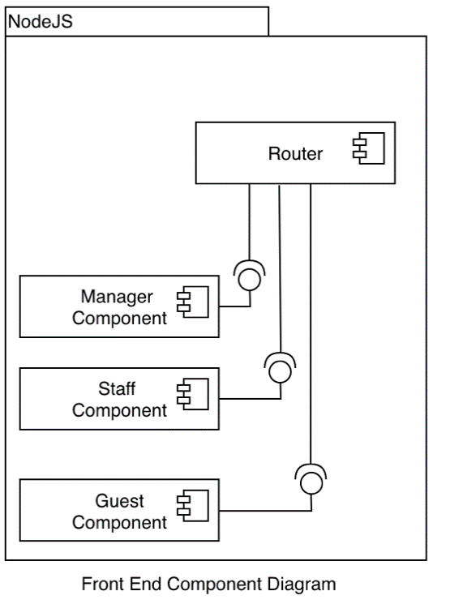

Figure 46 Front End Component Diagram

|  |  |
| --- | --- |
| COMPONENT DICTIONARY: DESCRIBES COMPONENTS | |
| NodeJS |  |
| Router | Handle request and response, accept input and convert it to commands for back end. |
| Manager Component | Handle manager activities in the system |
| Staff Component | Handle staff activities in the system |
| Guest Component | Handle guest activities in the system |

Table 46 Front End Component Diagram Dictionary

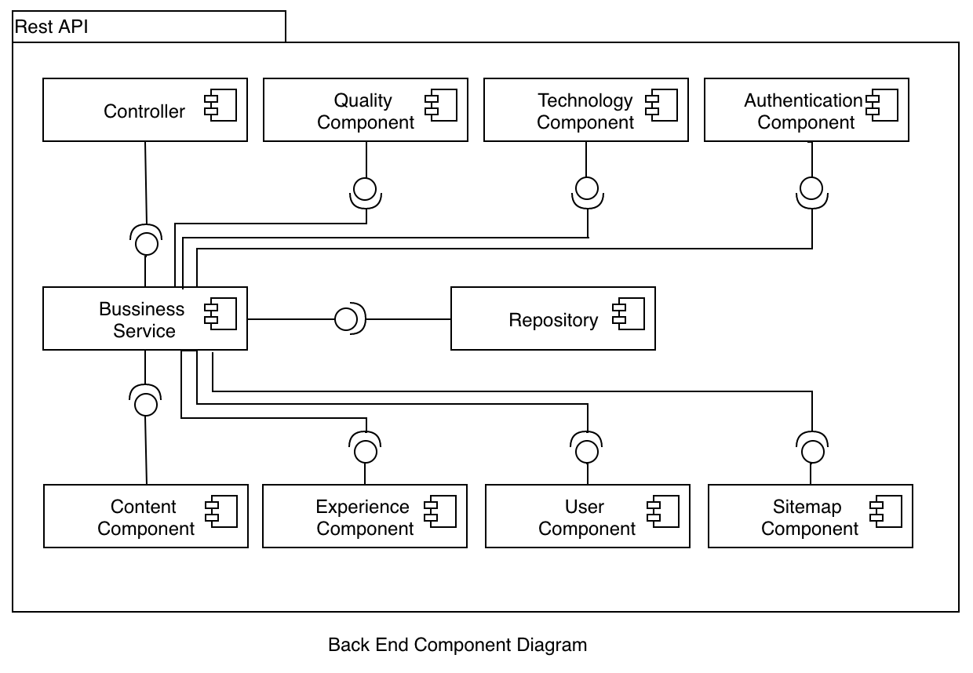

Figure 47 Back End Component Diagram

|  |  |
| --- | --- |
| COMPONENT DICTIONARY: DESCRIBES COMPONENTS | |
| Rest API |  |
| Controller | Handle requests and responses; accept input and convert it to commands for model and view. |
| Bussiness Servies | Handle system’s business operations |
| Repository | Store Data |

Table 47 Back End Component Diagram Dictionary

## Detailed Description

* 1. **Class Diagram**



Figure 48 Class Diagram

* 1. **Class Diagram Explanation**

|  |  |  |
| --- | --- | --- |
| **CLASS DICTIONARY: DESCRIBE CLASS** | | |
| **Class Name** | **Mapping column with Conceptual diagram** | **Description** |
| **Account** | N/A | Not exist in conceptual diagram but need this table to contain the user information |
| **Role** | N/A | Not exist in conceptual diagram but need this table to contain the information of a role |
| **Website** | Website | Contains the website information |
| **Dictionary** | Dictionary | Contains the dictionary information |
| **Sitemap** | Sitemap | Contains the sitemap information |
| **Page** | Page | Contains the page information |
| **Topic** | N/A | Not exist in conceptual diagram but need this table to contain the information of a topic information |
| **Warning Word** | N/A | Not exist in conceptual diagram but need this table to contain the information of a warning word information |
| **Version** | Version | Contains the information of version information |
| **GrammarReport** | Report | Contains the grammar report information |
| **SpellingReport** | Report | Contains the spelling report information |
| **WarningWorReport** | Report | Contains the warning word report information |
| **PageReport** | Report | Contains the page report information |
| **BrokenLinkReport** | Report | Contains the broken link report information |
| **BrokenPageReport** | Report | Contains the broken page report information |
| **ContactReport** | Report | Contains the contact report information |
| **RedirectionReport** | Report | Contains the redirection report information |
| **MissingFileReport** | Report | Contains the missing file report information |
| **FaviconReport** | Report | Contains the favicon report information |
| **SpeedReport** | Report | Contains the speed report information |
| **JavascriptReport** | Report | Contains the javascriprt error report information |
| **MobileLayoutReport** | Report | Contains the mobile layout report information |
| **CookieReport** | Report | Contains the cookie report information |
| **ServerBehaviorReport** | Report | Contains the server behavior report information |

Table 48 Class Diagram Dictionary

* + 1. **Account**

|  |  |  |  |
| --- | --- | --- | --- |
| **Attribute** | **Type** | **Visibility** | **Description** |
| Id | String | Private | Unique identifier of an account |
| Username | String | Private | Account’s username |
| Password | String | Private | Account’s password |
| Fullname | String | Private | Account’s fullname |
| Address | String | Private | Account’s address |
| Position | String | Private | Account’s position |

Table 49<Class Diagram Attributes> Account

|  |  |  |  |
| --- | --- | --- | --- |
| **Method** | **Redirect Type** | **Visibility** | **Description** |
| doLogin | Object | Public | Login |
| isAuth | Object | Public | Authentication |
| getFullName | Object | Public | Get full name |
| getAllInformation | Object | Public | Get all information |
| editInformation | Object | Public | Edit information |

Table 50 <Class Diagram Methods> Account

* + 1. **Role**

|  |  |  |  |
| --- | --- | --- | --- |
| **Attribute** | **Type** | **Visibility** | **Description** |
| Id | Long | Private | Unique identifier of a role |
| Rolename | String | Private | Role’s name |

Table 51 <Class Diagram Attributes> Role

|  |  |  |  |
| --- | --- | --- | --- |
| **Method** | **Redirect Type** | **Visibility** | **Description** |
| addRole | boolean | Public | Add new role |
| deleteRole | boolean | Public | Delete role |

Table 52<Class Diagram Methods> Role

* + 1. **Website**

|  |  |  |  |
| --- | --- | --- | --- |
| **Attribute** | **Type** | **Visibility** | **Description** |
| Id | Long | Private | Unique identifier of a website |
| Name | String | Private | Website’s name |
| Url | String | Private | Website’s url |
| TimeCreated | Datetime | Private | Website’s time created |
| TimeModified | Datetime | Private | Website’s time modidfied |

Table 53<Class Diagram Attributes> Website

|  |  |  |  |
| --- | --- | --- | --- |
| **Method** | **Redirect Type** | **Visibility** | **Description** |
| generatePage | object | Public | Generate page |
| assignUser | object | Public | Assign user |
| updateSitemap | object | Public | Update sitemap |

Table 54 <Class Diagram Methods> Website

* + 1. **Dictionary**

|  |  |  |  |
| --- | --- | --- | --- |
| **Attribute** | **Type** | **Visibility** | **Description** |
| Id | Long | Private | Unique identifier of a word |
| Word | String | Private | Word |
| WordForm | Integer | Private | Word Form |
| Definition | String | Private | Word’s definition |

Table 55 <Class Diagram Attributes> Dictionary

|  |  |  |  |
| --- | --- | --- | --- |
| **Method** | **Redirect Type** | **Visibility** | **Description** |
| addWord | Void | Public | Add new word |
| editWord | Void | Public | Edit word |
| removeWord | Void | Public | Remove word |

Table 56 <Class Diagram Methods> Dictionary

* + 1. **Sitemap**

|  |  |  |  |
| --- | --- | --- | --- |
| **Attribute** | **Type** | **Visibility** | **Description** |
| Id | Long | Private | Unique identifier of a sitemap |
| Map | String | Private | Sitemap’s map |
| Urlmap | String | Private | Url root |
| TypeMap | Integer | Private | Type map |

Table 57 <Class Diagram Attributes> Sitemap

|  |  |  |  |
| --- | --- | --- | --- |
| **Method** | **Redirect Type** | **Visibility** | **Description** |
| buildSitemap | Void | Public | Build sitemap |
| getAllPage | List | Public | Get all page from sitemap |
| getInternalPages | List | Public | Get all interanl pages |

Table 58 <Class Diagram Methods> Sitemap

* + 1. **WarningWord**

|  |  |  |  |
| --- | --- | --- | --- |
| **Attribute** | **Type** | **Visibility** | **Description** |
| Id | Long | Private | Unique identifier of a warning word |
| Word | String | Private | Warning word |

Table 59 <Class Diagram Attributes> Warningword

|  |  |  |  |
| --- | --- | --- | --- |
| **Method** | **Redirect Type** | **Visibility** | **Description** |
| addWord | Boolean | Public | Add new warning word |
| editWord | Boolean | Public | Edit warning word |
| removeWord | Boolean | Public | Remove warning word |

Table 60 <Class Diagram Methods> Warningword

* + 1. **Topic**

|  |  |  |  |
| --- | --- | --- | --- |
| **Attribute** | **Type** | **Visibility** | **Description** |
| Id | Long | Private | Unique identifier of a topic |
| Name | String | Private | Topic’s name |
| Description | String | Private | Topic’s desription |

Table 61 <Class Diagram Attributes> Topic

|  |  |  |  |
| --- | --- | --- | --- |
| **Method** | **Redirect Type** | **Visibility** | **Description** |
| addTopic | boolean | Public | Add new topic |
| editTopic | boolean | Public | Edit topic |
| removeTopic | Boolean | Public | Remove topic |

Table 62 <Class Diagram Methods> Topic

* + 1. **Page**

|  |  |  |  |
| --- | --- | --- | --- |
| **Attribute** | **Type** | **Visibility** | **Description** |
| Id | Long | Private | Unique identifier of a page |
| Type | Integer | Private | Page’s name |
| Url | String | Private | Page’s url |

Table 63 <Class Diagram Attributes> Page

|  |  |  |  |
| --- | --- | --- | --- |
| **Method** | **Redirect Type** | **Visibility** | **Description** |
| Getter | Attribute Type | Public | Get attribute value |
| Setter | Void | Public | Set attribute value |
| removePage | Void | Public | Remove page |
| checkProhibited | List | Public | Check prohibited word in page |
| checkSpelling | List | Public | Check spelling word on page |
| checkGrammar | List | Public | Check grammar on page |
| checkBrokenLink | List | Public | Check broken link on page |
| checkBrokenPage | List | Public | Check broken page on page |
| checkMissingFile | List | Public | Check missing file on page |
| checkFavicon | List | Public | Check favion on page |
| checkSpeed | List | Public | Measure the speed of page |
| checkMobileLayout | List | Public | Check page’s mobile layout |
| checkJavascript | List | Public | Check javascript error on page |
| checkCookie | List | Public | Check cookie on page |
| checkServerBehavior | List | Public | Check Server Behavior |
| checkRedirection | List | Public | Check page’s redirection |
| checkContact | List | Public | Check contact detail on page |
| checkPage | List | Public | Check page information |

Table 64 <Class Diagram Methods> Page

* + 1. **Version**

|  |  |  |  |
| --- | --- | --- | --- |
| **Attribute** | **Type** | **Visibility** | **Description** |
| Id | Long | Private | Unique identifier of a version |
| Version | Integer | Private | Version |
| Time | Datetime | Private | Time created |

Table 65 <Class Diagram Attributes> Version

* + 1. **GrammarReport**

|  |  |  |  |
| --- | --- | --- | --- |
| **Attribute** | **Type** | **Visibility** | **Description** |
| Id | Long | Private | Unique identifier of a grammar report |
| FoundAt | Long | Private | Grammar error is found at position |
| Excerpt | String | Private | Grammar errors excerpt |
| AppereanceInfo | String | Private | Appereance info |
| Reason | String | Private | Grammar error reason |
| Solution | String | Private | Grammar error solution |
| UserCreated | Long | Private | Staff’s id created |
| TimeCreated | Datetime | Private | Time created |

Table 66 <Class Diagram Attributes> GrammarReport

* + 1. **SpellingReport**

|  |  |  |  |
| --- | --- | --- | --- |
| **Attribute** | **Type** | **Visibility** | **Description** |
| Id | Long | Private | Unique identifier of a spelling report |
| FoundAt | Long | Private | Spelling error is found at |
| WrongWord | String | Private | Wrong word |
| AppereanceInfo | String | Private | Appereance info |
| Reason | String | Private | Spelling error reason |
| Solution | String | Private | Spelling error solution |
| UserCreated | Long | Private | Staff’s id created |
| TimeCreated | Datetime | Private | Time created |

Table 67 <Class Diagram Attributes> SpellingReport

|  |  |  |  |
| --- | --- | --- | --- |
| **Method** | **Redirect Type** | **Visibility** | **Description** |
| addNewWord | boolean | Public | Add new word |

Table 68 <Class Diagram Methods> SpellingReport

* + 1. **WarningWordReport**

|  |  |  |  |
| --- | --- | --- | --- |
| **Attribute** | **Type** | **Visibility** | **Description** |
| Id | Long | Private | Unique identifier of a warning word report |
| Solution | String | Private | Warning word solution |
| AppereanceInfo | String | Private | Appereance info |
| FoundWordId | Long | Private | Found word id |
| UserCreated | Long | Private | Staff’s id created |
| TimeCreated | Datetime | Private | Time created |

Table 69 <Class Diagram Attributes> WarningWordReport

* + 1. **PageReport**

|  |  |  |  |
| --- | --- | --- | --- |
| **Attribute** | **Type** | **Visibility** | **Description** |
| Id | Long | Private | Unique identifier of a page report |
| Url | String | Private | Page’s url |
| CanonicalUrl | String | Private | Page’s canonical url |
| Tittle | String | Private | Page’s title |
| HTTP | Integer | Private | Page’s http code response |
| UserCreated | Long | Private | Staff’s id created |
| TimeCreated | Datetime | Private | Time created |

Table 70 <Class Diagram Attributes> PageReport

* + 1. **ContactReport**

|  |  |  |  |
| --- | --- | --- | --- |
| **Attribute** | **Type** | **Visibility** | **Description** |
| Id | Long | Private | Unique identifier of a contact detail report |
| ContactType | String | Private | Email or phone number |
| AppereanceInfo | String | Private | Page’s url has Contact detail |
| UserCreated | Long | Private | Staff’s id created |
| TimeCreated | Datetime | Private | Time created |

Table 71 <Class Diagram Attributes> ContactReport

* + 1. **BrokenLinkReport**

|  |  |  |  |
| --- | --- | --- | --- |
| **Attribute** | **Type** | **Visibility** | **Description** |
| Id | Long | Private | Unique identifier of a broken link report |
| Url | String | Private | Broken link’s url |
| Issue | String | Private | Broken link’s issue |
| UserCreated | Long | Private | Staff’s id created |
| TimeCreated | Datetime | Private | Time created |

Table 72 <Class Diagram Attributes> BrokenLinkReport

* + 1. **RedirectionReport**

|  |  |  |  |
| --- | --- | --- | --- |
| **Attribute** | **Type** | **Visibility** | **Description** |
| Id | Long | Private | Unique identifier of a redirectios report |
| Url | String | Private | Page’s url is redirection |
| RedirectTo | String | Private | url is redirected |
| HttpCode | Integer | Private | Http code response |
| UserCreated | Long | Private | Staff’s id created |
| TimeCreated | Datetime | Private | Time created |

Table 73 <Class Diagram Attributes> RedirectionReport

* + 1. **BrokenPageReport**

|  |  |  |  |
| --- | --- | --- | --- |
| **Attribute** | **Type** | **Visibility** | **Description** |
| Id | Long | Private | Unique identifier of a broken page report |
| Url | String | Private | Broken page’s url |
| Issue | String | Private | Broken page’s issue |
| UserCreated | Long | Private | Staff’s id created |
| TimeCreated | Datetime | Private | Time created |

Table 74 <Class Diagram Attributes> BrokenPageReport

* + 1. **MissingFileReport**

|  |  |  |  |
| --- | --- | --- | --- |
| **Attribute** | **Type** | **Visibility** | **Description** |
| Id | Long | Private | Unique identifier of a missing file report |
| FileLink | String | Private | File’s link |
| FileType | String | Private | File’s type |
| Url | String | Private | Page’s url has missing file |
| Issues | String | Private | Missing file issues |
| UserCreated | Long | Private | Staff’s id created |
| TimeCreated | Datetime | Private | Time created |

Table 75 <Class Diagram Attributes> MissingFileReport

* + 1. **FaviconReport**

|  |  |  |  |
| --- | --- | --- | --- |
| **Attribute** | **Type** | **Visibility** | **Description** |
| Id | Long | Private | Unique identifier of a favicon report |
| Issue | String | Private | File’s link |
| FiviconType | String | Private | Favicon’s type |
| UserCreated | Long | Private | Staff’s id created |
| TimeCreated | Datetime | Private | Time created |

Table 76 <Class Diagram Attributes> FaviconReport

* + 1. **SpeedReport**

|  |  |  |  |
| --- | --- | --- | --- |
| **Attribute** | **Type** | **Visibility** | **Description** |
| Id | Long | Private | Unique identifier of a speed report |
| LoadTime | Integer | Private | Time to load |
| InteractiveTime | Integer | Private | Time to interactive |
| PageLoadSize | Integer | Private | Page load size |
| UserCreated | Long | Private | Staff’s id created |
| TimeCreated | Datetime | Private | Time created |

Table 77 <Class Diagram Attributes> SpeedReport

* + 1. **JavascriptReport**

|  |  |  |  |
| --- | --- | --- | --- |
| **Attribute** | **Type** | **Visibility** | **Description** |
| Id | Long | Private | Unique identifier of a javascript error report |
| MessageInfo | String | Private | Javscript error message |
| AppereanceInfo | String | Private | Appereance info |
| UserCreated | Long | Private | Staff’s id created |
| TimeCreated | Datetime | Private | Time created |

Table 78 <Class Diagram Attributes> JavascriptReport

* + 1. **MobileLayoutReport**

|  |  |  |  |
| --- | --- | --- | --- |
| **Attribute** | **Type** | **Visibility** | **Description** |
| Id | Long | Private | Unique identifier of a mobile layout report |
| Issues | String | Private | Mobile layout issues |
| Suggestion | String | Private | Mobile layout suggestion |
| AppereanceInfo | String | Private | Appereance info |
| UserCreated | Long | Private | Staff’s id created |
| TimeCreated | Datetime | Private | Time created |

Table 79<Class Diagram Attributes> MobileLayoutReport

* + 1. **CookieReport**

|  |  |  |  |
| --- | --- | --- | --- |
| **Attribute** | **Type** | **Visibility** | **Description** |
| Id | Long | Private | Unique identifier of a cookie report |
| Name | String | Private | Cookie’s name |
| Category | String | Private | Cookie’s category |
| PartyName | String | Private | Party name has cookie |
| PurposeDescription | String | Private | Cookie’s purpose description |
| IsLegal | String | Private | Cookie is legal |
| UserCreated | Long | Private | Staff’s id created |
| TimeCreated | Datetime | Private | Time created |

Table 80<Class Diagram Attributes> CookieReport

* + 1. **ServerBehaviorRepot**

|  |  |  |  |
| --- | --- | --- | --- |
| **Attribute** | **Type** | **Visibility** | **Description** |
| Id | Long | Private | Unique identifier of a server behavior report |
| Issue | String | Private | Server behavior’s issue |
| Description | String | Private | Server behavior’s description |
| UserCreated | Long | Private | Staff’s id created |
| TimeCreated | Datetime | Private | Time created |

Table 81<Class Diagram Attributes> ServerBehaviorReport

* 1. **Interaction Diagram**
     1. **Login**

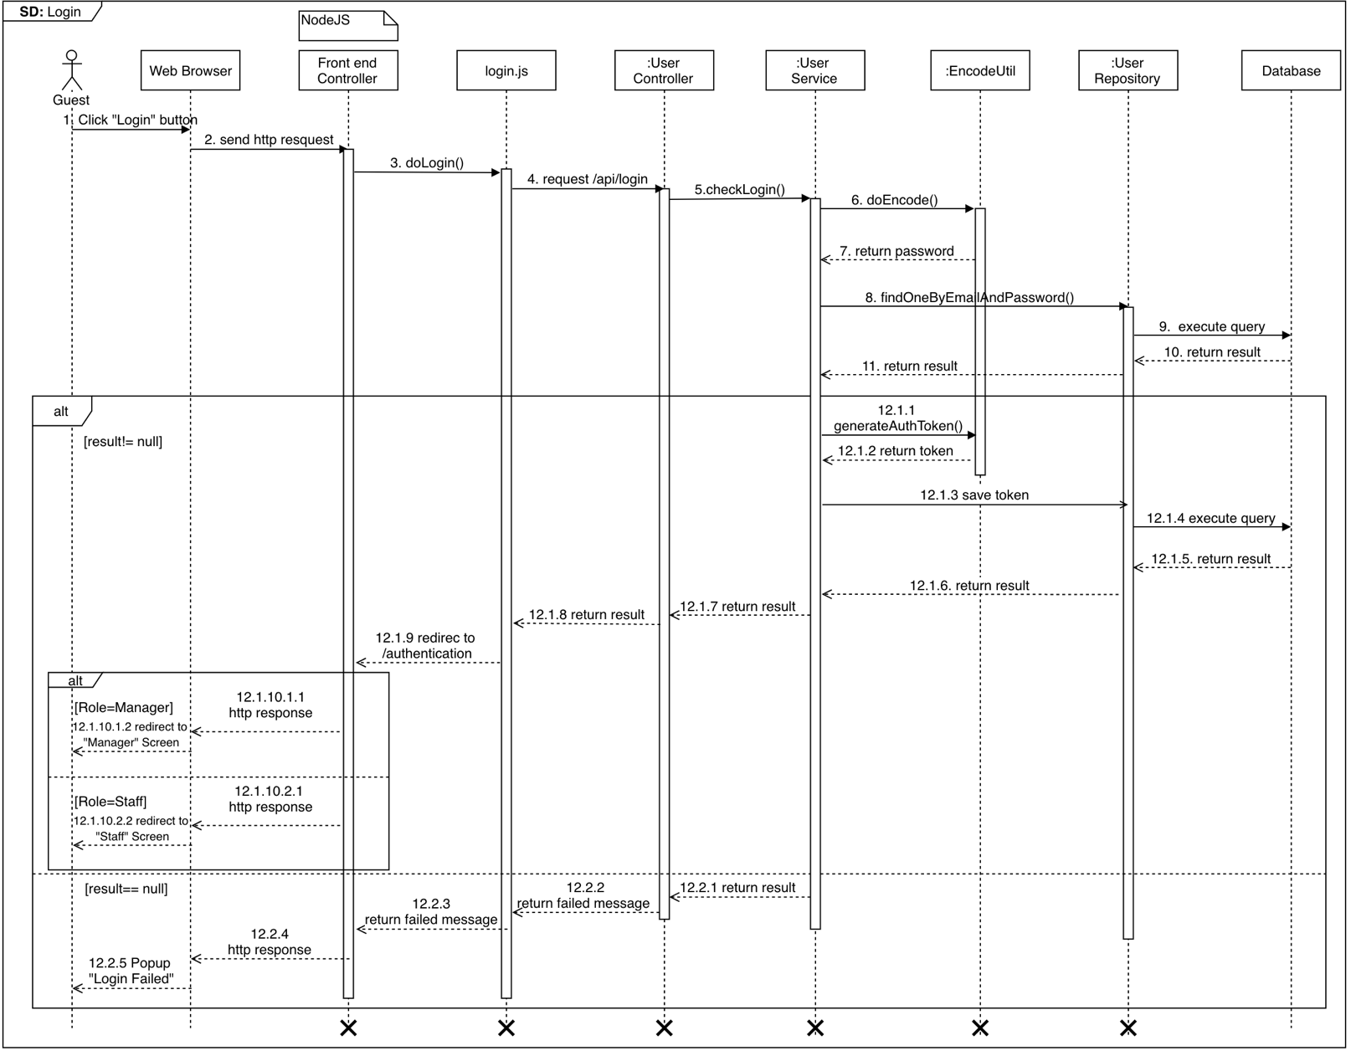

Figure 49 <Sequence Diagram> Guest Login

* + 1. **Test Pages**

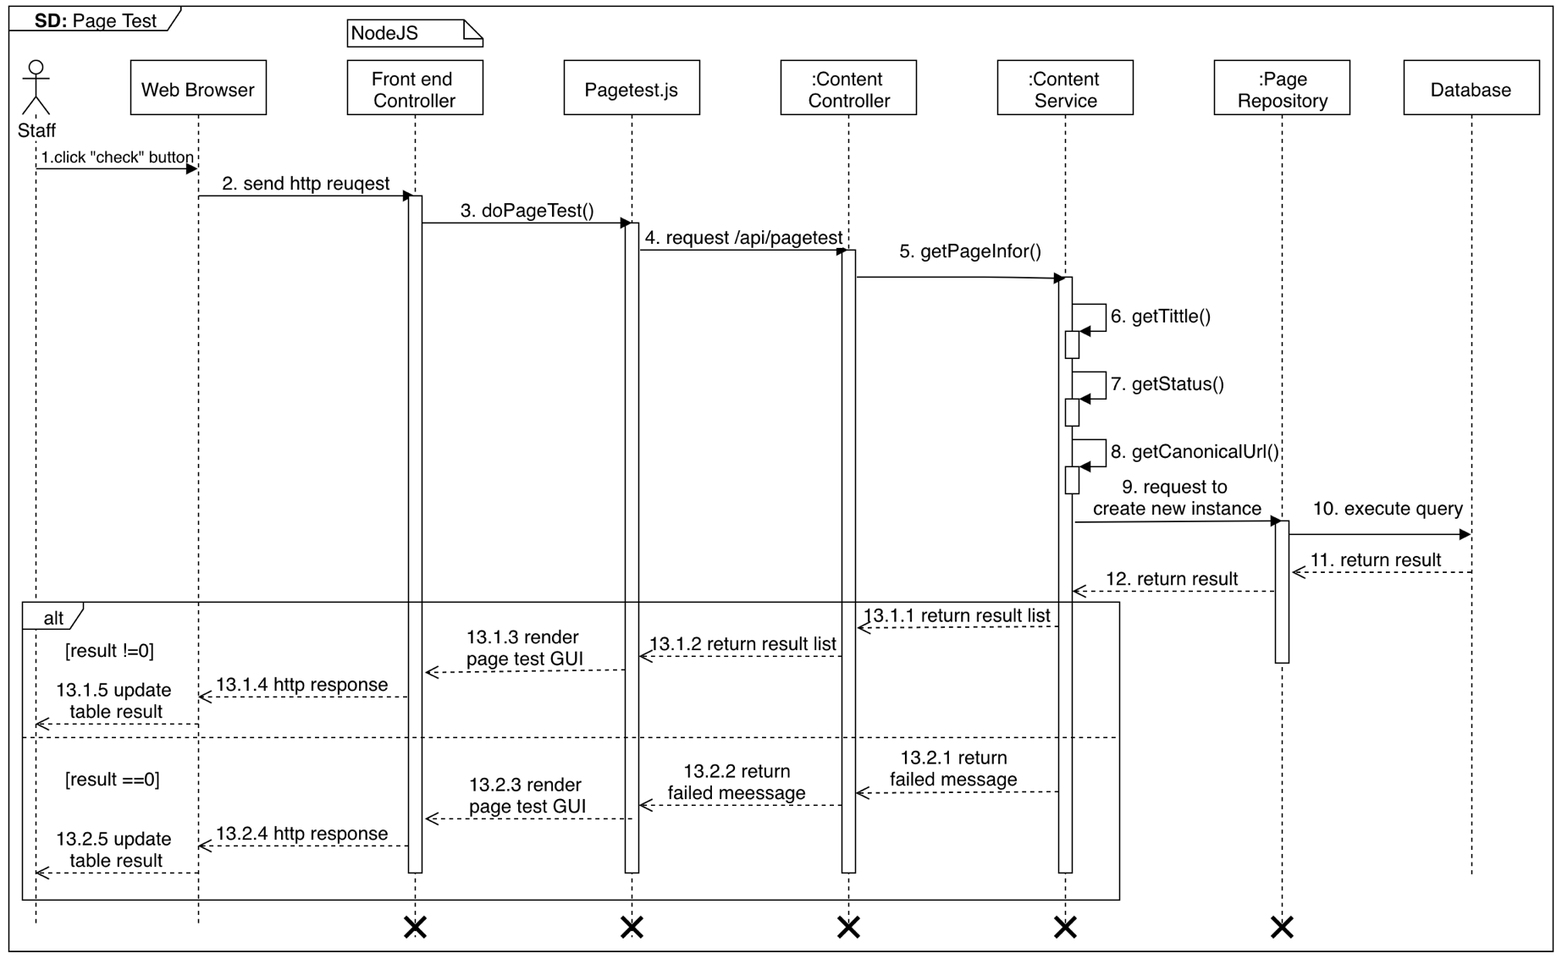

Figure 50 <Sequence Diagram> Staff Test Pages

* + 1. **Test Favicon**

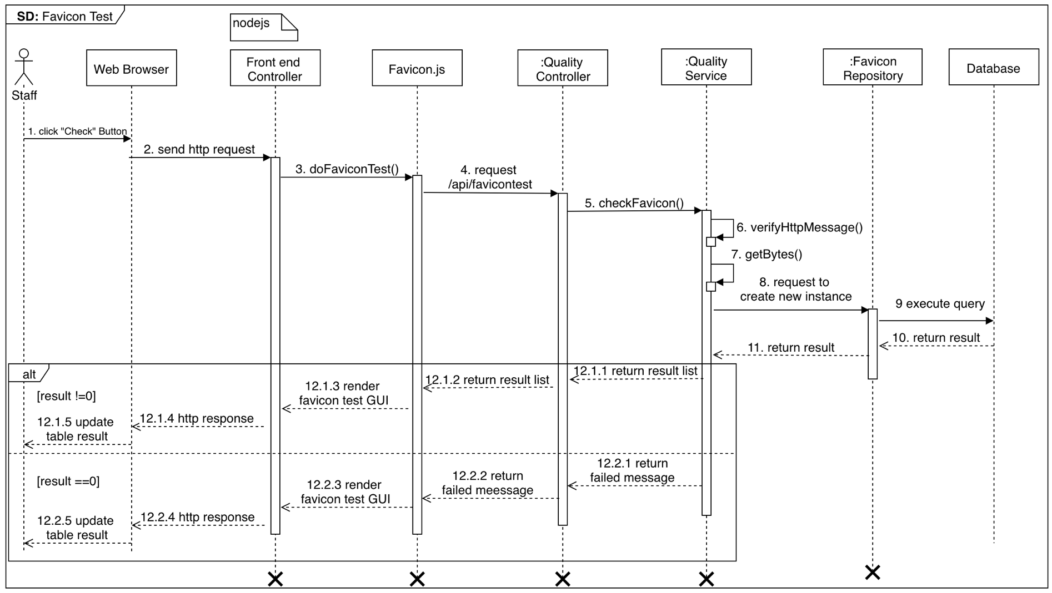

Figure 51 <Sequence Diagram> Staff Test Favicon

* + 1. 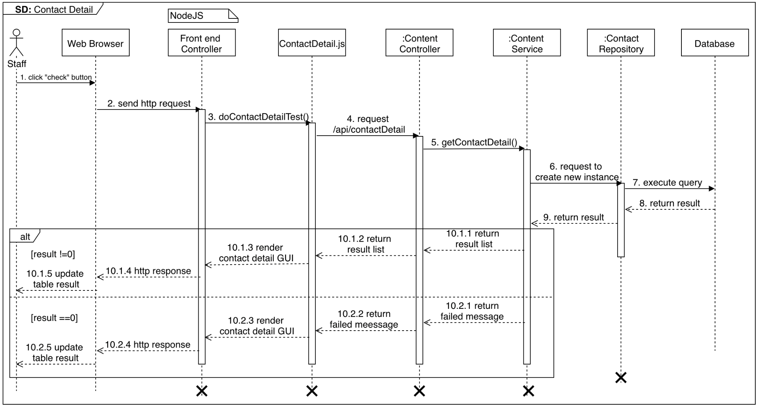**Test Contact Details**

Figure 52<Sequence Diagram> Staff Test Contact Details

* + 1. 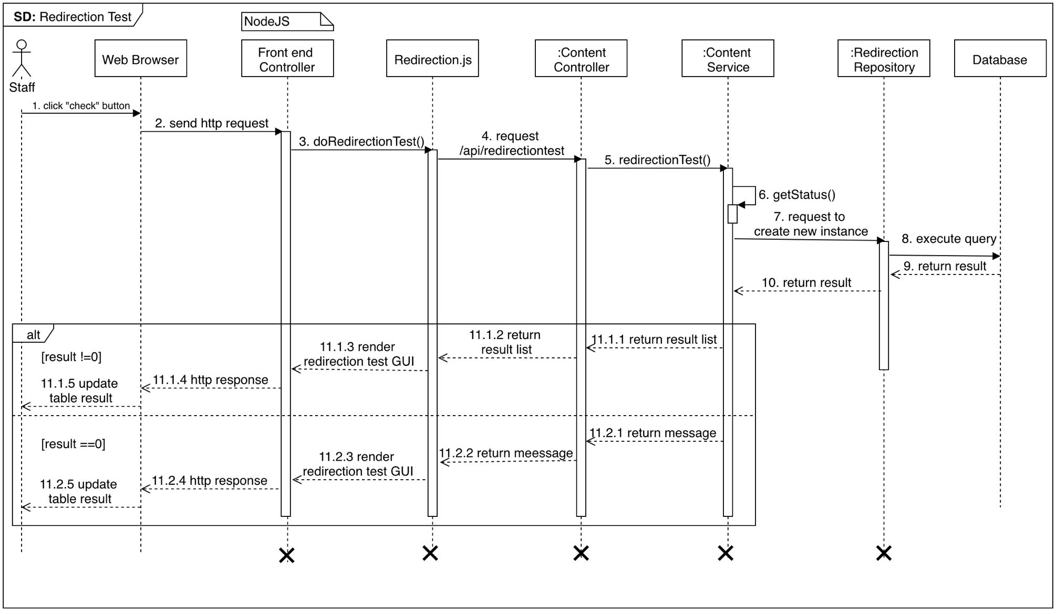**Test Redirection**

Figure 53 <Sequence Diagram> Staff Test Redirection

* + 1. 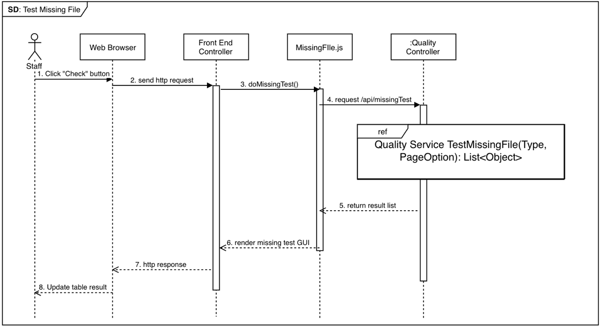**Test Missing File**

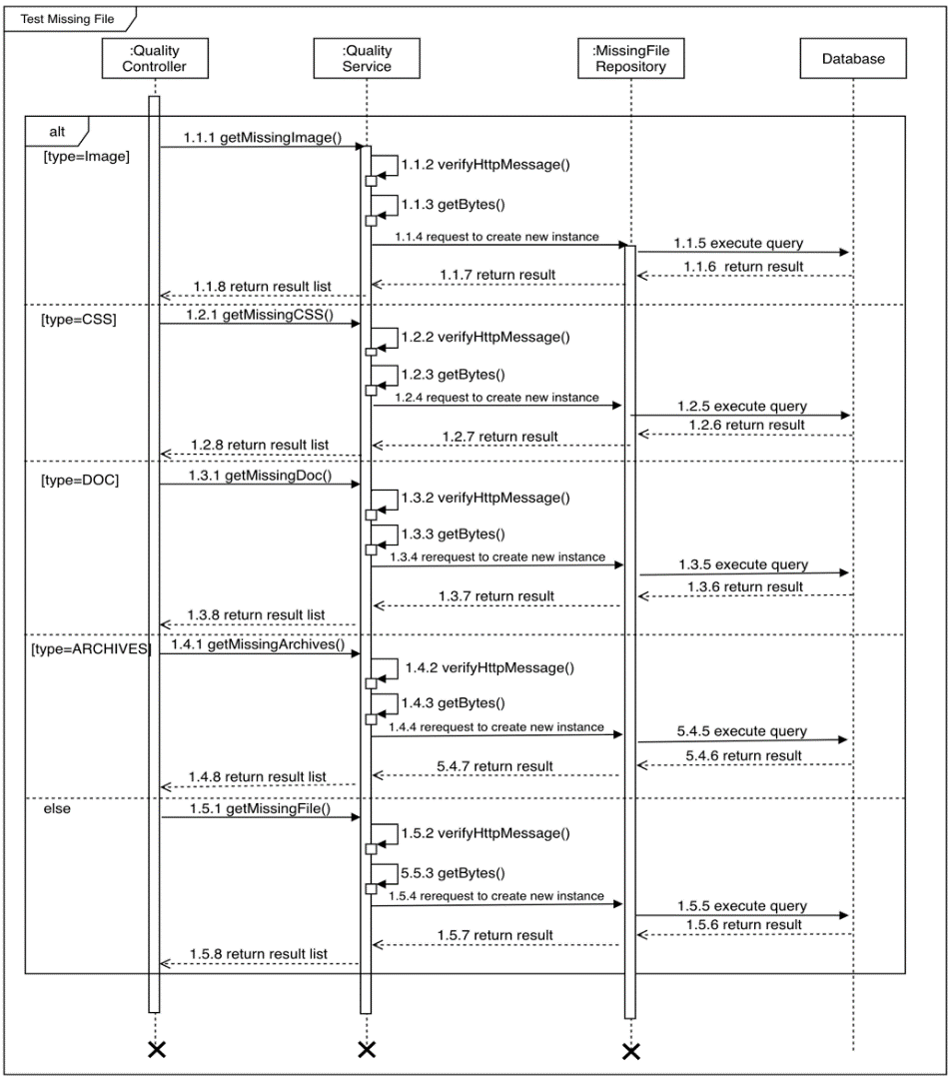

Figure 54 <Sequence Diagram> Staff Test Missing File

* + 1. **Build Sitemap**

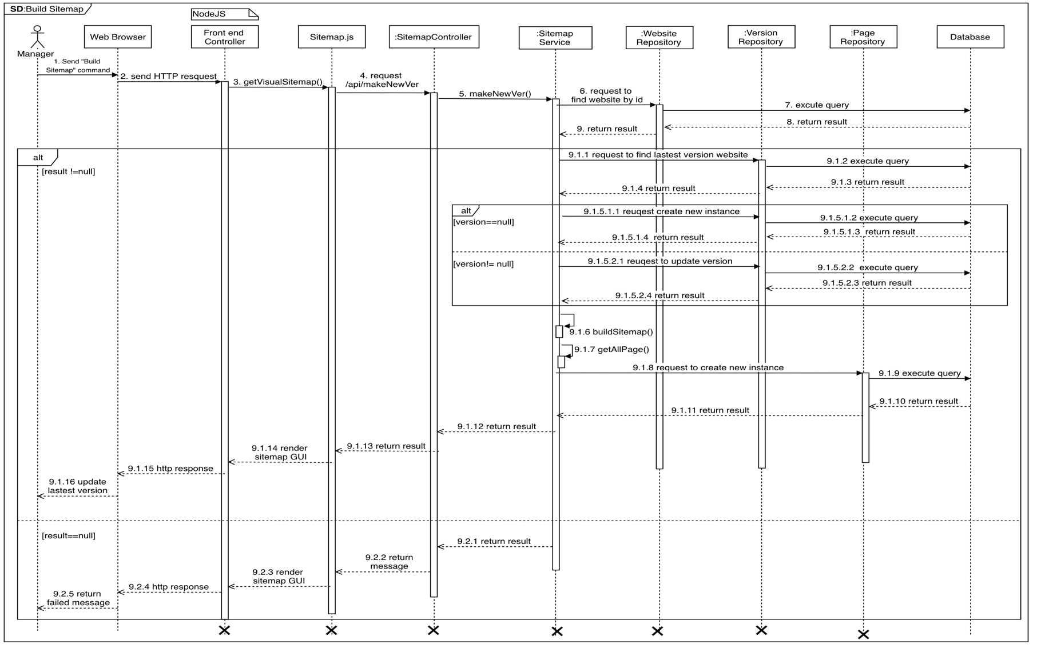

Figure 55 <Sequence Diagram> Manager Build Sitemap

* + 1. 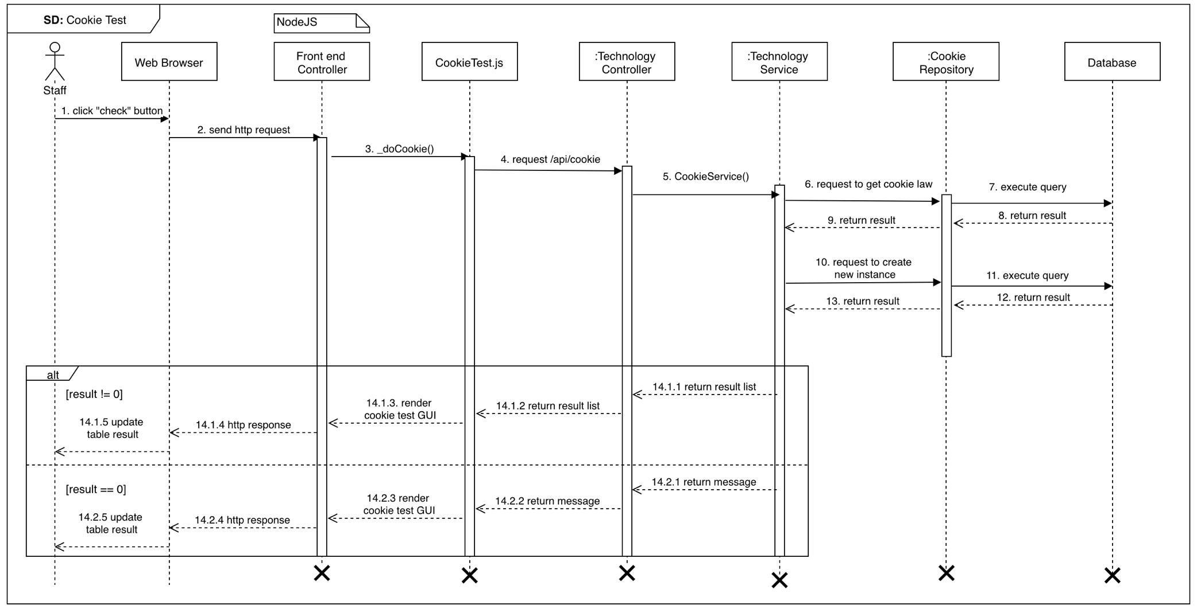**Test Cookie**

Figure 56 <Sequence Diagram> Staff Test Cookie

* + 1. **Test Broken Page**

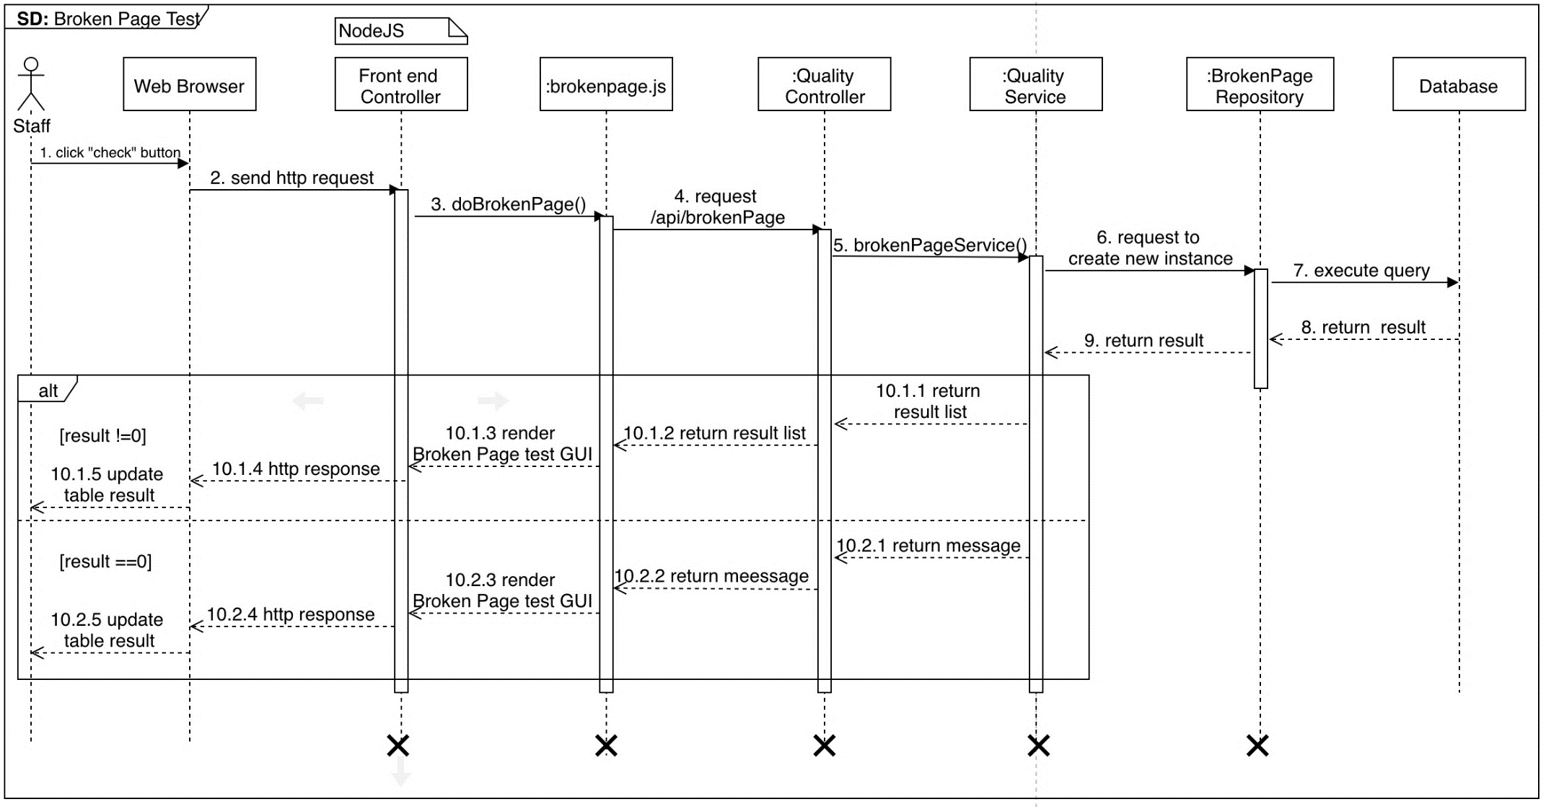

Figure 57 <Sequence Diagram> Staff Test Broken Pages

* + 1. 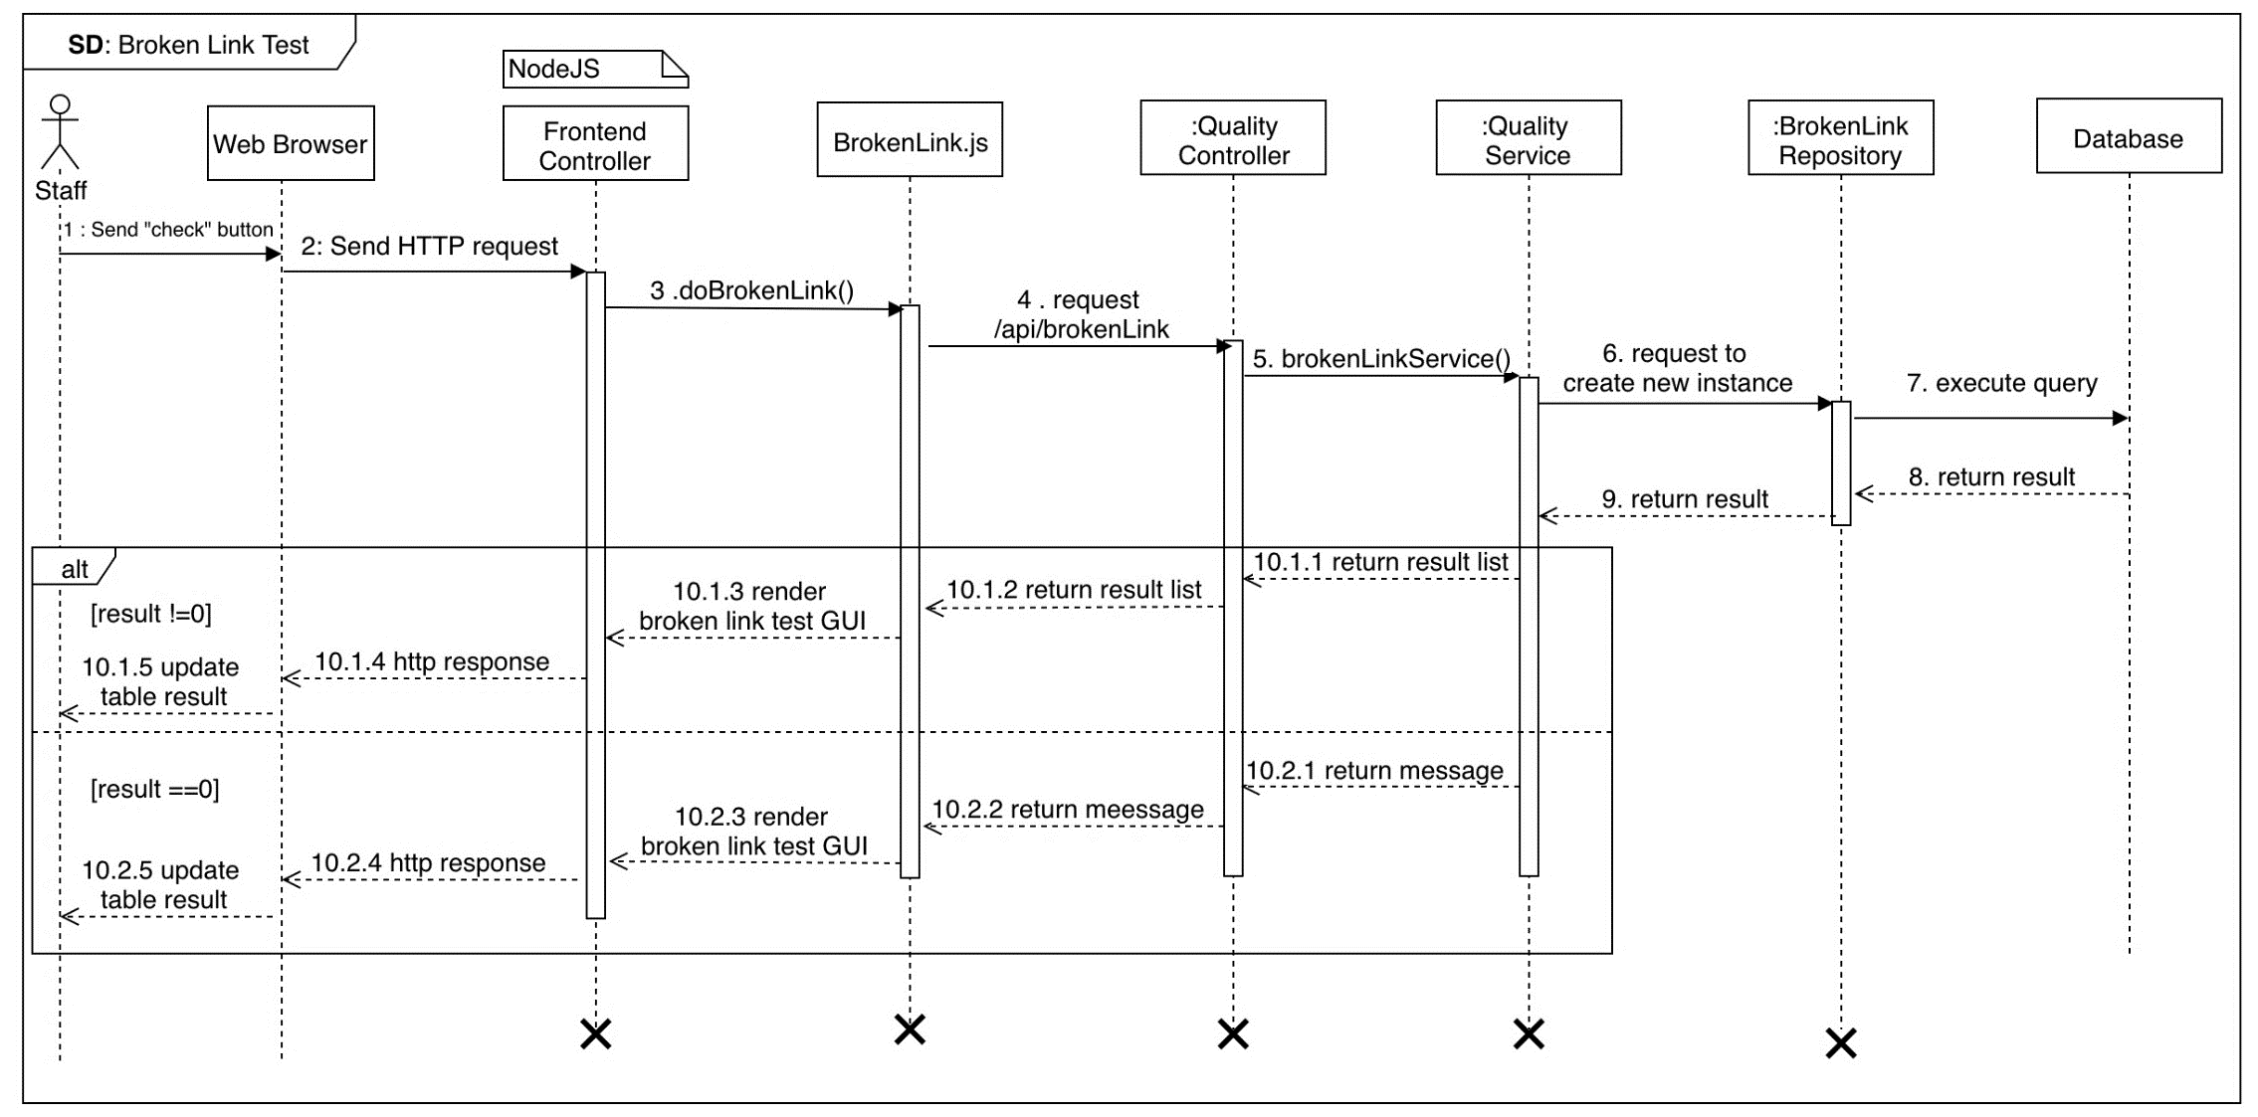**Test Broken Links**

Figure 58 <Sequence Diagram> Staff Test Broken Links

* + 1. **Test Mobile Layout**

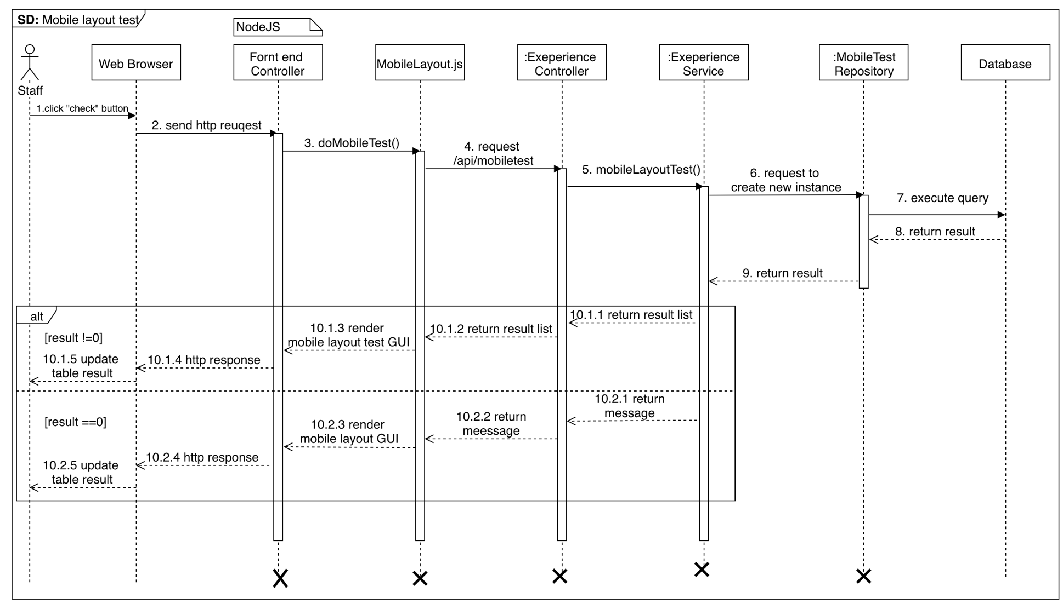

Figure 59 <Sequence Diagram> Staff Test Mobile Layout

* + 1. **Test Javascript errors**

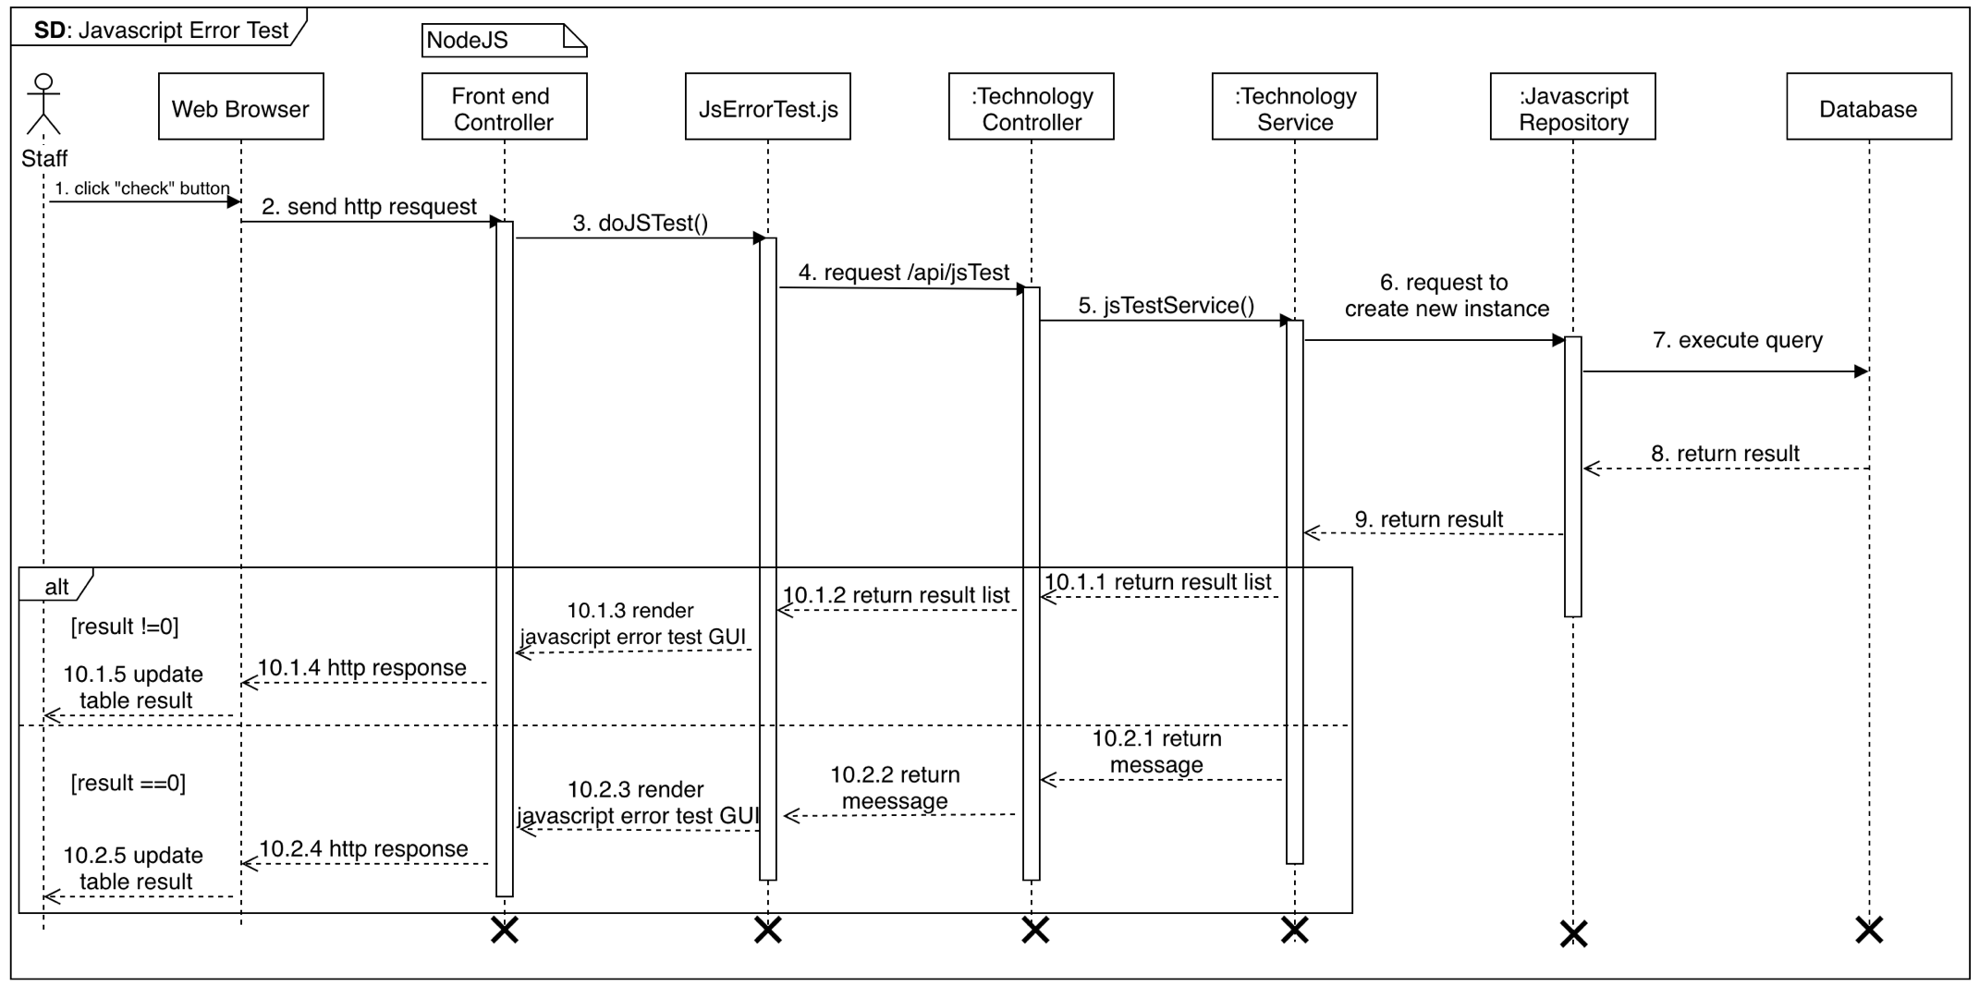

Figure 60 <Sequence Diagram> Staff Test Javascript Errors

* + 1. **Prohibited test**

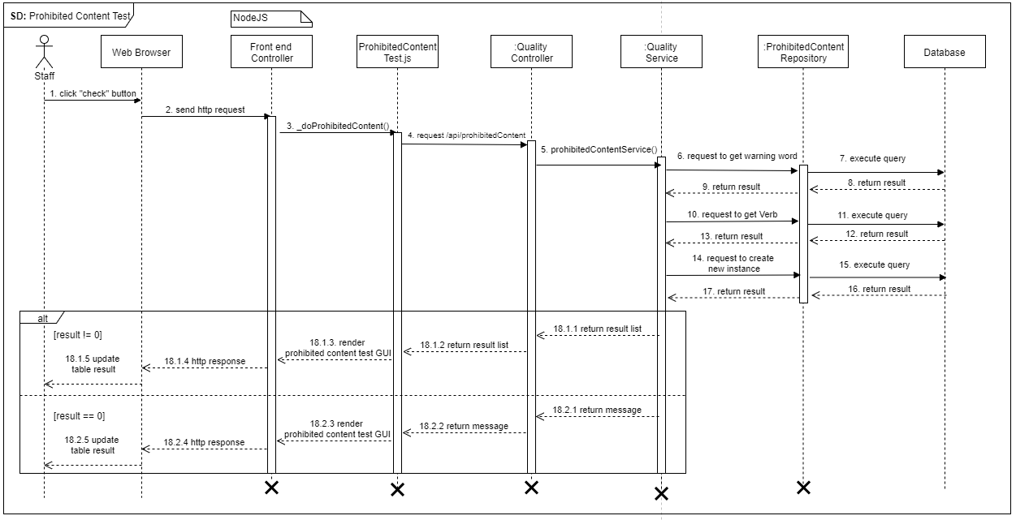

Figure 61 <Sequence Diagram> Staff Test Prohibited

* + 1. 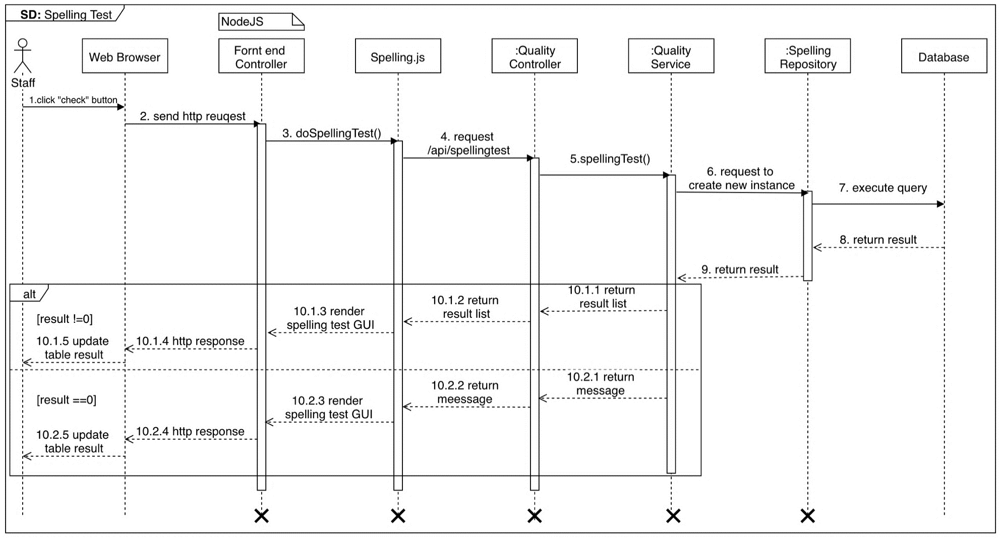**Spelling test**

Figure 62 <Sequence Diagram> Staff Test Spelling

* + 1. **Grammar Test**

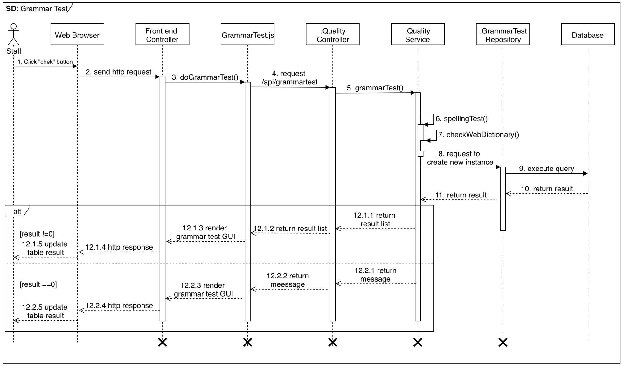

Figure 63 <Sequence Diagram> Staff Test Grammar

* + 1. **Test Server behavior**

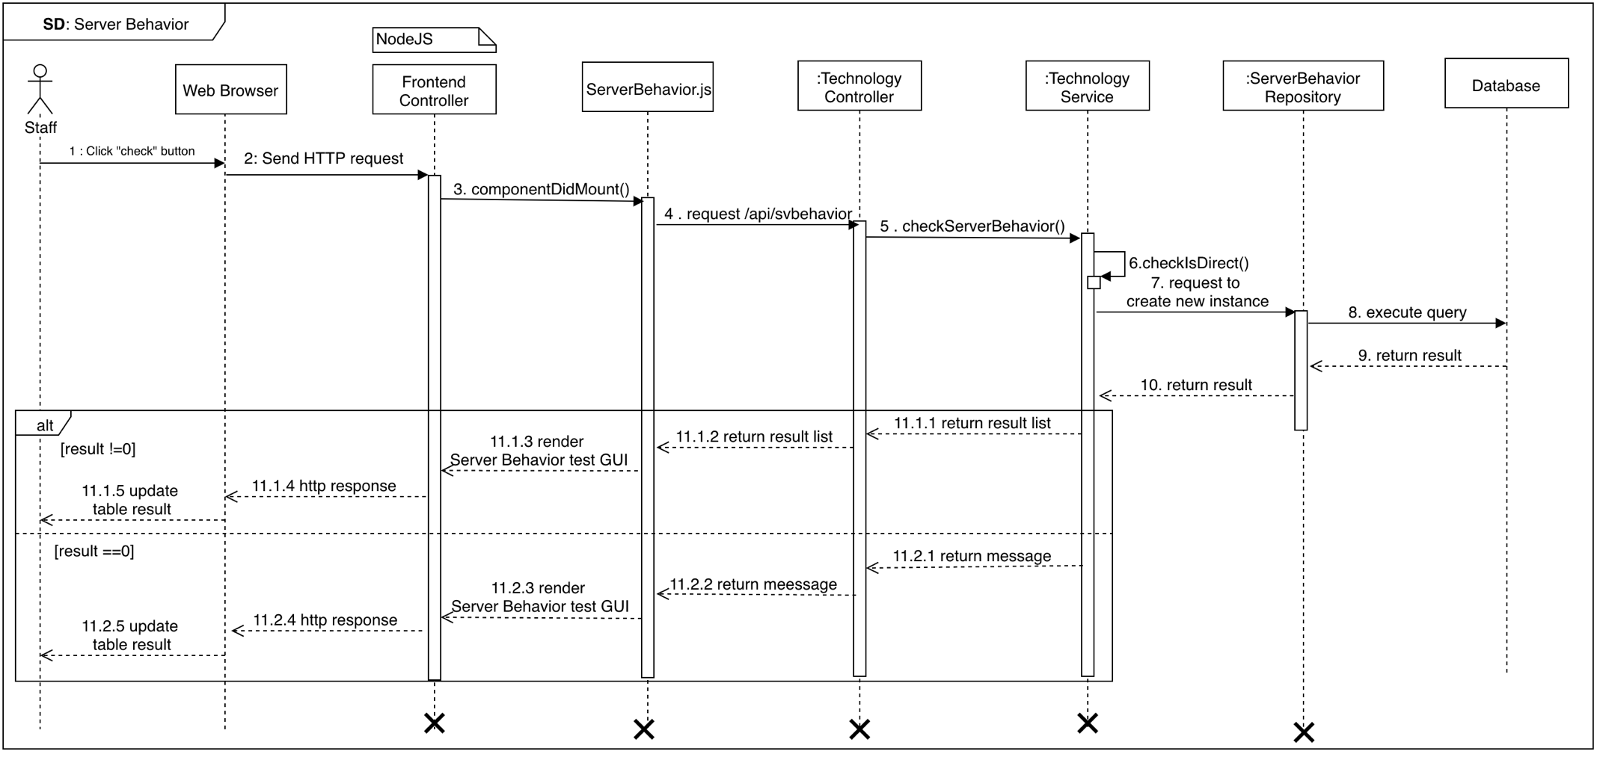

Figure 64 <Sequence Diagram> Staff Test Server Behavior

* + 1. **Measure the speed test**

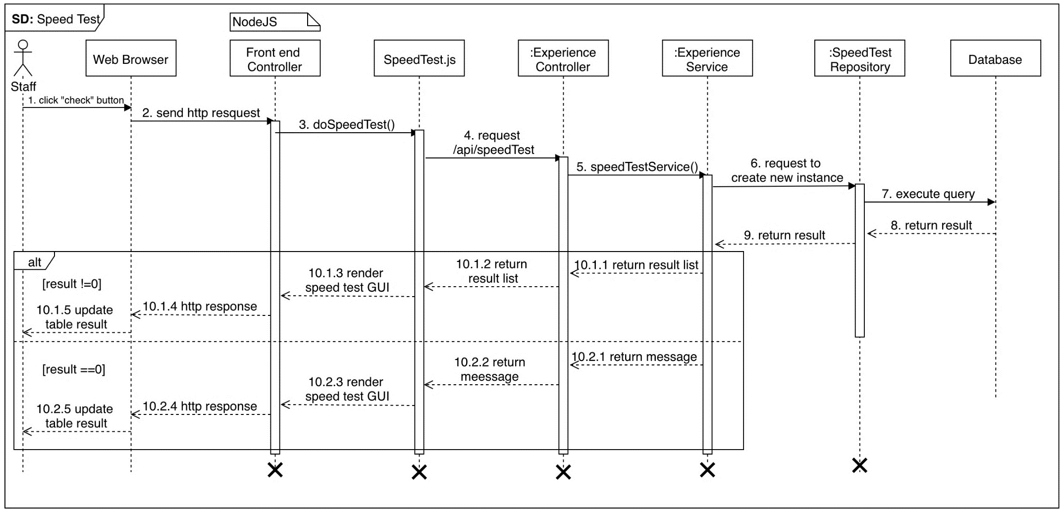

Figure 65 <Sequence Diagram>Staffmeasure the speed test

## Interface

## User Interface Design

## Login

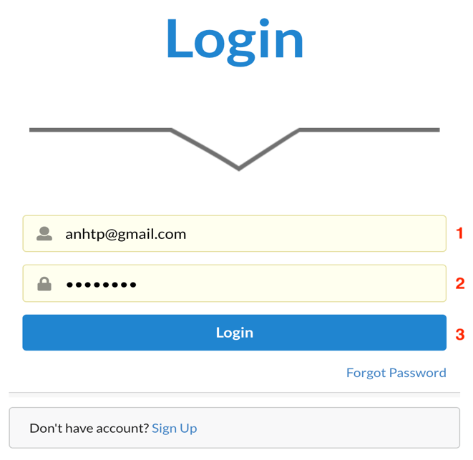

Figure 66 Login

**Fields**

|  |  |  |  |  |  |  |
| --- | --- | --- | --- | --- | --- | --- |
| **No** | **Field Name** | **Description** | **Read only** | **Mandatory** | **Control Type** | **Data Type** |
| 1 | Useranme | Username to login | No | Yes | TextBox | String |
| 2 | Password | Password to login | No | Yes | TexBox | String |

Table 82 <Fields> Login

**Buttons/Hyperlinks:**

|  |  |  |  |  |
| --- | --- | --- | --- | --- |
| **No** | **Function** | **Description** | **Validation** | **Outcome** |
| 3 | Login | Login into the system | Required | Transfer to Dashboard |

Table 83 <Buttons/Hyperlinks> Login

## Menu Manager

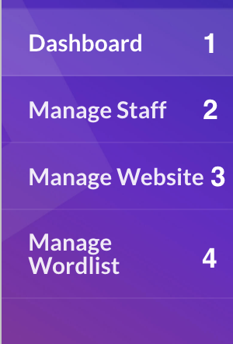

Figure 67 Menu Manager

**Buttons/Hyperlinks:**

|  |  |  |  |  |
| --- | --- | --- | --- | --- |
| **No** | **Function** | **Description** | **Validation** | **Outcome** |
| 1 | Dashboard | Dashboard | User must had been authorized. | Redirect to dashboard |
| 2 | Manage Staff | Manage staff | User must have one of these roles: Manager | Redirect to manage staff page |
| 3 | Manage Website | Manage website | User must have one of these roles: Manager | Redirect to manage website page |
| 4 | Manage Wordlist | Manage wordlist | User must have one of these roles: Manager | Redirect to manage word list page |

Table 84 <Buttons/Hyperlinks> Menu Manage

## Manage Staff

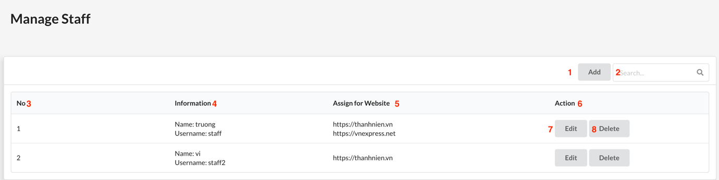

Figure 68 Manage Staff

**Fields**

|  |  |  |  |  |  |  |
| --- | --- | --- | --- | --- | --- | --- |
| **No** | **Field Name** | **Description** | **Read only** | **Mandatory** | **Control Type** | **Data Type** |
| 2 | Search | Search field | No | Yes | TextBox | String |
| 3 | No | Staff’s id | Yes | Yes | Text | String |
| 4 | Information | Staff’s information | Yes | Yes | Text | String |
| 5 | Assign for website | Staff assigned website | Yes | Yes | Text | String |

Table 85 <Fields> Manage Staff

**Buttons/Hyperlinks:**

|  |  |  |  |  |
| --- | --- | --- | --- | --- |
| **No** | **Function** | **Description** | **Validation** | **Outcome** |
| 1 | Add | Add new staff | N/A | Navigate to create staff page |
| 7 | Edit | Edit staff | N/A | Navigate to edit staff page |
| 8 | Delete | Delete staff | N/A | Delete staff  Reload table |

Table 86 <Buttons/Hyperlinks> Manage Staff

## Manage Website

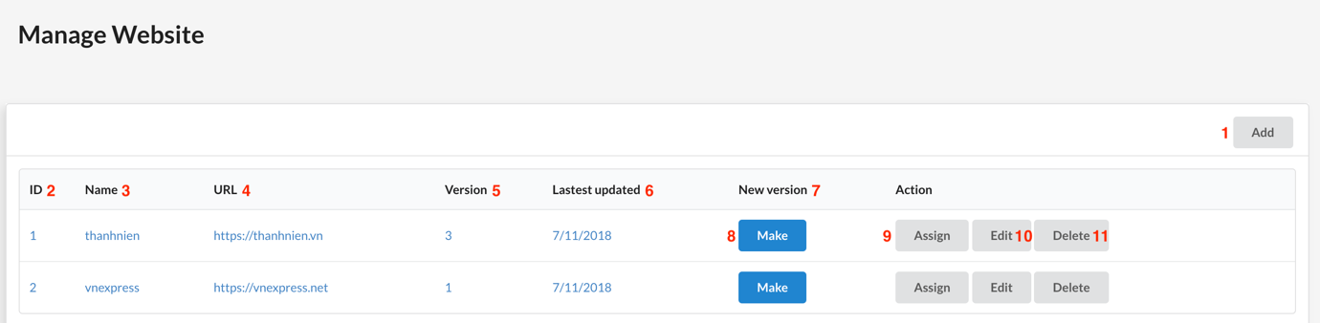

Figure 69 Manage Website

**Fields**

|  |  |  |  |  |  |  |
| --- | --- | --- | --- | --- | --- | --- |
| **No** | **Field Name** | **Description** | **Read only** | **Mandatory** | **Control Type** | **Data Type** |
| 2 | Id | Website id | Yes | Yes | Text | String |
| 3 | Name | Website name | Yes | Yes | Text | String |
| 4 | URL | Website URL | Yes | Yes | Text | String |
| 5 | Version | Website sitemap version | Yes | Yes | Text | String |
| 6 | Last updated | Time of the last sitemap updated | Yes | Yes | Text | String |
| 7 | New Version |  |  |  |  |  |

Table 87 <Fields> Manage Website

**Buttons/Hyperlinks:**

|  |  |  |  |  |
| --- | --- | --- | --- | --- |
| **No** | **Function** | **Description** | **Validation** | **Outcome** |
| 1 | Add | Add new website | N/A | Navigate to add website page. |
| 8 | Make | Make new website’s sitemap | N/A | Reload table |
| 9 | Assign | Assign website for staff | N/A | Navigate to assign website for staff page |
| 10 | Edit | Edit website information | N/A | Navigate to edit website page |
| 11 | Delete | Delete website | N/A | Delete website Reload table |

Table 88 <Buttons/Hyperlinks> Manage Website

## Menu Staff

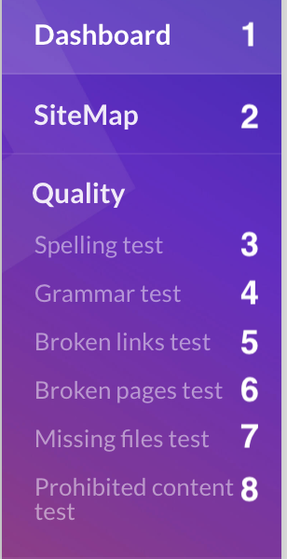 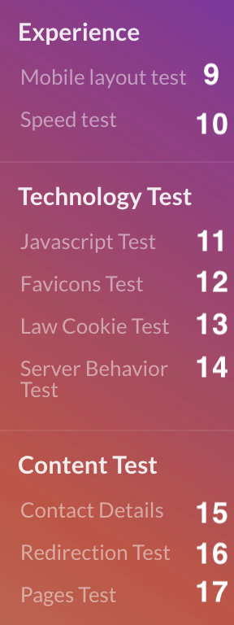

Figure 70 Menu Staff

**Buttons/Hyperlinks:**

|  |  |  |  |  |
| --- | --- | --- | --- | --- |
| **No** | **Function** | **Description** | **Validation** | **Outcome** |
| 1 | Dashboard | Dashboard | User must had been authorized. | Redirect to dashboard |
| 2 | Sitemap | Website sitemap | User must have one of these roles: staff | Redirect to sitemap page |
| 3 | Spelling test | Spelling test | User must have one of these roles: staff | Redirect to spelling test page |
| 4 | Grammar test | Grammar test | User must have one of these roles: staff | Redirect to grammar test page |
| 5 | Broken page test | Broken page test | User must have one of these roles: staff | Redirect to broken page test page |
| 6 | Broken link test | Broken link test | User must have one of these roles: staff | Redirect to broken link test page |
| 7 | Missing file test | Missing file test | User must have one of these roles: staff | Redirect to missing file test page |
| 8 | Prohibited content test | Prohibited content test | User must have one of these roles: staff | Redirect to prohibited content test page |
| 9 | Mobile Layout test | Mobile layout test | User must have one of these roles: staff | Redirect to mobile layout test page |
| 10 | Speed test | Measure the speed of each page | User must have one of these roles: staff | Redirect to Measure the speed of each page page |
| 11 | Javascript test | Javascript error test | User must have one of these roles: staff | Redirect to javascript error test page |
| 12 | Favicon test | Favicon test | User must have one of these roles: staff | Redirect to favion test page |
| 13 | Cookie test | Cookie test | User must have one of these roles: staff | Redirect to cookie test page |
| 14 | Server behavior test | Server behavior test | User must have one of these roles: staff | Redirect to server behavior test page |
| 15 | Contact details | Contact details test | User must have one of these roles: staff | Redirect to contact details test page |
| 16 | Redirection test | Redireaction test | User must have one of these roles: staff | Redirect to redirection test page |
| 17 | Page Test | Page test | User must have one of these roles: staff | Redirect to page test page |

Table 89 <Buttons/Hyperlinks> Menu Staff

## Sitemap

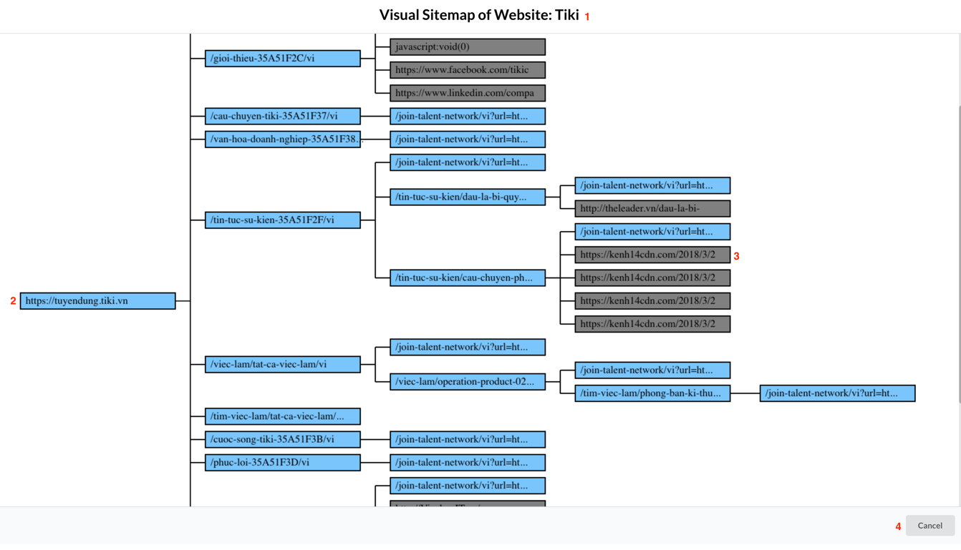

Figure 71 Sitemap

**Fields**

|  |  |  |  |  |  |  |
| --- | --- | --- | --- | --- | --- | --- |
| **No** | **Field Name** | **Description** | **Read only** | **Mandatory** | **Control Type** | **Data Type** |
| 1 | Name Sitemap | Name sitemap | Yes | Yes | Text | String |
| 2 | Internal link | Internal link | Yes | Yes | Text | String |
| 3 | External link | External link | Yes | Yes | Text | String |

Table 90 <Fields> Sitemap

**Buttons/Hyperlinks:**

|  |  |  |  |  |
| --- | --- | --- | --- | --- |
| **No** | **Function** | **Description** | **Validation** | **Outcome** |
| 4 | Cancel | Close sitemap | N/A | Navigate to manage website. |

Table 91 <Buttons/Hyperlinks> Sitemap

## Spelling test

Figure 72 Spelling Test

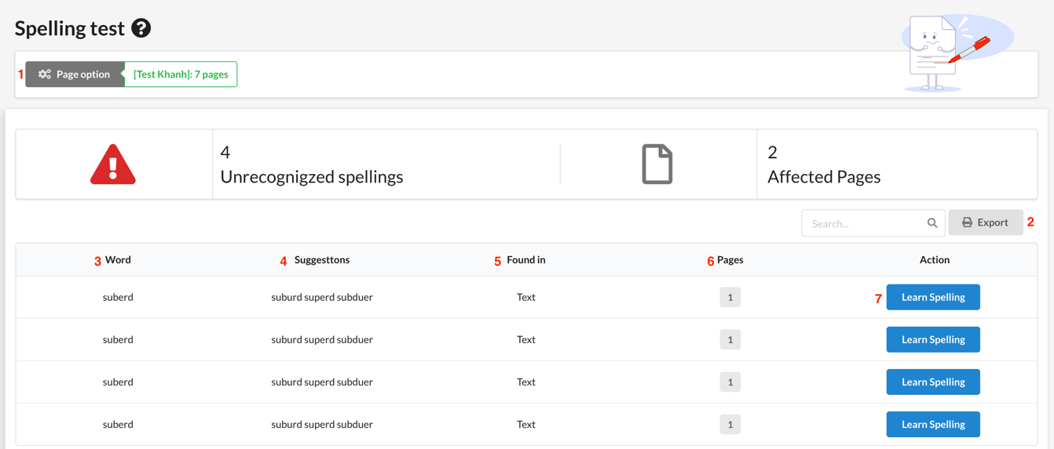**Fields**

|  |  |  |  |  |  |  |
| --- | --- | --- | --- | --- | --- | --- |
| **No** | **Field Name** | **Description** | **Read only** | **Mandatory** | **Control Type** | **Data Type** |
| 3 | Word | Word | Yes | Yes | Text | String |
| 4 | Suggestion | Suggestion word | Yes | Yes | Text | String |
| 5 | Found in | Found in | Yes | Yes | Text | String |
| 6 | Pages | Pages | Yes | Yes | Text | String |

Table 92 <Fields> Spelling Test

**Buttons/Hyperlinks:**

|  |  |  |  |  |
| --- | --- | --- | --- | --- |
| **No** | **Function** | **Description** | **Validation** | **Outcome** |
| 1 | Page Option | Page option | N/A | Navigate to page option page. |
| 5 | Export | Export excel | N/A | Export to excel |
| 7 | Learn Spelling | Learn spelling | N/A | Reload table result |

Table 93 <Buttons/Hyperlinks> Grammar Test

## Grammar test

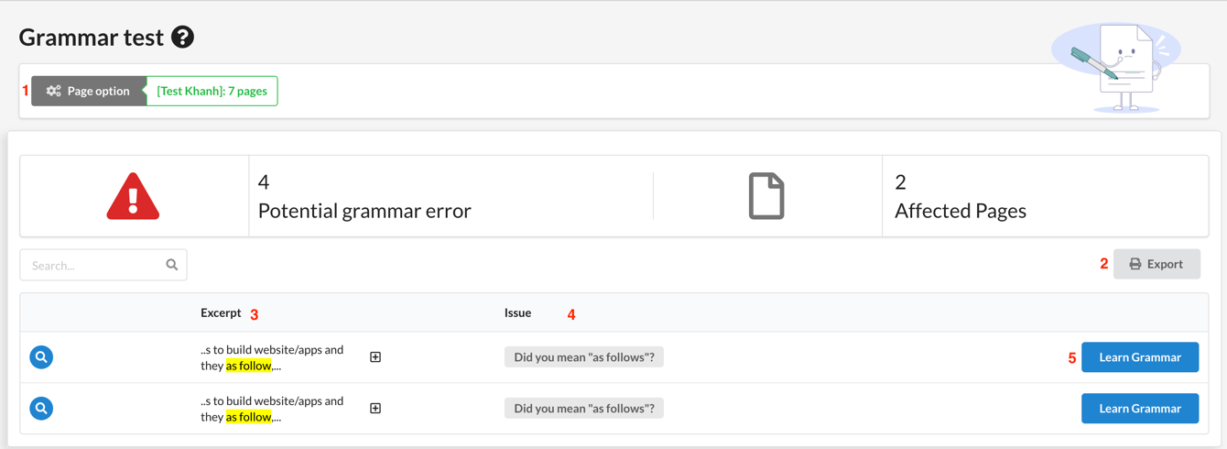

Figure 73 Grammar Test

**Fields**

|  |  |  |  |  |  |  |
| --- | --- | --- | --- | --- | --- | --- |
| **No** | **Field Name** | **Description** | **Read only** | **Mandatory** | **Control Type** | **Data Type** |
| 3 | Excerpt | Excerpt | Yes | Yes | Text | String |
| 4 | Issue | Issue | Yes | Yes | Text | String |

Table 94 <Fields> Grammar Test

**Buttons/Hyperlinks:**

|  |  |  |  |  |
| --- | --- | --- | --- | --- |
| **No** | **Function** | **Description** | **Validation** | **Outcome** |
| 1 | Page Option | Page option | N/A | Navigate to page option page. |
| 5 | Export | Export excel | N/A | Export to excel |
| 7 | Learn Grammar | Learn this grammar | N/A | Reload table result |

Table 95 <Buttons/Hyperlinks> Grammar Test

## Broken page test

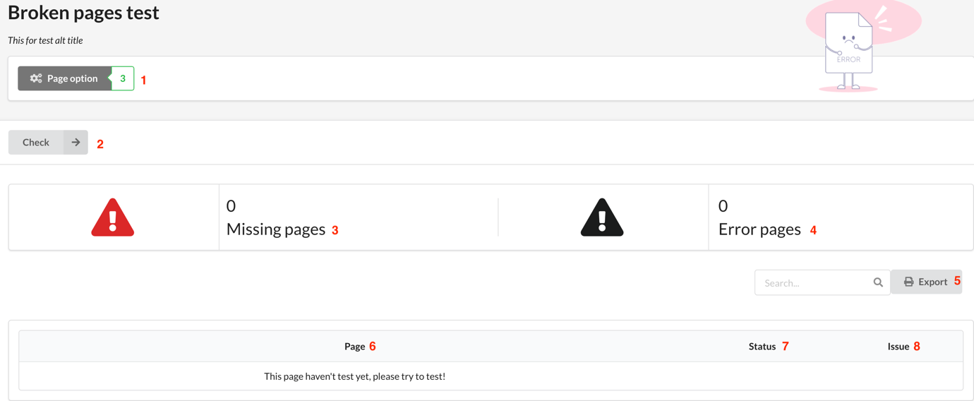

Figure 74 Broken Pages Test

**Fields**

|  |  |  |  |  |  |  |
| --- | --- | --- | --- | --- | --- | --- |
| **No** | **Field Name** | **Description** | **Read only** | **Mandatory** | **Control Type** | **Data Type** |
| 3 | Missing pages | Missing pages | Yes | Yes | Text | String |
| 4 | Error pages | Error pages | Yes | Yes | Text | String |
| 6 | Pages | Page’s url | Yes | Yes | Text | String |
| 7 | Status | http code response | Yes | Yes | Text | String |
| 8 | Issues | Broken page’s issues | Yes | Yes | Text | String |

Table 96 <Fields> Broken Pages Test

**Buttons/Hyperlinks:**

|  |  |  |  |  |
| --- | --- | --- | --- | --- |
| **No** | **Function** | **Description** | **Validation** | **Outcome** |
| 1 | Page Option | Page option | N/A | Navigate to page option page. |
| 2 | Check | Check | N/A | Reload table |
| 5 | Export | Export excel | N/A | Export to excel |

Table 97 <Buttons/Hyperlinks> Broken Pages Test

## Broken links test

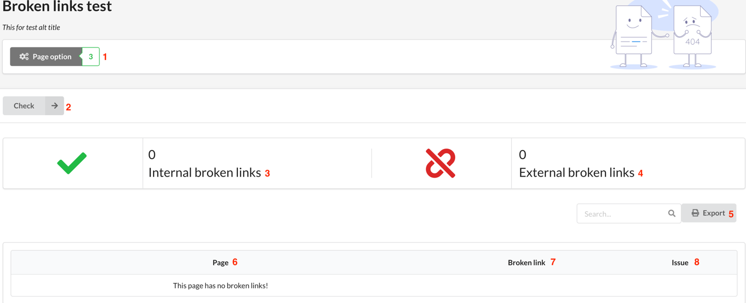

Figure 75 Broken Links Test

**Fields**

|  |  |  |  |  |  |  |
| --- | --- | --- | --- | --- | --- | --- |
| **No** | **Field Name** | **Description** | **Read only** | **Mandatory** | **Control Type** | **Data Type** |
| 3 | Internal Broken Links | Internal Broken Links | Yes | Yes | Text | String |
| 4 | External Broken Links | External Broken Links | Yes | Yes | Text | String |
| 6 | Pages | Page’s url | Yes | Yes | Text | String |
| 7 | Broken link | Broken link | Yes | Yes | Text | String |
| 8 | Issues | Broken link’s issues | Yes | Yes | Text | String |

Table 98 <Fields> Broken Links Test

**Buttons/Hyperlinks:**

|  |  |  |  |  |
| --- | --- | --- | --- | --- |
| **No** | **Function** | **Description** | **Validation** | **Outcome** |
| 1 | Page Option | Page option | N/A | Navigate to page option page. |
| 2 | Check | Check | N/A | Reload table |
| 5 | Export | Export excel | N/A | Export to excel |

Table 99 <Buttons/Hyperlinks> Broken Links Test

## Missing file test

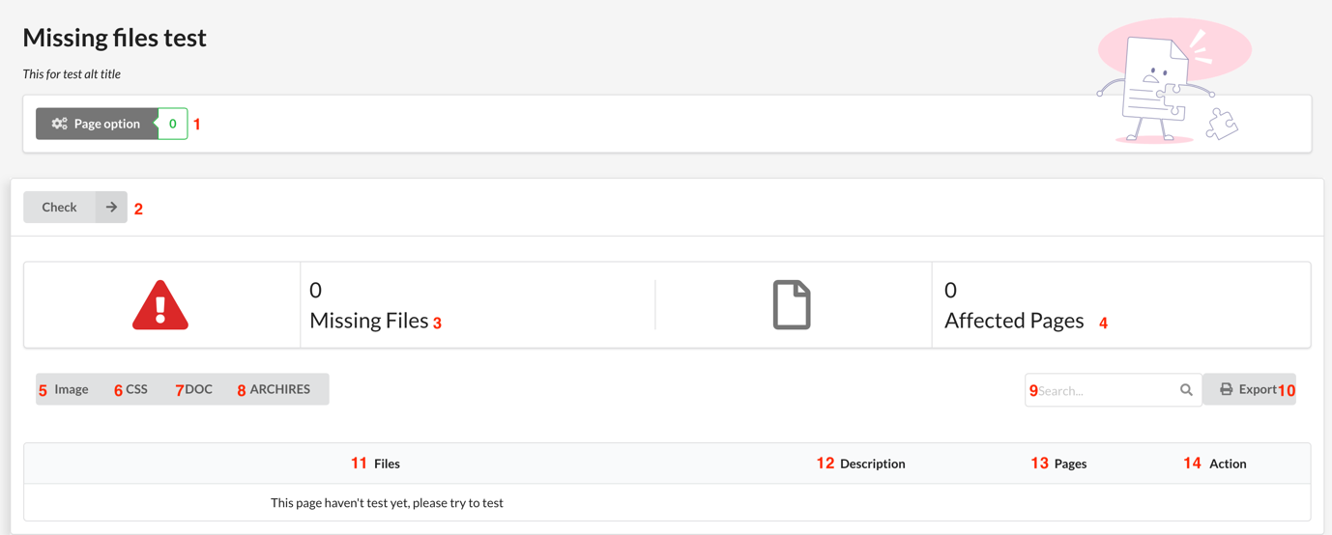

Figure 76 Missing File Test

**Fields**

|  |  |  |  |  |  |  |
| --- | --- | --- | --- | --- | --- | --- |
| **No** | **Field Name** | **Description** | **Read only** | **Mandatory** | **Control Type** | **Data Type** |
| 3 | Number of missing files | Numbers of missing file | Yes | Yes | Text | String |
| 4 | Number of affected pages | Number of affected pages | Yes | Yes | Text | String |
| 9 | Search | Search field | No | Yes | TextBox | String |
| 11 | Files | File missing | Yes | Yes | Text | String |
| 12 | Description | Description missing | Yes | Yes | Text | String |
| 13 | Pages | Pages affected | Yes | Yes | Text | String |
| 14 | Action | Edit | Yes | Yes | Text | String |

Table 100 <Fields> Missing File Test

**Buttons/Hyperlinks:**

|  |  |  |  |  |
| --- | --- | --- | --- | --- |
| **No** | **Function** | **Description** | **Validation** | **Outcome** |
| 1 | Page Option | Page option | N/A | Navigate to page option page. |
| 2 | Check | Check | N/A | Reload table |
| 5 | Image | Image option | N/A | Button image is active |
| 6 | CSS | CSS option | N/A | Button css is active |
| 7 | DOC | DOC option | N/A | Button doc is active |
| 8 | Archires | Archires option | N/A | Button arrhires is active |
| 10 | Export | Export excel | N/A | Export to excel |

Table 101 <Buttons/Hyperlinks> Missing File Test

## Prohibited content test

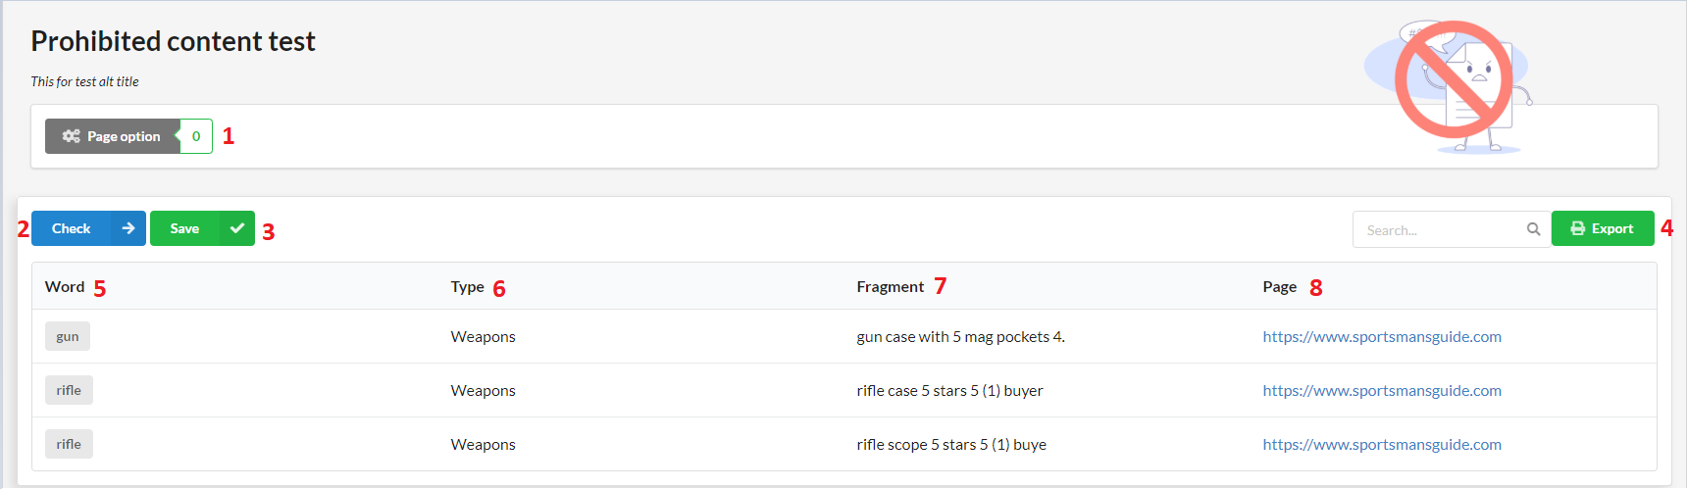

Figure 77 Prohibited content test

**Fields**

|  |  |  |  |  |  |  |
| --- | --- | --- | --- | --- | --- | --- |
| **No** | **Field Name** | **Description** | **Read only** | **Mandatory** | **Control Type** | **Data Type** |
| 5 | Word | Prohibited word | Yes | Yes | Text | String |
| 6 | Type | Type of prohibited word | Yes | Yes | Text | String |
| 7 | Fragment | Fragment includes prohibited word | Yes | Yes | Text | String |
| 8 | Page | Page’s url | Yes | Yes | Text | String |

Table 102 <Fields> Prohibited Content Test

**Buttons/Hyperlinks:**

|  |  |  |  |  |
| --- | --- | --- | --- | --- |
| **No** | **Function** | **Description** | **Validation** | **Outcome** |
| 1 | Page Option | Page option | N/A | Navigate to page option page. |
| 2 | Check | Check | N/A | Reload table |
| 3 | Save | Save | N/A | Reload table |
| 4 | Export | Export excel | N/A | Export to Excel |

Table 103 <Buttons/Hyperlinks> Prohibited Content Test

## Mobile layout test

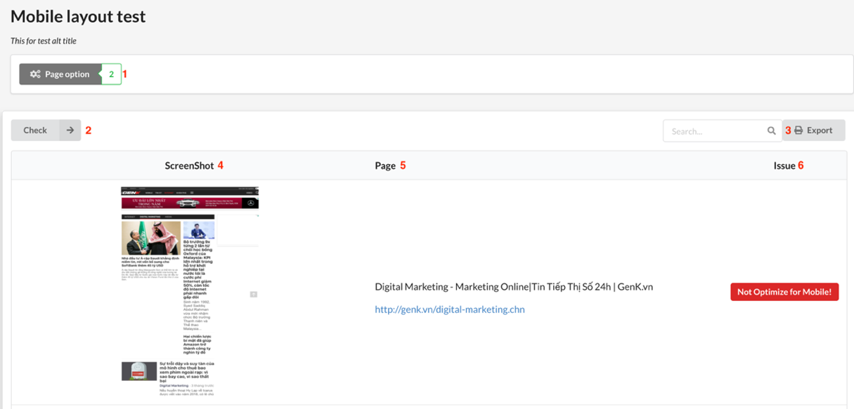

Figure 78 Mobile Layout Test

**Fields**

|  |  |  |  |  |  |  |
| --- | --- | --- | --- | --- | --- | --- |
| **No** | **Field Name** | **Description** | **Read only** | **Mandatory** | **Control Type** | **Data Type** |
| 4 | Screenshoot | Screenshoot website mobile layout | Yes | Yes | Text | String |
| 5 | Pages | Page’s url | Yes | Yes | Text | String |
| 6 | Issues | Mobile layout’s issue | Yes | Yes | Text | String |

Table 104 <Fields> Mobile Layout Test

**Buttons/Hyperlinks:**

|  |  |  |  |  |
| --- | --- | --- | --- | --- |
| **No** | **Function** | **Description** | **Validation** | **Outcome** |
| 1 | Page Option | Page option | N/A | Navigate to page option page. |
| 2 | Check | Check | N/A | Reload table |
| 3 | Export | Export excel | N/A | Export to excel |

Table 105 <Buttons/Hyperlinks> Mobile Layout Test

## Speed test

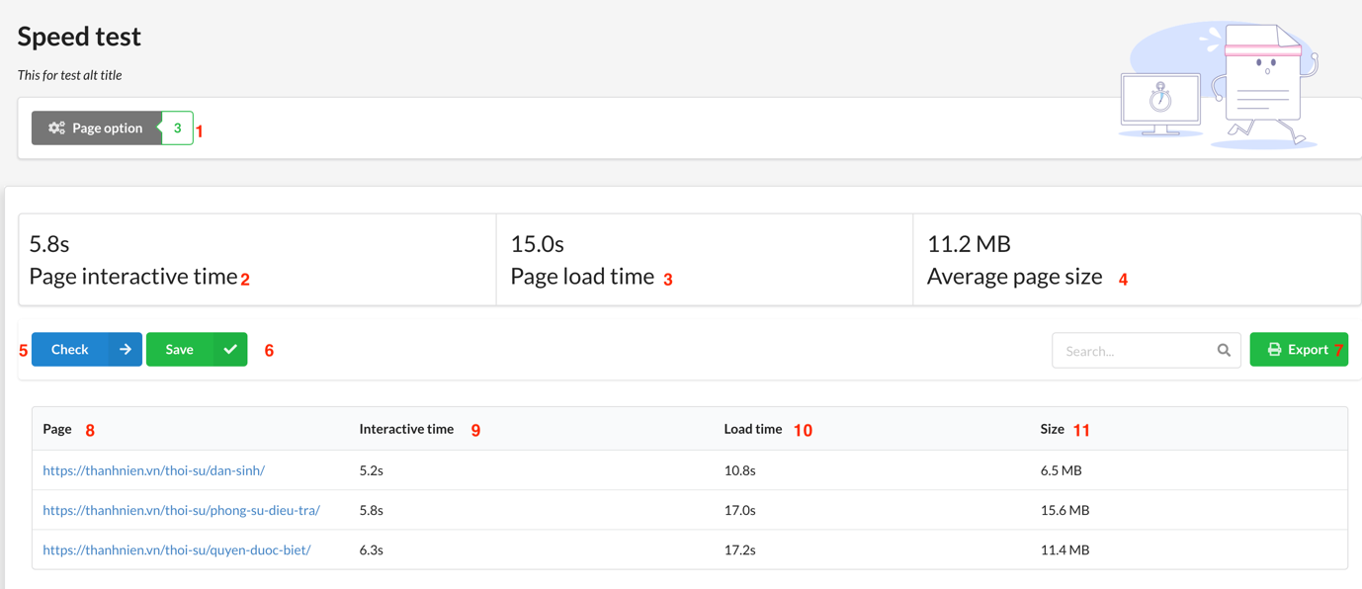

Figure 79 Speed Test

**Fields**

|  |  |  |  |  |  |  |
| --- | --- | --- | --- | --- | --- | --- |
| **No** | **Field Name** | **Description** | **Read only** | **Mandatory** | **Control Type** | **Data Type** |
| 2 | Page Interactive time | Average page interactive time | Yes | Yes | Text | String |
| 3 | Page load time | Average page load time | Yes | Yes | Text | String |
| 4 | Average page size | Average page size | Yes | Yes | Text | String |
| 8 | Page | Page’s url | Yes | Yes | Text | String |
| 9 | Interactive time | Page interactive time | Yes | Yes | Text | String |
| 10 | Load time | Page load time | Yes | Yes | Text | String |
| 11 | Size | Page size | Yes | Yes | Text | String |

Table 106 <Fields> Speed Test

**Buttons/Hyperlinks:**

|  |  |  |  |  |
| --- | --- | --- | --- | --- |
| **No** | **Function** | **Description** | **Validation** | **Outcome** |
| 1 | Page Option | Page option | N/A | Navigate to page option page. |
| 5 | Check | Check | N/A | Reload table |
| 6 | Save | Save | N/A | Reload table |
| 7 | Export | Export excel | N/A | Export to excel |

Table 107 <Buttons/Hyperlinks> Speed Test

## Javascript error test

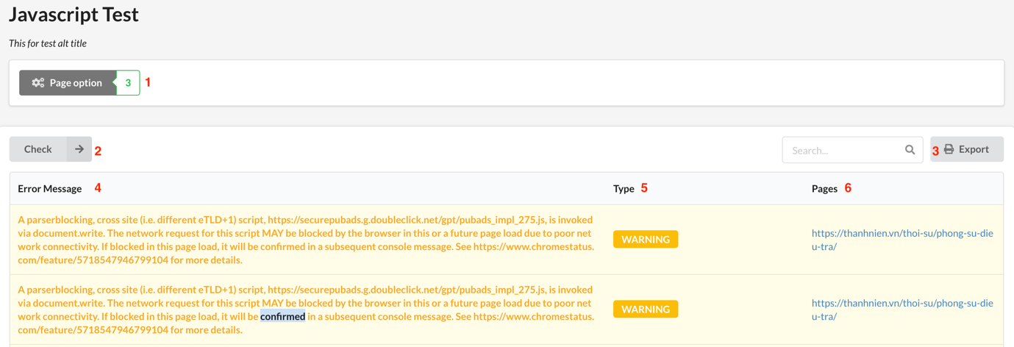

Figure 80 - JavaScript Errors Test

**Fields**

|  |  |  |  |  |  |  |
| --- | --- | --- | --- | --- | --- | --- |
| **No** | **Field Name** | **Description** | **Read only** | **Mandatory** | **Control Type** | **Data Type** |
| 4 | Error Message | Javascript Error’s information | Yes | Yes | Text | String |
| 5 | Type | Error type | Yes | Yes | Text | String |
| 6 | Pages | Page’s url | Yes | Yes | Text | String |

Table 108 <Fields> JavaScript Errors Test

**Buttons/Hyperlinks:**

|  |  |  |  |  |
| --- | --- | --- | --- | --- |
| **No** | **Function** | **Description** | **Validation** | **Outcome** |
| 1 | Page Option | Page option | N/A | Navigate to page option page. |
| 2 | Check | Check | N/A | Reload table |
| 3 | Export | Export excel | N/A | Export to excel |

Table 109 <Buttons/Hyperlinks> JavaScript Errors Test

## Favicon test

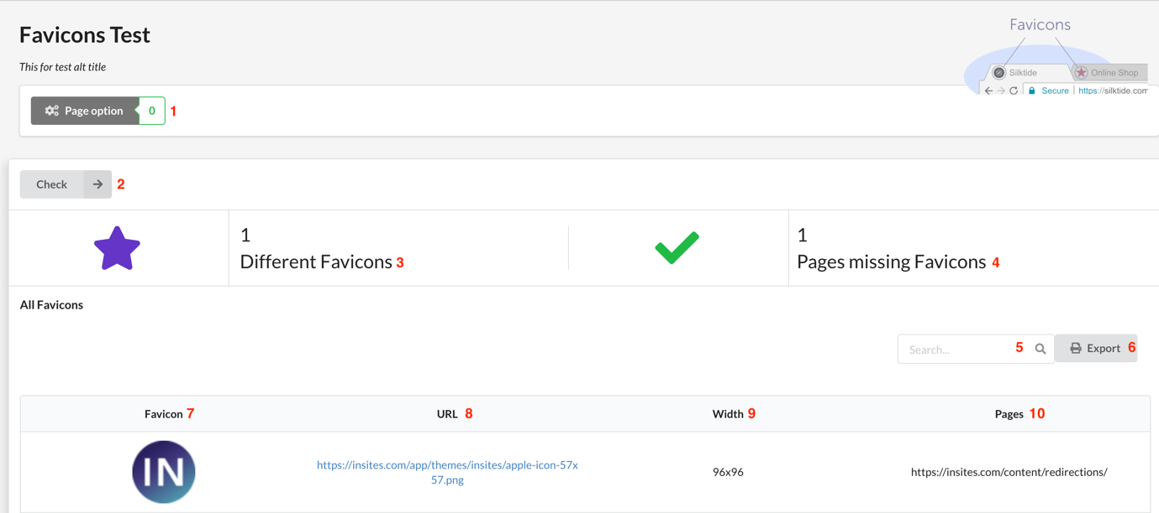

Figure 81 Favicon Test

**Fields**

|  |  |  |  |  |  |  |
| --- | --- | --- | --- | --- | --- | --- |
| **No** | **Field Name** | **Description** | **Read only** | **Mandatory** | **Control Type** | **Data Type** |
| 3 | Number of different favicons | Numbers of different favicons | Yes | Yes | Text | String |
| 4 | Number of pages missing favicons | Number of pages missing favicon | Yes | Yes | Text | String |
| 5 | Search | Search field | No | Yes | TextBox | String |
| 7 | Favicon | Favicon image | Yes | Yes | Text | String |
| 12 | URL | Favicon URL | Yes | Yes | Text | String |
| 13 | Width | Favicon width | Yes | Yes | Text | String |
| 14 | Pages | Pages affected | Yes | Yes | Text | String |

Table 110 <Fields> Favicon Test

**Buttons/Hyperlinks:**

|  |  |  |  |  |
| --- | --- | --- | --- | --- |
| **No** | **Function** | **Description** | **Validation** | **Outcome** |
| 1 | Page Option | Page option | N/A | Navigate to page option page. |
| 2 | Check | Check | N/A | Reload table |
| 6 | Export | Export excel | N/A | Export to excel |

Table 111 <Buttons/Hyperlinks> Favicon Test

## Cookie test

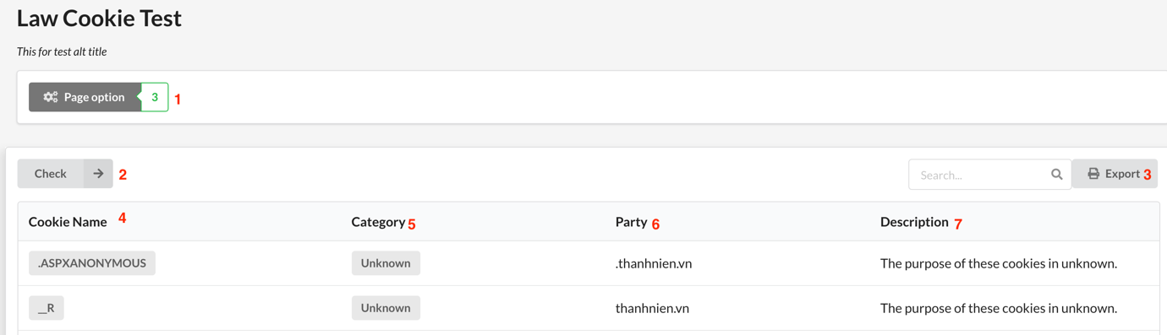

Figure 82 Cookie Test

**Fields**

|  |  |  |  |  |  |  |
| --- | --- | --- | --- | --- | --- | --- |
| **No** | **Field Name** | **Description** | **Read only** | **Mandatory** | **Control Type** | **Data Type** |
| 4 | Cookie name | Cookie name | Yes | Yes | Text | String |
| 5 | Category | Cookie category | Yes | Yes | Text | String |
| 6 | Party | Cookie party | Yes | Yes | Text | String |
| 7 | Description | Cookie description | Yes | Yes | Text | String |

Table 112 <Fields> Cookie Test

**Buttons/Hyperlinks:**

|  |  |  |  |  |
| --- | --- | --- | --- | --- |
| **No** | **Function** | **Description** | **Validation** | **Outcome** |
| 1 | Page Option | Page option | N/A | Navigate to page option page. |
| 2 | Check | Check | N/A | Reload table |
| 3 | Export | Export excel | N/A | Export to excel |

Table 113 <Buttons/Hyperlinks> Cookie Test

## Server behavior test

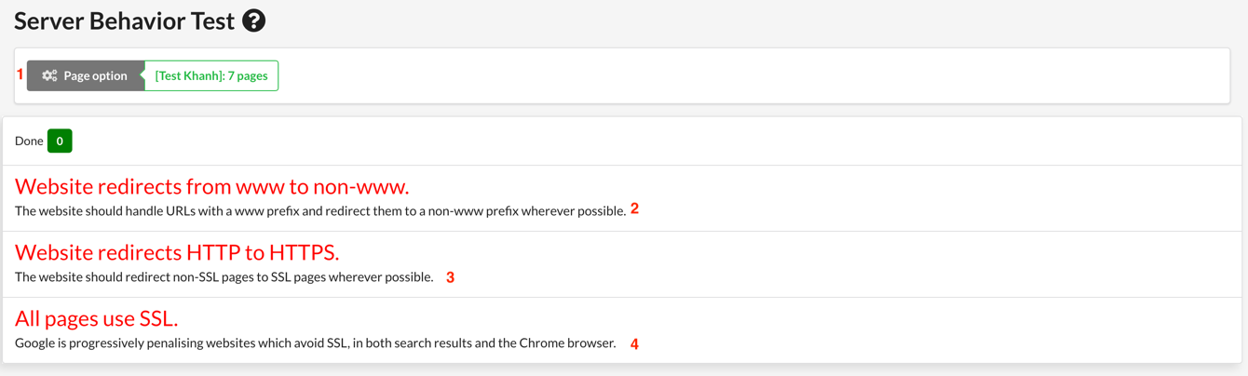

Figure 83 Server Behavior

**Fields**

|  |  |  |  |  |  |  |
| --- | --- | --- | --- | --- | --- | --- |
| **No** | **Field Name** | **Description** | **Read only** | **Mandatory** | **Control Type** | **Data Type** |
| 2 | Website redirects from www to non-www | Website redirects from www to non-www | Yes | Yes | Text | String |
| 3 | Website redirects from HTTP to HTTPS | Website redirects from HTTP to HTTPS | Yes | Yes | Text | String |
| 4 | All page use SSL | All page use SSL | Yes | Yes | Text | String |

Table 114 <Fields> Server Behavior

**Buttons/Hyperlinks:**

|  |  |  |  |  |
| --- | --- | --- | --- | --- |
| **No** | **Function** | **Description** | **Validation** | **Outcome** |
| 1 | Page Option | Page option | N/A | Navigate to page option page. |

Table 115 <Buttons/Hyperlinks> Server Behavior

## Contact detail test

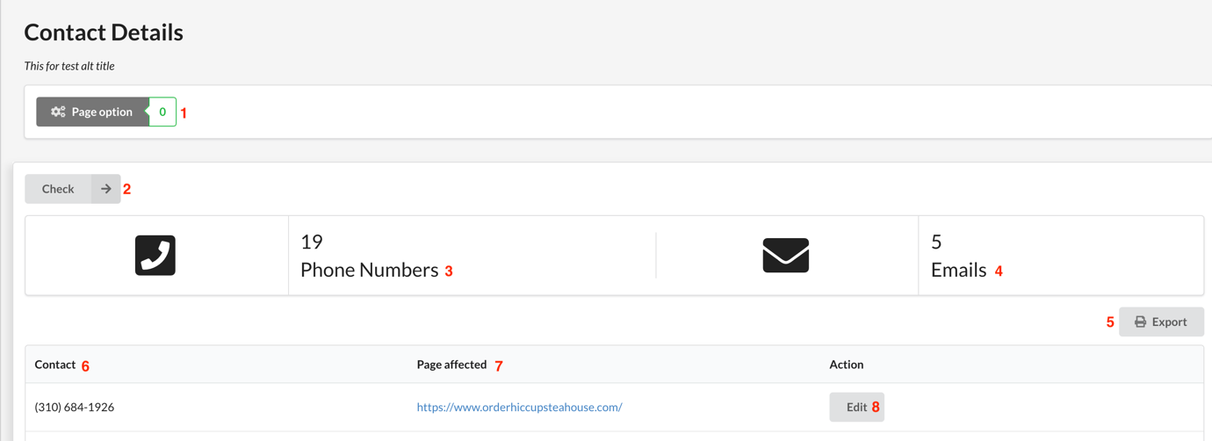

Figure 84 - Contact Details Test

**Fields**

|  |  |  |  |  |  |  |
| --- | --- | --- | --- | --- | --- | --- |
| **No** | **Field Name** | **Description** | **Read only** | **Mandatory** | **Control Type** | **Data Type** |
| 3 | Number of phone numbers | Numbers of phone numbers | Yes | Yes | Text | String |
| 4 | Number of emails | Number of emails | Yes | Yes | Text | String |
| 6 | Contact | Email or phone numbers | Yes | Yes | Text | String |
| 7 | Page affected | Page’s URL affected | Yes | Yes | Text | String |

Table 116 <Fields> Contact Details

**Buttons/Hyperlinks:**

|  |  |  |  |  |
| --- | --- | --- | --- | --- |
| **No** | **Function** | **Description** | **Validation** | **Outcome** |
| 1 | Page Option | Page option | N/A | Navigate to page option page. |
| 2 | Check | Check | N/A | Reload table |
| 5 | Export | Export excel | N/A | Export to excel |
| 8 | Edit | Edit | N/A | Reload table |

Table 117 <Buttons/Hyperlinks> Contact Details Test

## Redrection test

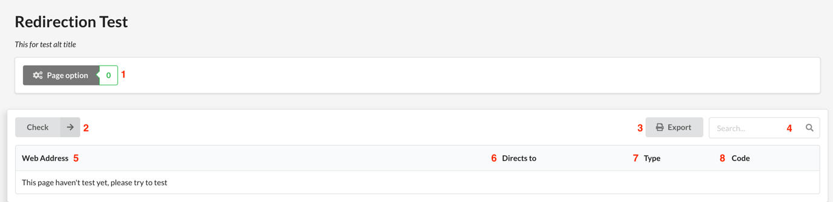

Figure 85 - Redirection Test

**Fields**

|  |  |  |  |  |  |  |
| --- | --- | --- | --- | --- | --- | --- |
| **No** | **Field Name** | **Description** | **Read only** | **Mandatory** | **Control Type** | **Data Type** |
| 4 | Search | Search fields | No | Yes | TextBox | String |
| 5 | Web address | Website address | Yes | Yes | Text | String |
| 6 | Directs to | Direct to URL | Yes | Yes | Text | String |
| 7 | Type | Type redirection | Yes | Yes | Text | String |
| 8 | Code | HTTP code response | Yes | Yes | Text | String |

Table 118 <Fields> Redirection Test

**Buttons/Hyperlinks:**

|  |  |  |  |  |
| --- | --- | --- | --- | --- |
| **No** | **Function** | **Description** | **Validation** | **Outcome** |
| 1 | Page Option | Page option | N/A | Navigate to page option page. |
| 2 | Check | Check | N/A | Reload table |
| 3 | Export | Export excel | N/A | Export to excel |

Table 119 <Buttons/Hyperlinks> Redirection Test

## Page test

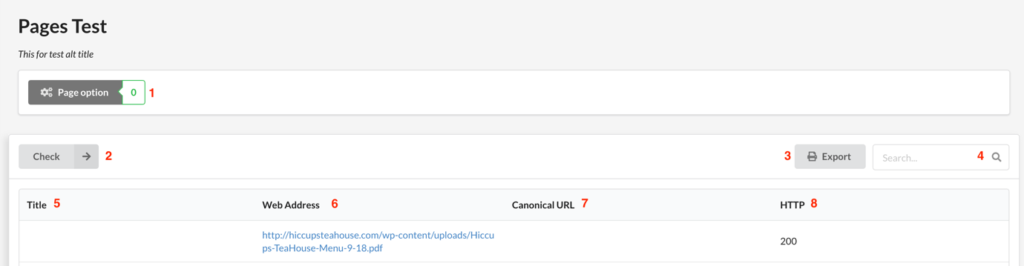

Figure 86 Page Test

**Fields**

|  |  |  |  |  |  |  |
| --- | --- | --- | --- | --- | --- | --- |
| **No** | **Field Name** | **Description** | **Read only** | **Mandatory** | **Control Type** | **Data Type** |
| 4 | Search | Search fields | No | Yes | TextBox | String |
| 5 | Title | Website title | Yes | Yes | Text | String |
| 6 | Web address | Website address | Yes | Yes | Text | String |
| 7 | Canonical URL | Canonical URL | Yes | Yes | Text | String |
| 8 | HTTP | HTTP code response | Yes | Yes | Text | String |

Table 120 <Fields> Page Test

**Buttons/Hyperlinks:**

|  |  |  |  |  |
| --- | --- | --- | --- | --- |
| **No** | **Function** | **Description** | **Validation** | **Outcome** |
| 1 | Page Option | Page option | N/A | Navigate to page option page. |
| 2 | Check | Check | N/A | Reload table |
| 3 | Export | Export excel | N/A | Export to excel |

Table 121 <Buttons/Hyperlinks> Page Test

## Database Design

## Entity relationship diagram (ERD)



Figure 87 Entity Relationship Diagram

## Data Dictionary

|  |  |
| --- | --- |
| Entity Data Dictionary: describe content of all entities | |
| Entity name | Description |
| Account | Contains the account’s information. |
| Role | Contains the role’s information. |
| Sitemap | Contains the sitemap’s information. |
| Version | Show the version of Sitemap. |
| Page | Contains the page’s information. |
| Website | Contains the website’s information. |
| Dictionary | Contains the dictionary’s information. |
| Topic | Contains the topic’s information. |
| WarningWord | Contains the warningWord’s information |
| WarningWordReport | Contains the warningWordReport’s information. |
| SpellingReport | Contains the spellingReport information |
| GrammarReport | Contains the grammarReport’s information. |
| BrokenLinkReport | Contains the brokenLinkReport’s information. |
| BrokenPageReport | Contains the brokenPageReport’s information. |
| MissingFileReport | Contains the missingFileReport information. |
| FaviconReport | Contains the faviconReport’s information. |
| SpeedReport | Contains the speedReport’s information. |
| JavaScriptReport | Contains the javaScriptReport’s information. |
| MobileLayoutReport | Contains the mobileLayoutReport’s information. |
| CookieReport | Contains the cookieReport’s information. |
| ServerBehaviorReport | Contains the serverBehaviorReport’s information. |
| RedirectionReport | Contains the redirectionReport’s information. |
| ContactReport | Contains the contactReport’s information. |
| PageReport | Contains the pageReport s information. |

Table 122 Entity Relationship Diagram Dictionary

|  |  |  |  |  |
| --- | --- | --- | --- | --- |
| Entity Name | Attributes | Description | Domain | Null |
| account | id | Id of account | BIGINT(20) | NO |
| position | Position of account | VARCHAR(255) | NO |
| address | Address of account | VARCHAR(255) | NO |
| fullname | Fullname of account | VARCHAR(255) | NO |
| password | Password of account | VARCHAR(255) | NO |
| username | Username of account | VARCHAR(255) | NO |
| role | id | Role id of account | BIGINT(20) | NO |
| role_name | Role name of account | VARCHAR(255) | NO |
| sitemap | id | Id of site map | BIGINT(20) | NO |
| map | Map of site map | VARCHAR(255) | NO |
| type_map | Type of site map | VARCHAR(255) | NO |
| url_map | Url of site map | VARCHAR(255) | NO |
| version | id | Id of version | BIGINT(20) | NO |
| version | Number of version. | BIGINT(20) | NO |
| time | Time created version | DATETIME | NO |
| page | id | Id of page | BIGINT(20) | NO |
| type | Type of page | BIGINT(20) | NO |
| url | Url of page | VARCHAR(255) | NO |
| website | id | Id of website | BIGINT(20) | NO |
| name | Name of website | VARCHAR(255) | NO |
| url | Url of website | VARCHAR(255) | NO |
| time_register | Time register of website | DATETIME | NO |
| time_modified | Time Modified of website | DATETIME | NO |
| topic | id | Id of topic | BIGINT(20) | NO |
| name | Name of topic | VARCHAR(255) | NO |
| description | Description of topic | VARCHAR(255) | NO |
| warningWord | id | Id of warning word | BIGINT(20) | NO |
| word | Warning word | VARCHAR(255) | NO |
| dictionary | id | Id of dictionary | BIGINT(20) | NO |
| word | Word in dictionary | VARCHAR(255) | NO |
| word_form | Word form of dictionary | VARCHAR(255) | NO |
| definition | Definition of word | VARCHAR(255) | NO |
| warningWordReport | id | Id of warning word report | BIGINT(20) | NO |
| found_word | Word found | VARCHAR(255) | NO |
| appearance_info | Appearance info | VARCHAR(255) | NO |
| solution | Solution | VARCHAR(255) | NO |
| creator | Who create | DATETIME | NO |
| time_created | Time to create | DATETIME | NO |
| spellingReport | id | Id of spelling report | BIGINT(20) | NO |
| found_at | Position found | VARCHAR(255) | NO |
| wrong_word | Wrong word | VARCHAR(255) | NO |
| appearance_info | Appearance info | VARCHAR(255) | NO |
| reason | Reason wrong | VARCHAR(255) | NO |
| solution | Solution | VARCHAR(255) | NO |
| creator | Who create | DATETIME | NO |
| time_created | Time to create | DATETIME | NO |
| grammarReport | id | Id of grammar report | BIGINT(20) | NO |
| excerpt | Excerpt of grammar report | VARCHAR(255) | NO |
| found_at | Where found error | VARCHAR(255) | NO |
| appearanceInfo | Appearance info | VARCHAR(255) | NO |
| reason | Reason wrong | VARCHAR(255) | NO |
| solution | Solution | VARCHAR(255) | NO |
| creator | Who create | DATETIME | NO |
| time_created | Time to create | DATETIME | NO |
| brokenLinkReport | id | Id of broken link report | BIGINT(20) | NO |
| url | url of broken link | VARCHAR(255) | NO |
| issue | Issue of broken link | VARCHAR(255) | NO |
| creator | Who create | DATETIME | NO |
| time_created | Time to create | DATETIME | NO |
| brokenPageReport | id | Id of broken page report | BIGINT(20) | NO |
| url | issue of broken page | VARCHAR(255) | NO |
| issue | Issue of broken page | VARCHAR(255) | NO |
| creator | Who create | DATETIME | NO |
| time_created | Time to create | DATETIME | NO |
| missingFileReport | id | Id of missing file report | BIGINT(20) | NO |
| file_link | Link file error | VARCHAR(255) | NO |
| file_type | Type file error | VARCHAR(255) | NO |
| issue | Issue of file error | VARCHAR(255) | NO |
| creator | Who create | DATETIME | NO |
| time_created | Time to create | DATETIME | NO |
| faviconReport | id | Id of favicon Report | BIGINT(20) | NO |
| favicon_type | Type of favicon | VARCHAR(255) | NO |
| issue | Issue of favicon | VARCHAR(255) | NO |
| creator | Who create | DATETIME | NO |
| time_created | Time to create | DATETIME | NO |
| speedReport | id | Id of speed report | BIGINT(20) | NO |
| load_time | Time to load | VARCHAR(255) | NO |
| interactive_time | Time to interactive | VARCHAR(255) | NO |
| creator | Who create | DATETIME | NO |
| time_created | Time to create | DATETIME | NO |
| JavaScriptReport | id | Id of JavaScript report | BIGINT(20) | NO |
| message | Message error | VARCHAR(255) | NO |
| appearance_info | Appearance info | VARCHAR(255) | NO |
| creator | Who create | DATETIME | NO |
| time_created | Time to create | DATETIME | NO |
| mobileLayoutReport | id | Id of mobile layout report | BIGINT(20) | NO |
| issue | Issue of mobile layout | VARCHAR(255) | NO |
| appearance_info | Appearance info | VARCHAR(255) | NO |
| suggestion | Suggestion for user | VARCHAR(255) | NO |
| creator | Who create | DATETIME | NO |
| time_created | Time to create | DATETIME | NO |
| cookieReport | id | Id of cookie report | BIGINT(20) | NO |
| name | Message content | VARCHAR(255) | NO |
| category | Category of cookie | VARCHAR(255) | NO |
| party_name | Party name of cookie | VARCHAR(255) | NO |
| purpose_discription | Purpose of cookie | VARCHAR(255) | NO |
| legality | Legality of file | VARCHAR(255) | NO |
| creator | Who create | DATETIME | NO |
| time_created | Time to create | DATETIME | NO |
| serverBehaviorReport | Id | Id of server behavior report | BIGINT(20) | NO |
| issue | Issue of server | VARCHAR(255) | NO |
| description | Description server behavior | VARCHAR(255) | NO |
| creator | Who create | DATETIME | NO |
| time_created | Time to create | DATETIME | NO |
| redirectionReport | id | Id of redirection Report | BIGINT(20) | NO |
| url | url of link | VARCHAR(255) | NO |
| redirect_to | url redirect to | VARCHAR(255) | NO |
| http_code | Http code of link | VARCHAR(255) | NO |
| creator | Who create | DATETIME | NO |
| time_created | Time to create | DATETIME | NO |
| contactReport | id | Id of contact report | BIGINT(20) | NO |
| contact_type | Type of contact | VARCHAR(255) | NO |
| appearance_info | Appearance info | VARCHAR(255) | NO |
| creator | Who create | DATETIME | NO |
| time_created | Time to create | DATETIME | NO |
| pageReport | id | Id of page report | BIGINT(20) | NO |
| url | url of page | VARCHAR(255) | NO |
| canonical_url | Canonical url of page | VARCHAR(255) | NO |
| title | Title of page | VARCHAR(255) | NO |
| httpCode | Http code of page | BIGINT(20) | NO |
| creator | Who create | DATETIME | NO |
| time_created | Time to create | DATETIME | NO |

## Algorithms

1. **Sitemap Generator**
   1. **Defininition:**

Enqueue each level of a tree sequentially as the root of any subtree is encountered. There are 2 cases in the iterative algorithm:

* **Root case**: The traversal queue is initially empty so the root node must be added before the general case.
* **General case**: Process any items in the queue, while also expanding their children. Stop if the queue is empty. The general case will halt after processing the bottom level as leaf nodes have no children.

**Input**: the root URL of a website

**Output**: The sitemap.

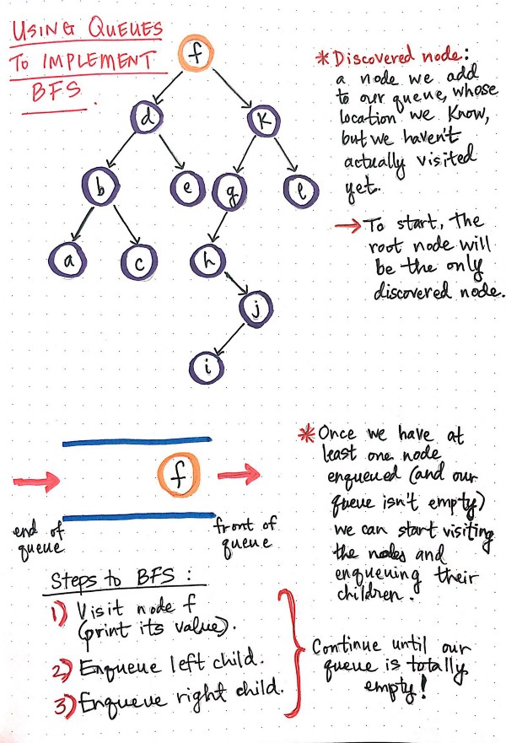****

Figure 88 Define Sitemap

* **Implementation**

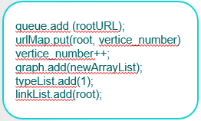

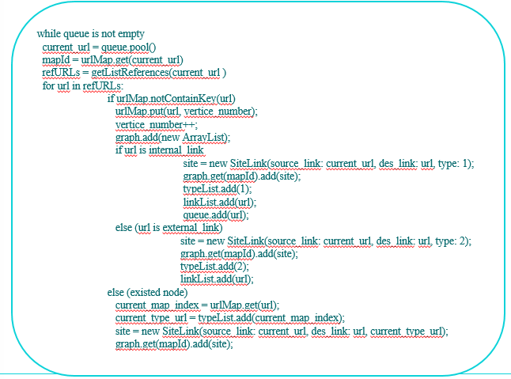

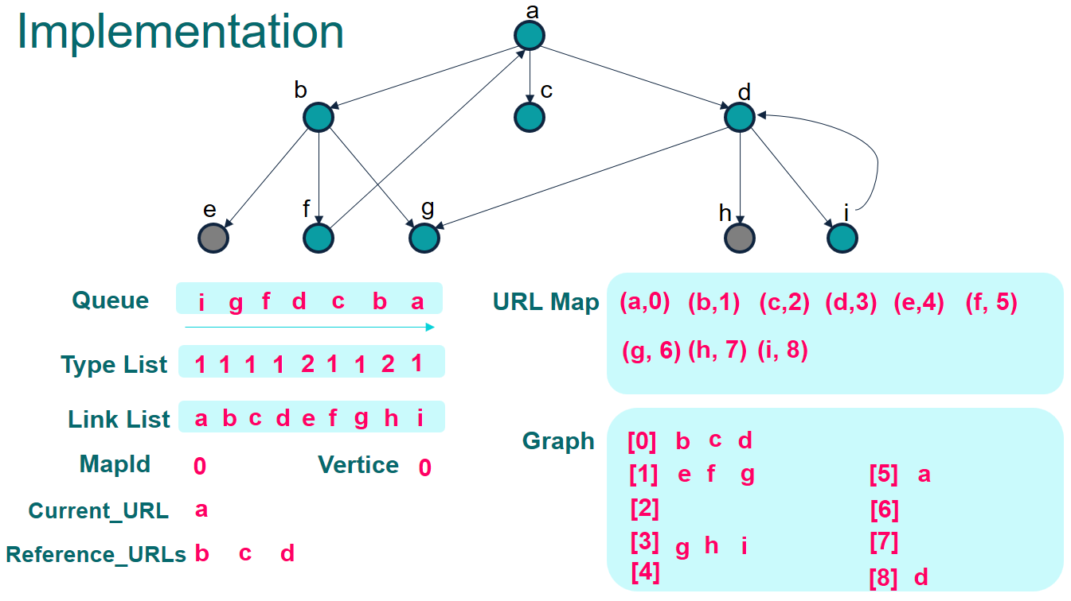

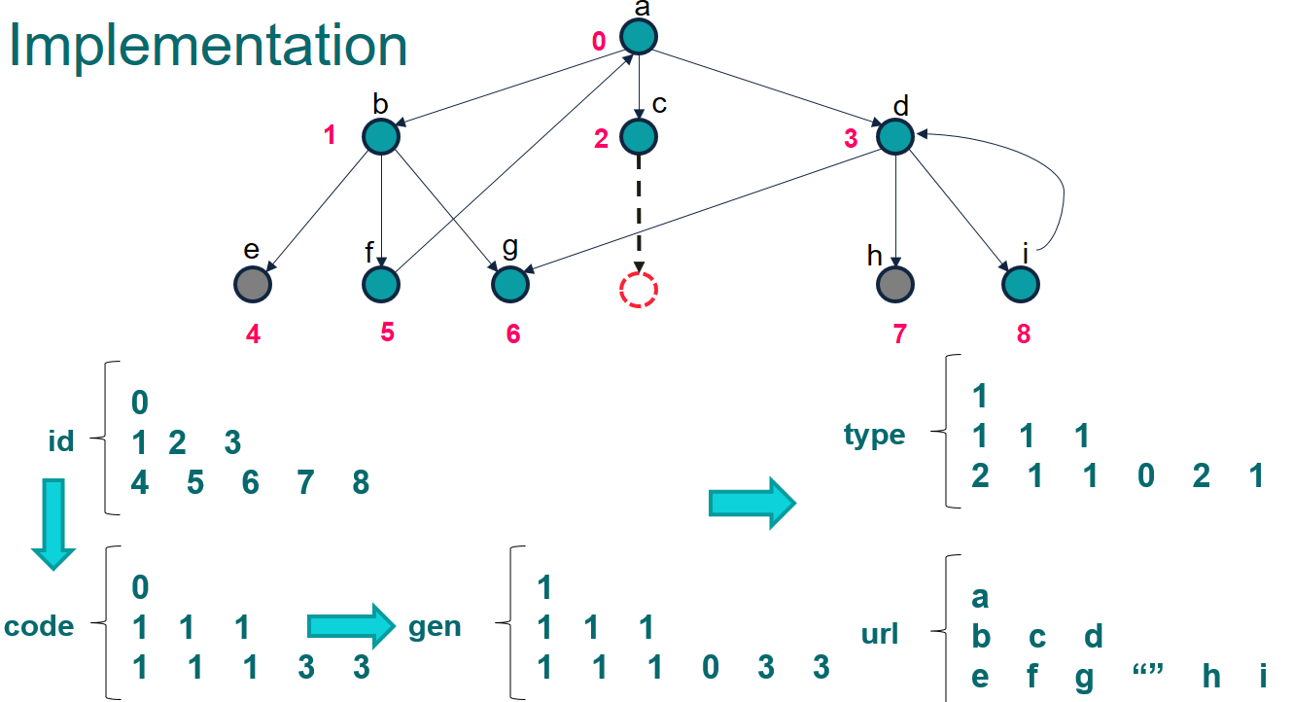

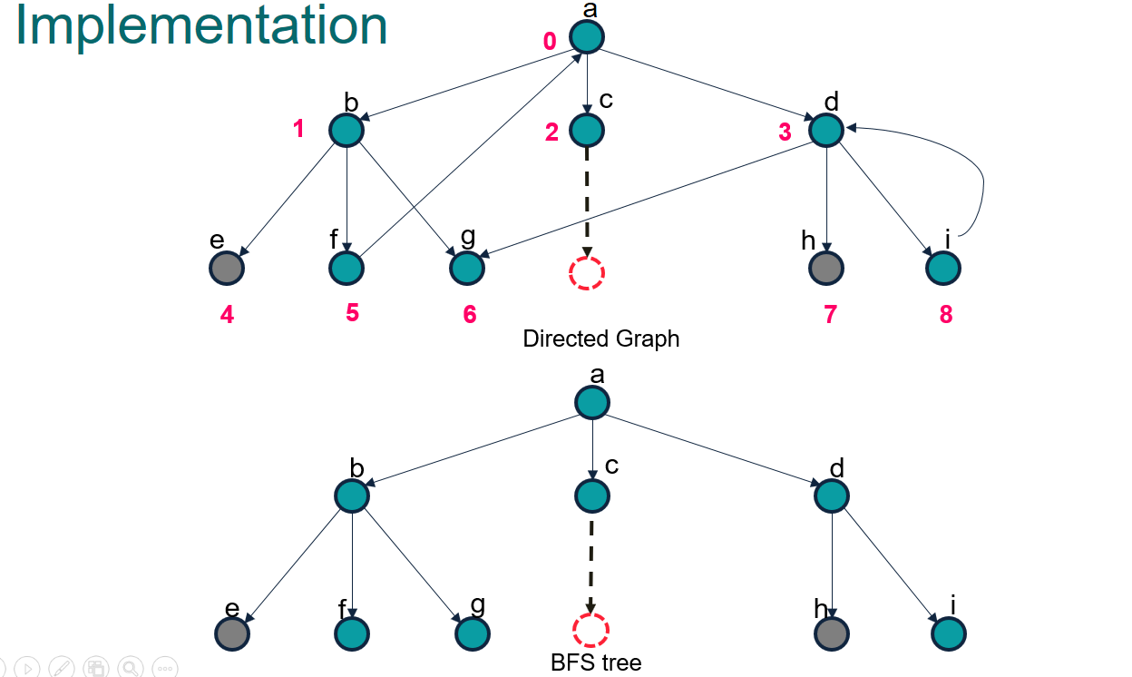

* 1. **Sitemap Structures**
* SiteLink: object with attributes:
  + src: source link
  + des: destination link
  + desType: type of destination link (internal, external)
* HashMap<String, Integer> urlMap: Number URLSs into distinct integers, which is also the vertex index on the graph.
* List<List<SiteLink>> graph: adjacency list
* List<List<SiteLink>> invGraph: adjacency list represents graph with all inverse edges from origin graph.
* List<Integer> urlType: get type of link from vertice index.
* List<String> links: inverse mapping with urlMap, allow get url link from vertice index.
* codeGraph: string encoded of graph to create visual image.

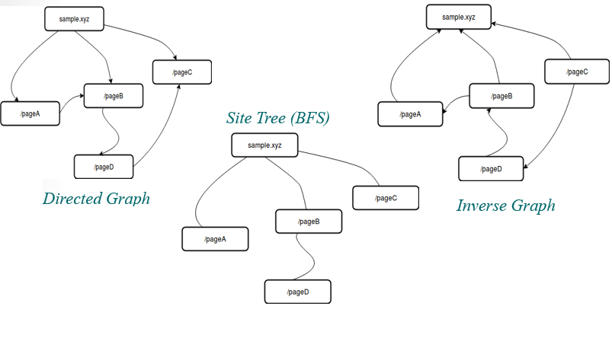**Define some functions**

* CreateEdge(u, v): create edge from u to v and add to graph, also create an inverse edge v to u and store to invGraph.
* getListReferences(url): crawl with url and list all others url links in that page. We could also get more information like urlType.
* getUniqueID(): get new unique integer number.

**Pseudo code for BFS**

1: **function** BFS(rootURL)

2: **Queue q → init empty**

3: urlMap.mark(rootURL) = **getUniqueID**()

4: **while** q is not empty

5: URL = q.pool()

6: refURLs = **getListReferences**(URL)

7: f**or** url **in** refURLs:

8: **createEdge**(URL, urlMap) // create edge of graph

9: **if** urlMap.notContainKey(url)

10: urlMap.mark(url) = **getUniqueID**()

11: q.add (url)

Note:

* The depth of the sitemap-tree is always minimal
* A tree path from one vertex to another is a way to get to the desired link through the link.

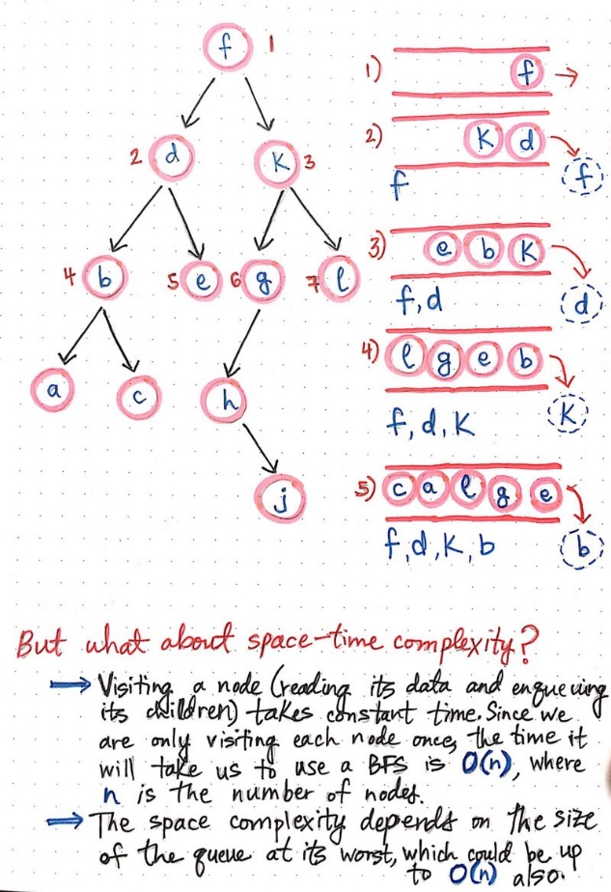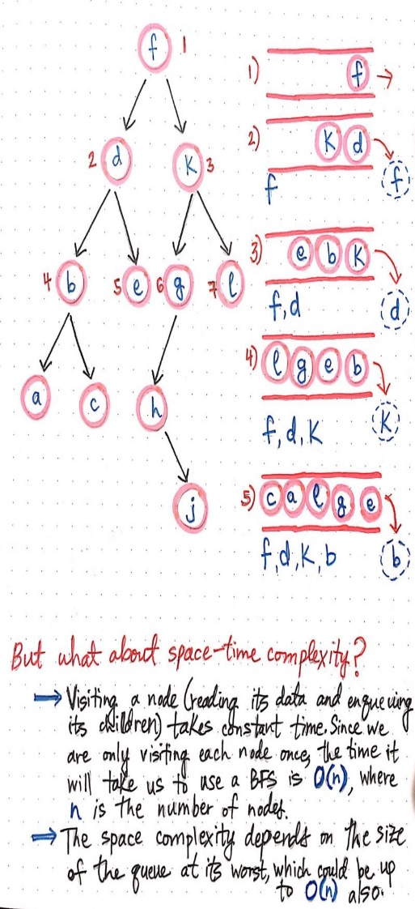

1. **Spelling test**
   1. **Definition Trie Tree**

A **trie** is a tree-like data structure whose nodes store the letters of an alphabet. By structuring the nodes in a particular way, words and strings can be retrieved from the structure by traversing down a branch path of the tree.

We know that tries are often used to represent words in an alphabet. In the illustration shown here, we can start to get a sense of how exactly that representation works.

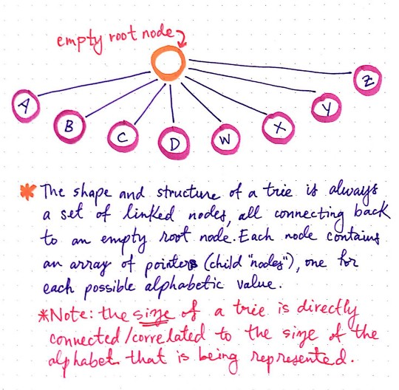

Figure 89 Trie Tree

Each trie has an empty root node, with links (or references) to other nodes — one for each possible alphabetic value.

The shape and the structure of a trie is always a set of linked nodes, connecting back to an empty root node. An important thing to note is that the number of child nodes in a trie depends completely upon the total number of values possible. For example, if we are representing the English alphabet, then the total number of child nodes is directly connected to the total number of letters possible. In the English alphabet, there are 26 letters, so the total number of child nodes will be 26.

* 1. **Structures of Trie node**

- isLeaf: determine true if the path from root to current node could build a correct word in dictionary.

- eWeight: the frequently of failure when user type wrong.

- refNode: List of reference link to another Trie Node, normally, Trie Node has 26 reference links corresponding to 'a' --> 'z', we can extend the number of reference link if the collection of character has larger.

A single node in a trie contains just two things:

1. A value, which might be null
2. An array of references to child nodes, all of which also might be null

Each node in a trie, including the root node itself, has only these two aspects to it. When a trie representing the English language is created, it consists of a single root node, whose value is usually set to an empty string: "".

That root node will also have an array that contains 26 references, all of which will point to null at first. As the trie grows, those pointers start to get filled up with references to other nodes nodes.

The way that those pointers or references are represented is particularly interesting. We know that each node contains an array of references/links to other nodes. What’s cool about this is that we can use the array’s indexes to find specific references to nodes. For example, our root node will hold an array of indexes 0 through 25, since there are 26 possible slots for the 26 letters of the alphabet. Since the alphabet is in order, we know that the reference to the node that will contain the letter A will live at index 0.

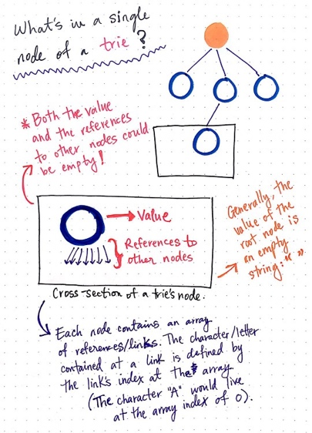

Figure 90 Structure Trie Tree

Looking at our trie, we can see that we have an empty root node, as is typical for a trie structure. We also have six different words that we’re representing in this trie: Peter, piper, picked, peck, pickled, and peppers.

To make this trie easier to look at, I’ve only drawn the references that actually have nodes in them; it’s important to remember that, even though they’re not illustrated here, every single node has 26 references to possible child nodes.

Notice how there are six different “branches” to this trie, one for each word that’s being represented. We can also see that some words are sharing parent nodes. For example, all of the branches for the words Peter, peck, and peppers share the nodes for p and for e. Similarly, the path to the word picked and pickled share the nodes p, i, c, and k.

So, what if we wanted to add the word pecked to this list of words represented by this trie? We’d need to do two things in order to make this happen:

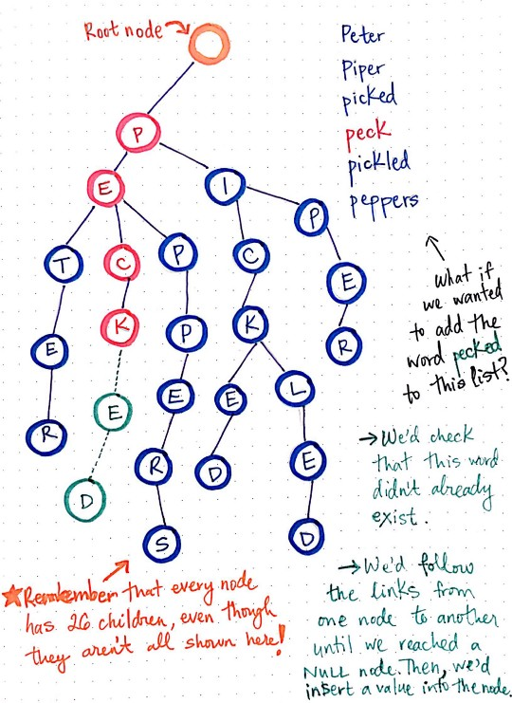

First, we’d need to check that the word pecked doesn’t already exist in this trie.

Next, if we’ve traversed down the branch where this word ought to live and the words doesn’t exist yet, we’d insert a value into the node’s reference where the word should go. In this case, we’d insert e and d at the correct references.

But how do we actually go about checking if the word exists? And how do we insert the letters into their correct places?

* **Idea of inserting method:** go through each character of word, check if has reference link correspond with this character. If not, we make new reference link. If the link has, just follow the path. Finally, mark the current node as a Leaf - that mean path from root to this node form correct word in dictionary.

**Pseudo code for Insert word to Trie Tree**

1: **function** mapPosition(char letter)

2: **return** (letter - 'a')

3:

4: **function** insertWord(String word)

5: Node currentNode = root

6: **for each** char w **of** word:

7: position = mapPosition(w)

8: **if** currentNode.getRefNode(position) = null **then**

9: currentNode.setRefNode(position, new Node())

10: currentNode = currentNode.getRefNode(position)

11: currentNode.isLeaf = True

* **Idea id searching on Trie Tree:** The method is quite same the insert method but when we check in some Trie Node if doesn't contain reference link, just return with False result. If could find the path, check if this Trie Node is Leaf.

**Pseudo code for Search word in Trie Tree**

1: **function** searchWord(String word)

2: Node currentNode = root

3: **for each** char w **of** word:

4: position = mapPosition(w)

5: **if** currentNode.getRefNode( position) = null **then**

6: **return** False

7: currentNode = currentNode.getRefNode(position)

8: **return** currentNode.isLeaf

* 1. **Spelling generator using recursion**

We come up with the smallest case: wrong one letter.

That mean, if the needed check word has wrong one letter (missing, redundant, difference), the system will provide some suggestion words in dictionary.

Normal method is “brute force”, we can generate all cases of a word could be, by adding one letter to word: happ → happ + y, by changing one word: ha**p**p → ha**r**p, or remove one letter: ha**p**p → hap.

We make generator use recursion:

Let function **Generator** (word, position, currentGenWord, changed) is a state when we generate word with:

* word: the word we need to generate to all posible
* position: we stand at word.charAt(position), if position > word.length the method terminate.
* currentGenWord: current word that we are constructing, when postion reach the end of word, then currentGenWord is finished made.
* changed: the flag to verify that if currentGenWord is differ one letter with original word.

Transform state:

* if **changed** = False:
  + - We couldn’t make any change to origin **word**, so just add:
    - currentGenWord → currentGenWord + word.charAt(position)
    - position → position + 1
* if **changed** = True:
  + We could do nothing one word, it’s same case above when **changed** is False. The difference that **changed** still get True.
  + We could remove current letter by just increase **position** and go the another state:
    - position → position + 1
    - changed → False
  + We could add one letter to current **position** and make no change **position**:
    - currentGenWord → currentGenWord + (any char from ‘a’ to ‘z’)
    - changed → False
* We could change current letter:
  + - curretnGenWord → currentGenWord + replaceOther(word.charAt(position) )
    - changed → False

Finally, we get the generator for wrong one letter. We could improve the method to flexible extend by changing the flag **changed** from boolean value to int value with mean, the remain of change we could make on origin **word**. Then if we check wrong for two or three letters, just pass the param **changed** = 2 or 3 when call the recursion.

After have generator, we combine with any searching method, we could make a list of suggestion words. Currently, we compare the speed with two searches method:

* Linear Search
* Trie Tree Search

The Trie Tree Search’s speed dominate of Linear Search, faster than about 150 times with 10 input words. Because the time to search one word in Trie Tree equal length of input word when we have to iterator all words in dictionary if using Linear Search.

But, we still could improve method better by combine Trie Tree Search on recursion generator: we keep a Trie Node go follow with recursion. We can terminate if it current Trie Node is null.

The recursion method now look like: **Generator** (word, position, currentGenWord, changed, currentTrieNode).

**Pseudo code for Generator combine Trie Tree search**

1: **function** Generator(word, position, currentGenWord, changed, currentTrieNode)

2: **if** currentTrieNode = null **return** // terminate condition

3: **if** position > word.length **return** // terminate condition

4: **for** all **of** possible states:

**Generator** (word, new position, new currentGenWord, new changed, new TrieNode)

Note that: new TrieNode could get simple by follow the modify letter: if we add letter ‘a’, the new TrieNode will equal link from current Trie Node to refNode.get(‘a’).

The method after optimizing is quite fast than normal search. We could see that the method will stop when could not found on tree that prevent to generate all cases that wasted a lot of time.

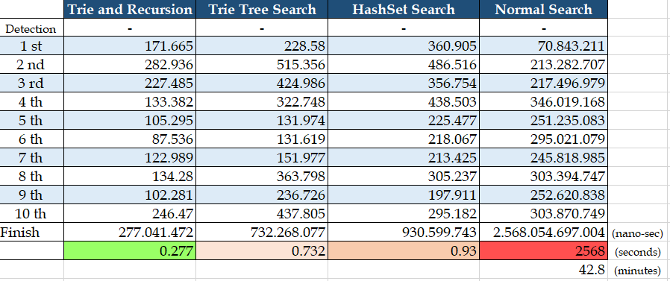

# System Implementation & Test

## Introduction

* 1. **Overview**

This section describes approach and methodologies used by our team to plan, organize and manage testing process of WCS.

It provides all necessary information about implementation and testing procedure of the system including test plans, test cases, test results and pass/fail criteria as well as testing flow to cover all possible cases.

* 1. **Test Approach**
* **Goal:** Test main features in the whole WCS based on core flow
* **Method:** Black-box testing

## Data Relationship Diagram

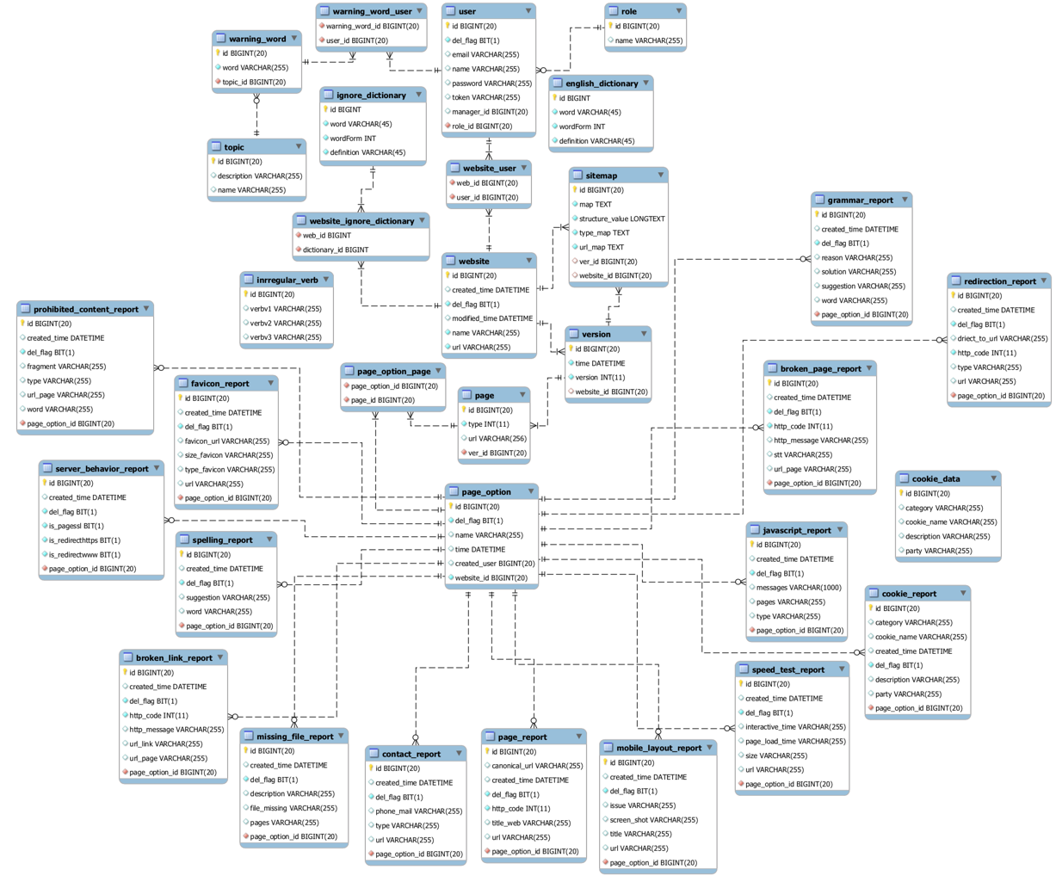

Figure 91 Physical Diagram

|  |  |  |
| --- | --- | --- |
| **Entity Data Dictionary: Describe content of all tables** | | |
| **No.** | **Table Name** | **Description** |
| 1 | user | Contain account information. |
| 2 | roles | Contain role information. |
| 3 | website | Contain website information. |
| 4 | website_user | Contain information about relationship between a user with a website. |
| 5 | sitemap | Contain sitemap information. |
| 6 | version | Contain version information. |
| 7 | page | Contain page information. |
| 8 | page_option | Contain page option information. |
| 9 | page_option_page | Contain information about relationship between a page with a page option |
| 10 | warning_word | Contain warning word information. |
| 11 | warning_word_user | Contain information about relationship between a user with a warning word. |
| 12 | topic | Contain topic information. |
| 13 | spelling_report | Contain spelling test report information. |
| 14 | speed_test_report | Contain speed test report information. |
| 15 | server_behavior_report | Contain server behavior report information. |
| 16 | cookie_report | Contain cookie report information. |
| 17 | broken_link_report | Contain broken link test report information. |
| 18 | missing_file_report | Contain missing file report information. |
| 19 | javascript_report | Contain javascript report information. |
| 20 | prohibited_content_report | Contain prohibited content report information. |
| 21 | mobile_layout_report | Contain mobile layout report information. |
| 22 | broken_page_report | Contain broken page report information. |
| 23 | page_report | Contain page report information. |
| 24 | redirection_report | Contain redirection report information. |
| 25 | favicon_report | Contain favicon report information. |
| 26 | grammar report | Contain grammar report information. |
| 27 | contact_report | Contain contact report information. |

Table 123 Physical Diagram Dictionary

## Test Plan

The overall purpose of testing is to ensure WCS meets its entire technical, functional and business requirement. The purpose of this document is to describe the test plan and strategy for testing the WCS. The following part will describe which features to be tested and which will not.

## Features To Be Tested

* Staff:
* Manage page option
* Spelling test
* Grammar test
* Broken links test
* Broken pages test
* Missing files test
* Prohibited content test
* Mobile layout test
* Speed test
* JavaScript errors test
* Favicons test
* Cookie law test
* Server behavior test
* Pages test
* Contact details test
* Redirections test

## Features Not To Be Tested

* Guest: Login, sign up.
* Manager:
* Manage Staff
* Manage Website
* Manager word list

## System Testing Test Case

***4.1 Staff Test Case  
 4.1.1 Manage page option***

|  |  |  |  |  |  |  |  |
| --- | --- | --- | --- | --- | --- | --- | --- |
| ID | Test Case Description | Test case procedure | Expected output | *Inter Dependence -test Case* | Result | Test Date | Note |
| *MPO_1* | Staff create a page option with blank name. | 1. Staff click “+” button.  2. Staff input blank.  3. Staff send create page option. | System shows error message “Please input something”. | N/A | Pass | 26/11/2018 |  |
| *MPO_2* | Staff delete a page option. | 1. Staff double click to page option name  2. Staff send delete page option. | Page option will be deleted. | N/A | Pass | 26/11/2018 |  |
| *MPO_3* | Staff select pages for page option. | 1. Staff click Toggle to select or unselect page for page option.  2. Staff send select pages for page option. | Page option include pages selected will be created. | N/A | Pass | 26/11/2018 |  |

Table 124 <Test case> Manage Page Option

***4.1.2 Broken links test***

|  |  |  |  |  |  |  |  |
| --- | --- | --- | --- | --- | --- | --- | --- |
| ID | Test Case Description | Test case procedure | Expected output | *Inter Dependence -test Case* | Result | Test Date | Note |
| *BLT_1* | Staff send broken links test command with page option unselected. | 1. Staff click “Check” button. | System return test result with information: “Page”, “Broken Link”, “Issue” of root page. | N/A | Pass | 26/11/2018 |  |
| *BLT_2* | Staff send broken links test command with page option selected. | 1. Staff select page option.  2. Staff click “Check” button. | System return test result with information: “Page”, “Broken Link”, “Issue” of all page in page option. | N/A | Pass | 26/11/2018 |  |

Table 125<Test case> Broken Links Test

***4.1.3 Broken pages test***

|  |  |  |  |  |  |  |  |
| --- | --- | --- | --- | --- | --- | --- | --- |
| ID | Test Case Description | Test case procedure | Expected output | *Inter Dependence -test Case* | Result | Test Date | Note |
| *BPT_1* | Staff send broken pages test command with page option unselected. | 1. Staff click “Check” button. | System return test result with information: “Page”, “Status”, “Issue” of root page. | N/A | Pass | 26/11/2018 |  |
| *BPT_2* | Staff send broken pages test command with page option selected. | 1. Staff select page option.  2. Staff click “Check” button. | System return test result with information: “Page”, “Status”, “Issue” of all page in page option. | N/A | Pass | 26/11/2018 |  |

Table 126 <Test case> Broken Pages Test

***4.1.4 Prohibited content test***

|  |  |  |  |  |  |  |  |
| --- | --- | --- | --- | --- | --- | --- | --- |
| ID | Test Case Description | Test case procedure | Expected output | *Inter Dependence -test Case* | Result | Test Date | Note |
| *PCT_1* | Staff send prohibited content test command with page option unselected. | 1. Staff click “Check” button. | System return test result with information: “Word”, “Type”, “Fragment” and “URL” of root page. | N/A | Pass | 26/11/2018 |  |
| *PCT_2* | Staff send prohibited content test command with page option selected. | 1. Staff select page option.  2. Staff click “Check” button. | System return test result with information: “Word”, “Type”, “Fragment”, “URL” of all page in page option. | N/A | Pass | 26/11/2018 |  |

Table 127 <Test case> Prohibited Content Test

***4.1.5 Mobile layout test***

|  |  |  |  |  |  |  |  |
| --- | --- | --- | --- | --- | --- | --- | --- |
| ID | Test Case Description | Test case procedure | Expected output | *Inter Dependence -test Case* | Result | Test Date | Note |
| *MLT_1* | Staff send mobile layout test command with page option unselected. | 1. Staff click “Check” button. | System return test result with information: “Screenshot”, “Page”, “Issue” of root page. | N/A | Pass | 26/11/2018 |  |
| *MLT_2* | Staff send mobile layout test command with page option selected. | 1. Staff select page option.  2. Staff click “Check” button. | System return test result with information: “Screenshot”, “Page”, “Issue” of all page in page option. | N/A | Pass | 26/11/2018 |  |

Table 128 <Test case> Mobile Layout Test

***4.1.6 Speed test***

|  |  |  |  |  |  |  |  |
| --- | --- | --- | --- | --- | --- | --- | --- |
| ID | Test Case Description | Test case procedure | Expected output | *Inter Dependence -test Case* | Result | Test Date | Note |
| *ST_1* | Staff send speed test command with page option unselected. | 1. Staff click “Check” button. | System return test result with information: “Page”, “Interactive time”, “Load time”, “Size” of root page. | N/A | Pass | 26/11/2018 |  |
| *ST_2* | Staff send speed test command with page option selected. | 1. Staff select page option.  2. Staff click “Check” button. | System return test result with information: “Page”, “Interactive time”, “Load time”, “Size” of all page in page option. | N/A | Pass | 26/11/2018 |  |

Table 129 <Test case> Speed Test

***4.1.7 JavaScript test***

|  |  |  |  |  |  |  |  |
| --- | --- | --- | --- | --- | --- | --- | --- |
| ID | Test Case Description | Test case procedure | Expected output | *Inter Dependence -test Case* | Result | Test Date | Note |
| *JST_1* | Staff send JavaScript test command with page option unselected. | 1. Staff click “Check” button. | System return test result with information: “Error message”, “Type”, “Page” of root page. | N/A | Pass | 26/11/2018 |  |
| *JST_2* | Staff send JavaScript test command with page option selected. | 1. Staff select page option.  2. Staff click “Check” button. | System return test result with information: “Error message”, “Type”, “Page” of all page in page option. | N/A | Pass | 26/11/2018 |  |

Table 130 <Test case> Javascript Errors Test

***4.1.8 Cookie law test***

|  |  |  |  |  |  |  |  |
| --- | --- | --- | --- | --- | --- | --- | --- |
| ID | Test Case Description | Test case procedure | Expected output | *Inter Dependence -test Case* | Result | Test Date | Note |
| *CLT_1* | Staff send cookie law test command with page option unselected. | 1. Staff click “Check” button. | System return test result with information: “Name”, “Category”, “Party” and “Description” of root page. | N/A | Pass | 26/11/2018 |  |
| *CLT_2* | Staff send cookie law test command with page option selected. | 1. Staff select page option.  2. Staff click “Check” button. | System return test result with information: “Name”, “Category”, “Party”, “Description” of all page in page option. | N/A | Pass | 26/11/2018 |  |

Table 131 <Test case> Cookie Law Test

***4.1.9 Server behavior test***

|  |  |  |  |  |  |  |  |
| --- | --- | --- | --- | --- | --- | --- | --- |
| ID | Test Case Description | Test case procedure | Expected output | *Inter Dependence -test Case* | Result | Test Date | Note |
| *SBT_1* | Staff send server behavior test command with page option unselected. | 1. Staff click “Check” button. | System return test result of root page. | N/A | Pass | 26/11/2018 |  |
| *SBT_2* | Staff send server behavior test command with page option selected. | 1. Staff select page option.  2. Staff click “Check” button. | System return test result of all page in page option. | N/A | Pass | 26/11/2018 |  |

Table 132 <Test case> Server Behavior Test

***4.1.10 Missing File test***

|  |  |  |  |  |  |  |  |
| --- | --- | --- | --- | --- | --- | --- | --- |
| ID | Test Case Description | Test case procedure | Expected output | *Inter Dependence -test Case* | Result | Test Date | Note |
| *MFT_1* | Staff send missing file test command with page option unselected. | 1. Staff click “Check” button. | System return test result with information: “Files”, “Description”, “Pages” and “Action” of root page. | N/A | Pass | 26/11/2018 |  |
| *MFT_2* | Staff send missing file test command with page option selected. | 1. Staff select page option.  2. Staff click “Check” button. | System return test result with information: “Files”, “Description”, “Pages” and “Action” of all page in page option. | N/A | Pass | 26/11/2018 |  |
| *MFT_3* | Staff send missing file test command with page option unselected and select specific type to test. | 1. Staff select type to test.  2. Staff click “Check” button. | System return test result with information: “Files”, “Description”, “Pages” and “Action” of root page and type selected. | N/A | Pass | 26/11/2018 |  |
| *MFT_3* | Staff send missing file test command with page option selected and select specific type to test. | 1. Staff select page option.  2. Staff select type to test.  3. Staff click “Check” button | System return test result with information: “Files”, “Description”, “Pages” and “Action” of all page in page option and type selected. | N/A | Pass | 26/11/2018 |  |

Table 133 <Test case> Missing File Test

***4.1.11 Favicons test***

|  |  |  |  |  |  |  |  |
| --- | --- | --- | --- | --- | --- | --- | --- |
| ID | Test Case Description | Test case procedure | Expected output | *Inter Dependence -test Case* | Result | Test Date | Note |
| *CLT_1* | Staff send favicons test command with page option unselected. | 1. Staff click “Check” button. | System return test result with information: “Favicon”, “URL”, “Width”, “Type” and “Pages” of root page. | N/A | Pass | 26/11/2018 |  |
| *CLT_2* | Staff send favicons test command with page option selected. | 1. Staff select page option.  2. Staff click “Check” button. | System return test result with information: “Favicon”, “URL”, “Width”, “Type” and “Pages” of all page in page option. | N/A | Pass | 26/11/2018 |  |

Table 134 <Test case> Favicon Test

***4.1.12 Contact Details test***

|  |  |  |  |  |  |  |  |
| --- | --- | --- | --- | --- | --- | --- | --- |
| ID | Test Case Description | Test case procedure | Expected output | *Inter Dependence -test Case* | Result | Test Date | Note |
| *CDT_1* | Staff send contact details test command with page option unselected. | 1. Staff click “Check” button. | System return test result with information: “Contact”, “Page affected” and “Action” of root page. | N/A | Pass | 26/11/2018 |  |
| *CDT_2* | Staff send contact details test command with page option selected. | 1. Staff select page option.  2. Staff click “Check” button. | System return test result with information: “Contact”, “Page affected” and “Action” of all page in page option. | N/A | Pass | 26/11/2018 |  |

Table 135 <Test case> Contact Details Test

***4.1.14 Redirection test***

|  |  |  |  |  |  |  |  |
| --- | --- | --- | --- | --- | --- | --- | --- |
| ID | Test Case Description | Test case procedure | Expected output | *Inter Dependence -test Case* | Result | Test Date | Note |
| *RET_1* | Staff send redirection test command with page option unselected. | 1. Staff click “Check” button. | System return test result with information: “Web Address”, “Directs to”, “Type” and “Code” of root page. | N/A | Pass | 26/11/2018 |  |
| *RET_2* | Staff send redirection test command with page option selected. | 1. Staff select page option.  2. Staff click “Check” button. | System return test result with information: “Web Address”, “Directs to”, “Type” and “Code” of all page in page option. | N/A | Pass | 26/11/2018 |  |

Table 136 <Test case> Redirection Test

***4.1.14 Pages test***

|  |  |  |  |  |  |  |  |
| --- | --- | --- | --- | --- | --- | --- | --- |
| ID | Test Case Description | Test case procedure | Expected output | *Inter Dependence -test Case* | Result | Test Date | Note |
| *CDT_1* | Staff send pages test command with page option unselected. | 1. Staff click “Check” button. | System return test result with information: “Title”, “Web Address”, “Canonical URL” and “HTTP” of root page. | N/A | Pass | 26/11/2018 |  |
| *CDT_2* | Staff send pages test command with page option selected. | 1. Staff select page option.  2. Staff click “Check” button. | System return test result with information: “Title”, “Web Address”, “Canonical URL” and “HTTP” of all page in page option. | N/A | Pass | 26/11/2018 |  |

Table 137 <Test case> Pages Test

***4.1.15 Spelling test***

|  |  |  |  |  |  |  |  |
| --- | --- | --- | --- | --- | --- | --- | --- |
| ID | Test Case Description | Test case procedure | Expected output | *Inter Dependence -test Case* | Result | Test Date | Note |
| *SPT_1* | Staff send spelling test command with page option unselected. | 1. Staff click “Check” button. | System return test result with information: “Word”, “Suggestions”, “Found in”, “Page” and “Action” of root page. | N/A |  |  |  |
| *SPT_2* | Staff send spelling test command with page option selected. | 1. Staff select page option.  2. Staff click “Check” button. | System return test result with information: “Word”, “Suggestions”, “Found in”, “Page” and “Action” of all page in page option. | N/A |  |  |  |

Table 138 <Test case> Spelling Test

***4.1.16 Grammar test***

|  |  |  |  |  |  |  |  |
| --- | --- | --- | --- | --- | --- | --- | --- |
| ID | Test Case Description | Test case procedure | Expected output | *Inter Dependence -test Case* | Result | Test Date | Note |
| *GRT_1* | Staff send grammar test command with page option unselected. | 1. Staff click “Check” button. | System return test result with information: “Excerpt”, “Issue”, and “Action” of root page. | N/A |  |  |  |
| *GRT_2* | Staff send grammar test command with page option selected. | 1. Staff select page option.  2. Staff click “Check” button. | System return test result with information: “Excerpt”, “Issue”, and “Action” of all page in page option. | N/A |  |  |  |

Table 139 <Test case> Grammar Test

# Software User’s Manual

1. **Installation Guide**
   1. **Setting up enviroment at server side**
      1. **Hardware requirements**

|  |  |  |
| --- | --- | --- |
| **Server** | **Minimum Requirements** | **Recommended** |
| **Internet Connection** | Cable, Wi-Fi (8 Mbps) | Cable, Wi-Fi (50 Mbps or more) |
| **Operating System** | XP, Vista, 7, 10, Window Server 2008 | 10, Window Server 2008 |
| **Computer Processor** | Intel® Xeon ® 1.4GHz | Intel® Xeon ® Quad Core (12M Cache, 2.50 GHz) |
| **Computer Memory** | 4GB RAM | 32GB or more |
| **Storage space** | 1GB | 5GB or more |

Table 140 - Hardware requirement for server

* + 1. **Software requirements**

|  |  |  |
| --- | --- | --- |
| **Name** | **Name/Version** | **Description** |
| **Environment** | Java EE 8.0,Node v10,npm v6 | Specification for developing web application |
| **Operating System** | Window 10 | Operating system and platform for development |
| **Modeling tool** | StarUML | Used to design diagram |
| **IDE** | IntelliJ IDEA 2018.1.5, Visual Studio Code 1.27.2 | Programming tools |
| **DBMS** | MySQL 8.0 | Used to create & manage the database for system |
| **Web server** | Apache Tomcat 8 | Deployment environment |
| **Web browser** | Chrome 69 or above. | Testing browser |

Table 141 - Software requirement for server

* 1. **Deployment at server side**

**1.2.1 Prepare deployement package**

**Step 1:** Download and Install Java 8

Link download: <http://www.oracle.com/technetwork/java/javase/downloads/java-archive-javase8-2177648.html>

**Step 2:** Download and setup Tomcat 8

Link download: <https://tomcat.apache.org/download-80.cgi>

**Step 3:** Download and Install Node v10

Link download: https://nodejs.org/en/download/

**Step 4:** Download and Install IntelliJ IDE

Link download: <https://www.jetbrains.com/idea/download/#section=windows>

**Step 5:** Download, Install and configure MySQL 8.0

Link download: <https://dev.mysql.com/downloads/installer/>

**1.2.2 Configure server before deploy**

Step 1: Go to %Tomcat folder%\conf\

Step 2: Edit port to 8080 in server.xml at

<Connector port="8080" protocol="HTTP/1.1"

connectionTimeout="20000"

redirectPort="8443" />

Step 3: Delete all files and folders in %Tomcat folder%\webapps

Step 4: Rename production java build to ROOT.WAR and copy to

%Tomcat folder%\webapps.

* 1. **Setting up enviroment at client side**

The client devices should have one of the following browsers to access the website:

* + - Google Chrome

Link download: <https://www.google.com/chrome/>

* + - Firefox

Link download: <https://www.mozilla.org/vi/firefox/channel/desktop/>

**2. User Guide**

**2.1 Manager**

**2.1.1 Add Staff**

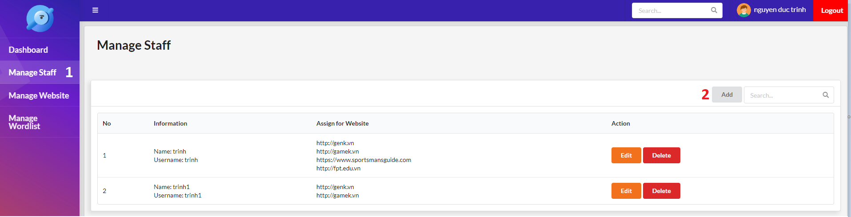

Figure 92 - Add Staff UI

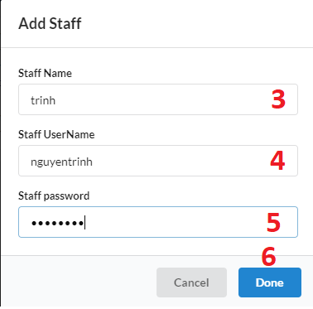

Figure 93 - Add Staff Popup

|  |  |
| --- | --- |
| **Step** | **Description** |
| Pre-condition | Login as Manager |
| 1 | Click “Manage Staff” in the navigation bar |
| 2 | Click “Add” button |
| 3 | Fill the field “Staff Name” |
| 4 | Fill the field “Staff Username” |
| 5 | Fill the field “Staff Password” |
| 6 | Click “Done” button |

Table 142 - Add Staff Steps

**2.1.2 Edit Staff**

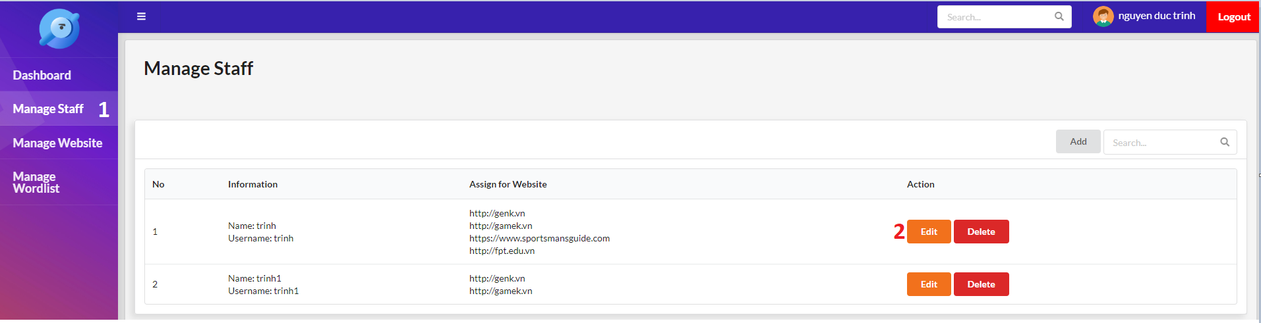

Figure 94 - Edit Staff UI

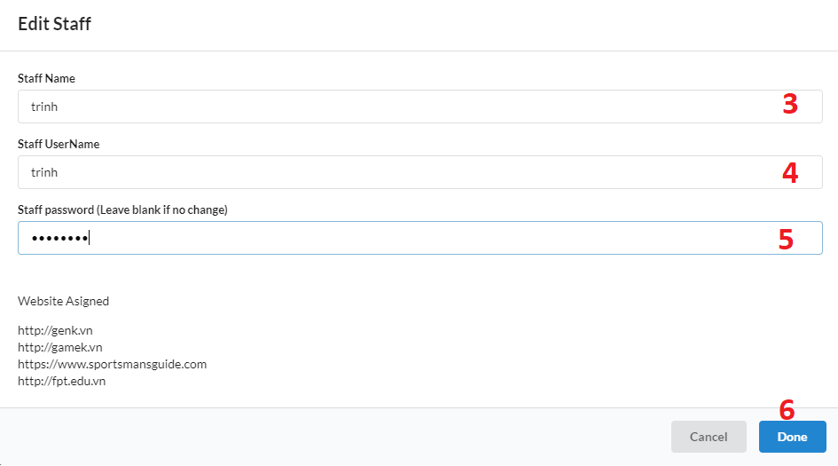

Figure 95 - Edit Staff Popup

|  |  |
| --- | --- |
| **Step** | **Description** |
| Pre-condition | Login as Manager |
| 1 | Click “Manage Staff” in the navigation bar |
| 2 | Click “Edit” button |
| 3 | Fill the field “Staff Name” |
| 4 | Fill the field “Staff Username” |
| 5 | Fill the field “Staff Password” |
| 6 | Click “Done” button |

Table 143 - Edit Staff Steps

**2.1.3 Delete Staff**

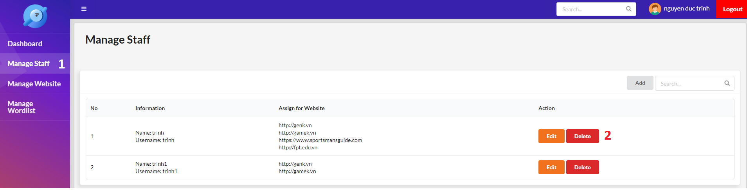

Figure 96 - Delete Staff UI

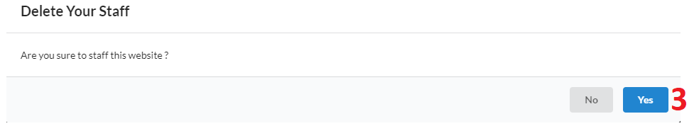

Figure 97 - Delete Staff Popup

|  |  |
| --- | --- |
| **Step** | **Description** |
| Pre-condition | Login as Manager |
| 1 | Click “Manage Staff” in the navigation bar |
| 2 | Click “Delete” button |
| 3 | Click “Yes” button |

Table 144 - Delete Staff Steps

**2.1.4 Make new version of the website**

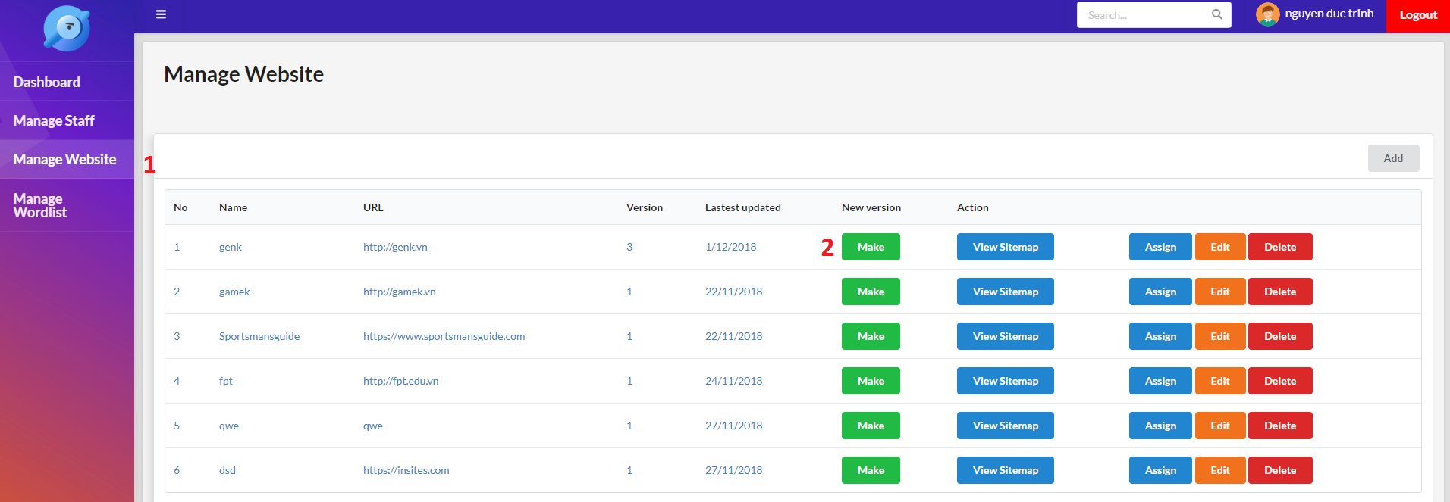

Figure 98 - Make new version UI

|  |  |
| --- | --- |
| **Step** | **Description** |
| Pre-condition | Login as Manager |
| 1 | Click “Manage Website” in the navigation bar |
| 2 | Click “Make” button |

Table 145 - Make new version Steps

**2.1.5 View Sitemap**

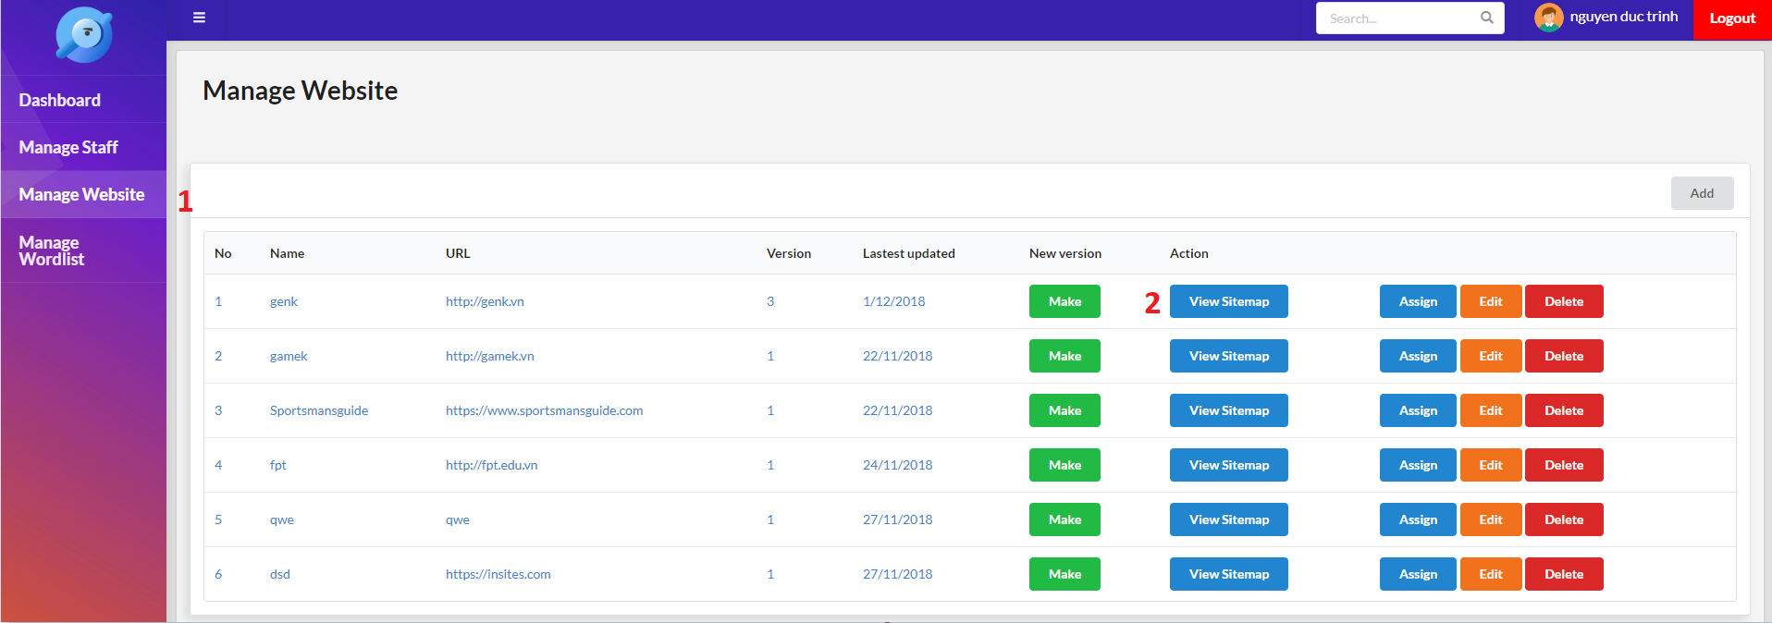

Figure 99 - View Sitemap UI

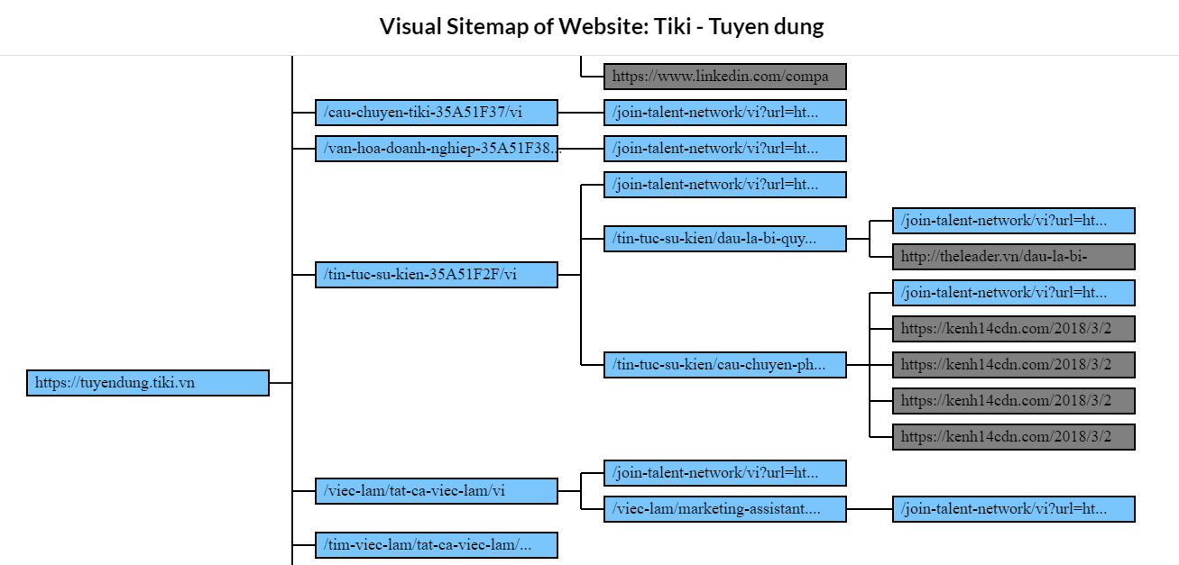

Figure 100 - Sitemap Screen

|  |  |
| --- | --- |
| **Step** | **Description** |
| Pre-condition | Login as Manager |
| 1 | Click “Manage Website” in the navigation bar |
| 2 | Click “View Sitemap” button |

Table 146 - View Sitemap Steps

**2.1.6 Assign website for Staff**

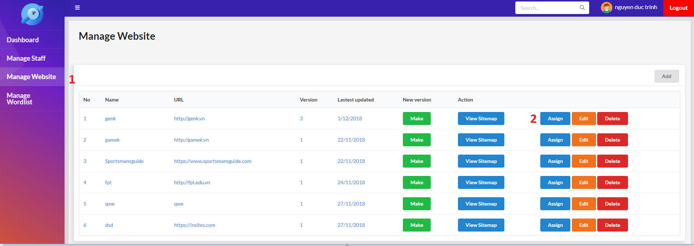

Figure 101 - Assign website UI

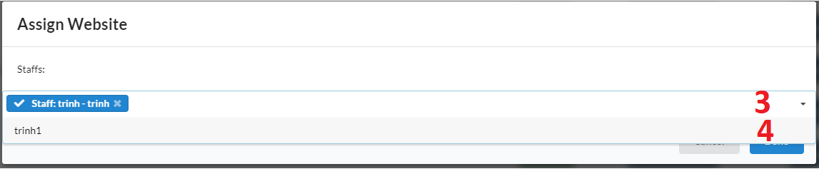

Figure 102 - Assign website popup

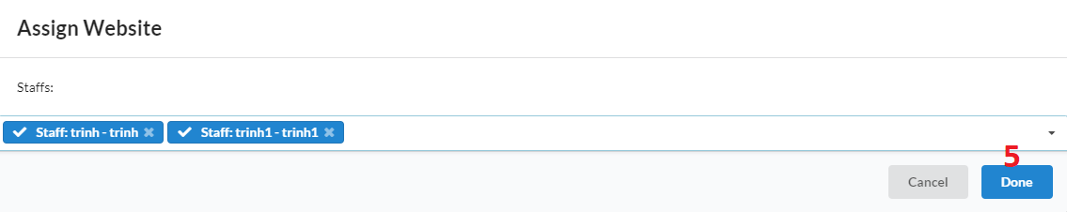

Figure 103 - Assign website popup

|  |  |
| --- | --- |
| **Step** | **Description** |
| Pre-condition | Login as Manager |
| 1 | Click “Manage Website” in the navigation bar |
| 2 | Click “Assign” button |
| 3 | Click “Staffs” dropdown |
| 4 | Select Staff |
| 5 | Click “Done” button |

Table 147 - Assign website steps

**2.1.7 Add warning word**

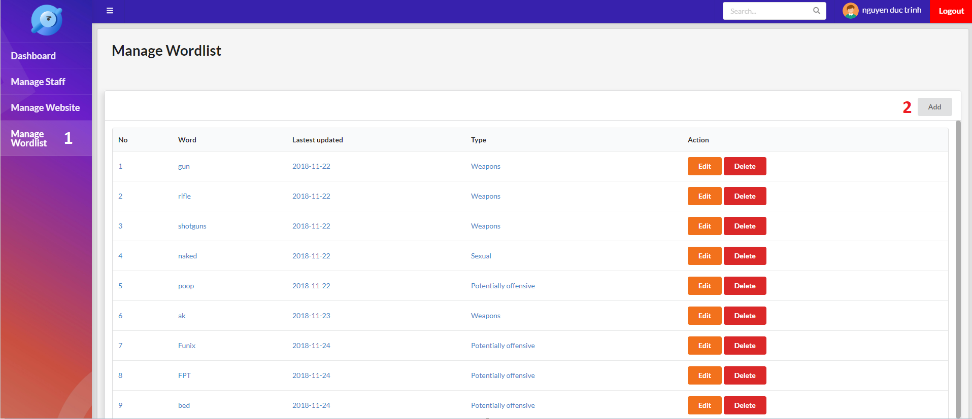

Figure 104 - Add warning word UI

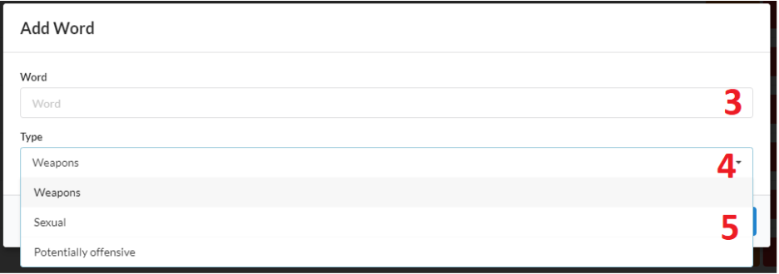

Figure 105 - Add warning word popup

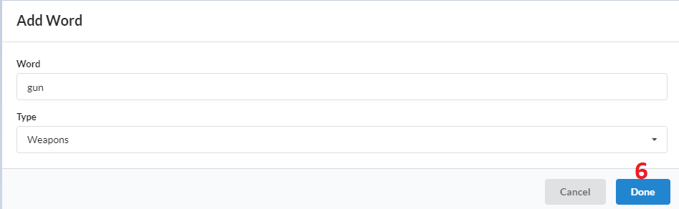

Figure 106 - Add warning word popup

|  |  |
| --- | --- |
| **Step** | **Description** |
| Pre-condition | Login as Manager |
| 1 | Click “Manage Wordlist” in the navigation bar |
| 2 | Click “Add” button |
| 3 | Fill the field “Word” |
| 4 | Click “Type” dropdown |
| 5 | Select Type |
| 6 | Click “Done” button |

Table 148 - Add warning word steps

**2.1.8 Edit warning word**

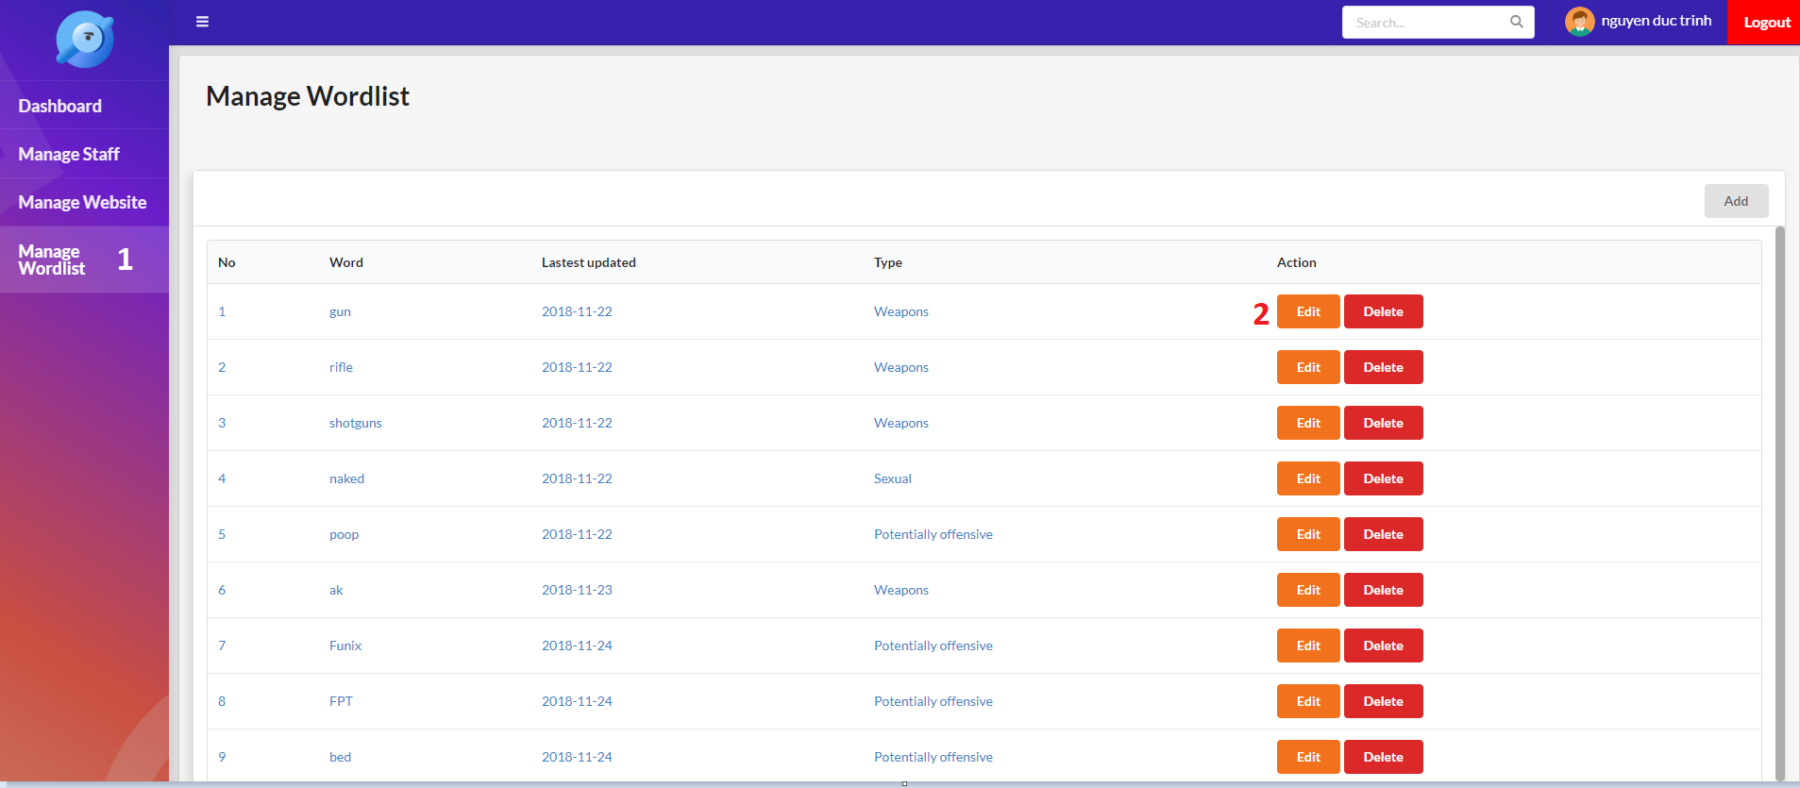

Figure 107 - Edit warning word UI

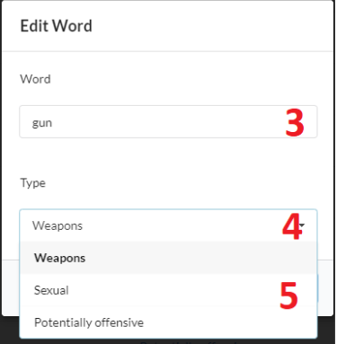

Figure 108 - Edit warning word popup

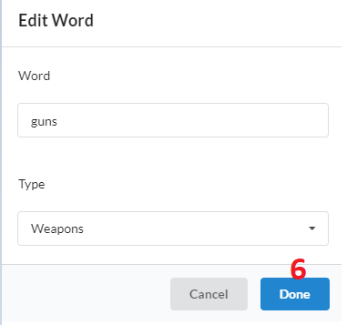

Figure 109 - Edit warning word popup

|  |  |
| --- | --- |
| **Step** | **Description** |
| Pre-condition | Login as Manager |
| 1 | Click “Manage Wordlist” in the navigation bar |
| 2 | Click “Edit” button |
| 3 | Fill the field “Word” |
| 4 | Click “Type” dropdown |
| 5 | Select Type |
| 6 | Click “Done” button |

Table 149 - Edit warning word steps

**2.2 Staff**

**2.2.1 Select website to test**

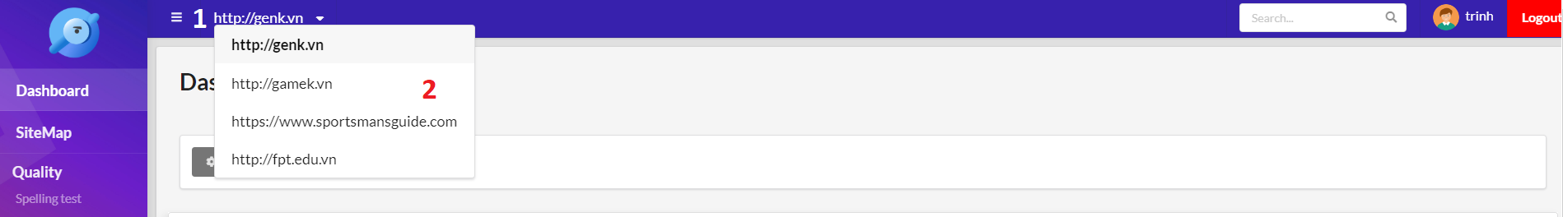

Figure 110 - Select website UI

|  |  |
| --- | --- |
| **Step** | **Description** |
| Pre-condition | Login as Staff |
| 1 | Click “Website” dropdown in the header |
| 2 | Select website |

Table 150 - Select website steps

**2.2.2 Add page option**

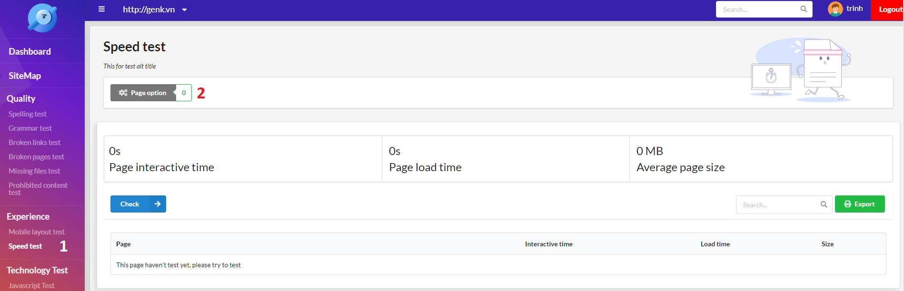

Figure 111 - Select page option UI

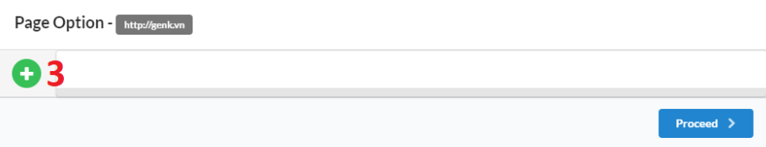

Figure 112 - Add page option popup

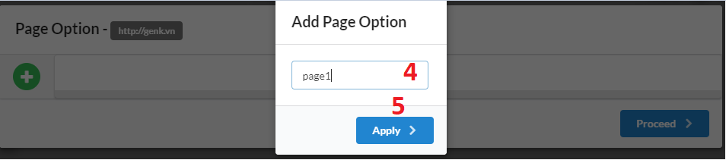

Figure 113 - Add page option popup

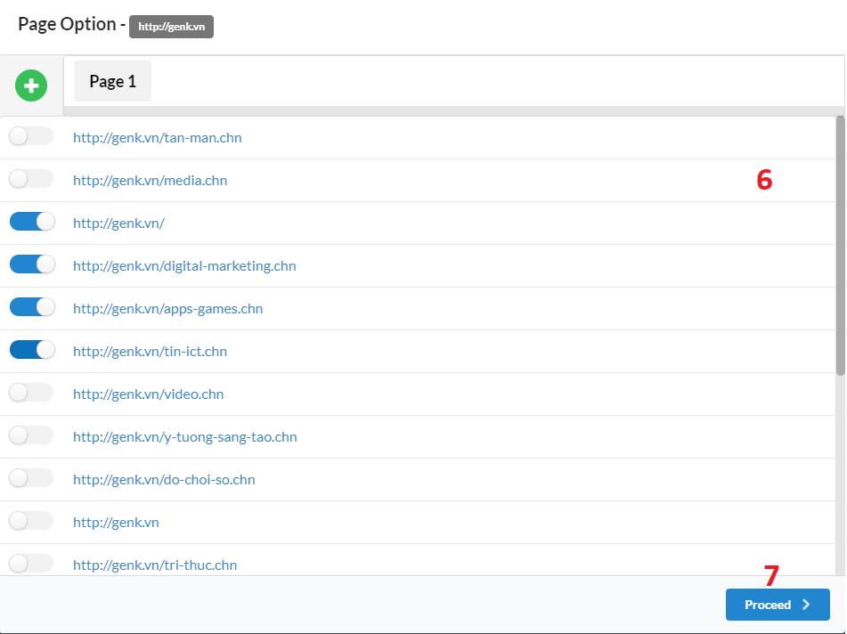

Figure 114 - Add page option popup

|  |  |
| --- | --- |
| **Step** | **Description** |
| Pre-condition | Login as Staff |
| 1 | Select any test function in the navigation bar |
| 2 | Click “Page Option” button |
| 3 | Click “Plus” button |
| 4 | Fill the field “Page option name” |
| 5 | Click “Apply” button |
| 6 | Select page for page option |
| 7 | Click “Proceed” button |

Table 151 - Add page option steps

**2.2.3 Rename or Delete page option**



Figure 115 - Select page option UI

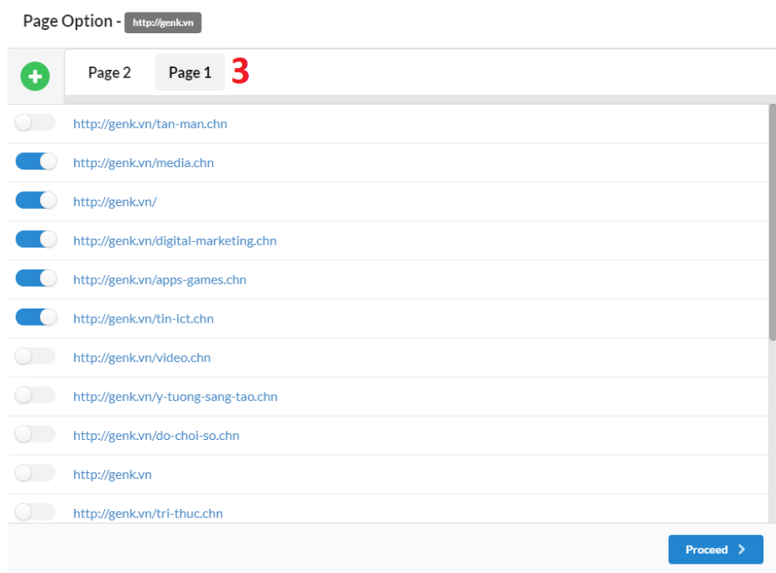

Figure 116 - Select page option popup

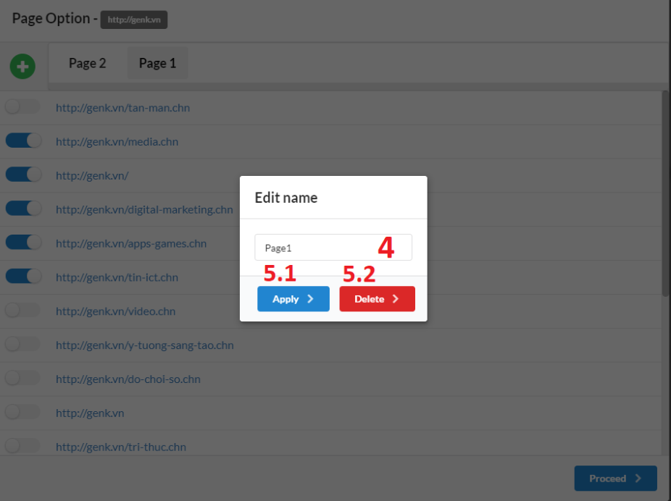

Figure 117 - Rename or Delete page option popup

|  |  |
| --- | --- |
| **Step** | **Description** |
| Pre-condition | Login as Staff |
| 1 | Select any test function in the navigation bar |
| 2 | Click “Page Option” button |
| 3 | Double click page option name |
| 4 | Fill the field “Page option name” |
| 5.1 | Click “Apply” button to rename page option |
| 5.2 | Click “Apply” button to delete page option |

Table 152 - Rename or Delete page option steps

**2.2.4 Do a test function**



Figure 118 - Select page option UI

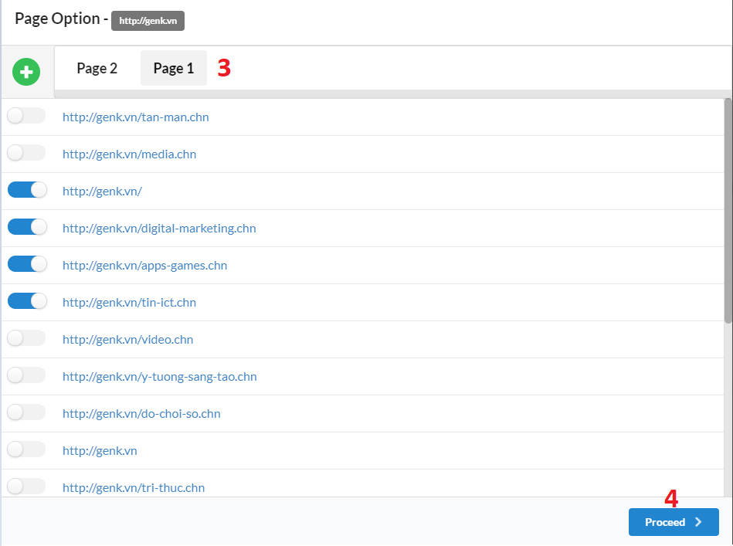

Figure 119 - Select page option popup

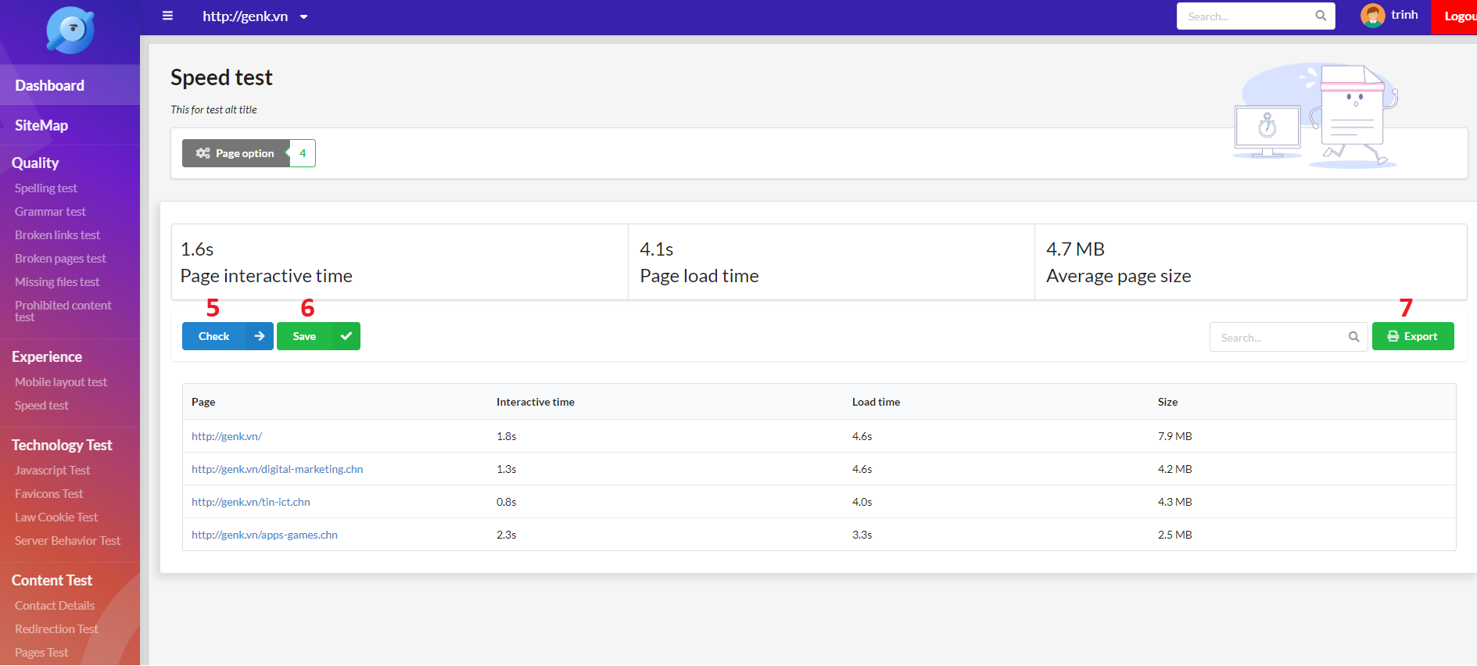

Figure 120 - Test function UI

|  |  |
| --- | --- |
| **Step** | **Description** |
| Pre-condition | Login as Staff |
| 1 | Select any test function in the navigation bar |
| 2 | Click “Page Option” button |
| 3 | Click to choose page option |
| 4 | Click “Proceed” button |
| 5 | Click “Test” button |
| 6 | Click “Save” button to save result |
| 7 | Click “Export” button to export result |

Table 153 - Do a test function steps

# Appendix

* + - 1. **Spring Framework** *[Online]* Available: [https:/spring.io/docs/reference](https://spring.io/docs/reference).
      2. **The Unified Certification** *[Online]* Available: <https://www.omg.org/ocup-2/index.htm>.
      3. **MySQL** *[Online]* Available: <https://dev.mysql.com/doc/>.
      4. **ReactJS** *[Online]* Available: <https://reactjs.org/docs/getting-started.html>
      5. **IntelliJ IDEA** *[Online]* Available: <https://www.jetbrains.com/idea/documentation/>
      6. **Visual Studio Code** *[Online]* Available: <https://code.visualstudio.com/docs>
      7. **Jsoup** *[Online]* Available: <https://jsoup.org/apidocs/overview-summary.html>
      8. **Selenium** *[Online]* Available: https://www.seleniumhq.org/docs/
      9. **Nodejs** *[Online]* Available: <https://nodejs.org/en/docs/>
      10. **HtppCode** *[Online]* Available: <https://www.w3.org/Protocols/rfc2616/rfc2616-sec10.html>
      11. **Regular Expression** *[Online]* Available: <https://docs.oracle.com/javase/7/docs/api/java/util/regex/Pattern.html>
      12. **Cookie Law** *[Online]* Available: <https://www.cookielaw.org/faq/>
      13. **DFS and BFS Algorithms using Stacks and Queues, Professor Lawrence L. Larmore** *[Online]* Available: <http://web.cs.unlv.edu/larmore/Courses/CSC477/bfsDfs.pdf>
      14. **The Breadth-First Search Algorithm, Khan Academy** *[Online]* Available: <https://www.khanacademy.org/computing/computer-science/algorithms/breadth-first-search/a/the-breadth-first-search-algorithm>
      15. **Data Structure — Breadth First Traversal, TutorialsPoint** *[Online]* Available: <https://www.tutorialspoint.com/data_structures_algorithms/breadth_first_traversal.htm>
      16. **Binary tree: Level Order Traversal, mycodeschool** *[Online]* Available: <https://www.youtube.com/watch?v=86g8jAQug04>
      17. **Breadth-First Traversal of a Tree, Computer Science Department of Boston University** *[Online]* Available: <https://www.cs.bu.edu/teaching/c/tree/breadth-first/>
      18. **Digit-based sorting and data structures, Professor Avrim Blum** *[Online]* Available: <https://www.cs.cmu.edu/~avrim/451f11/recitations/rec0921.pdf>
      19. **Lecture Notes on Tries, Professor Frank Pfenning** *[Online]* Available: <https://www.cs.cmu.edu/~fp/courses/15122-f10/lectures/18-tries.pdf>
      20. **Algorithms: Tries, Robert Sedgewick and Kevin Wayne** *[Online]* Available: <https://algs4.cs.princeton.edu/lectures/52Tries.pdf>
      21. **Tries, Brilliant Learning** *[Online]* Available: <https://brilliant.org/wiki/tries/>
      22. **Tries, Daniel Ellard** *[Online]* Available: <http://ellard.org/dan/www/libsq/cb_1998/c06.pdf>
      23. **Tries, Harvard CS50** *[Online]* Available: <https://www.youtube.com/watch?v=TRg9DQFu0kU>
      24. **Sitemap, Garenne Bigby** *[Online]* Available: https://dynomapper.com/blog/16-sitemap-generator/164-top-50-sitemap-generators-for-creating-sitemaps